Name___________________

Date____________________

# Mitosis Drawings

**Purpose**

The purpose of this exercise is to illustrate and explain the stages of mitosis. [1]

**Procedure**

**Materials:**

1. 8 ½ x 11 inch sheet of paper
2. Colored pencils or pens
3. Notes/text book

**Sequence of Steps**

1. Separate an 8 ½ x 11” sheet of paper into 4 sections.
2. Using colored pencils, draw a cell as it goes through each of the 4 stages of mitosis. *(This is not art class; however, you need to put forth some effort so that you have a visual of the mitosis process.)*
3. Label each stage
4. Briefly explain what occurs in each stage.
5. C:\Users\Angela\AppData\Local\Microsoft\Windows\Temporary Internet Files\Content.IE5\DRP2N1IJ\MCj04242300000[1].wmfMake sure to include your name, date and period.
6. When your drawings are complete, answer the review questions below.

C:\Users\Angela\AppData\Local\Microsoft\Windows\Temporary Internet Files\Content.IE5\DRP2N1IJ\MCj04242300000[1].wmf

**Review Questions**

1. What are the four stages of mitosis? Explain briefly what happens at each stage.

2. In plants and animals, which cells go through the process of mitosis?

3. What is the purpose of mitosis? What does it produce?

4. Animals are continuously going through mitosis at different places in their body. Identify two areas where mitosis could be taking place in an animal.

5. Plants go through mitosis continuously as well. Identify a reason that plants go through mitosis. What does mitosis produce in plants?

**Teacher Notes:**

*Below are student samples for your reference.*

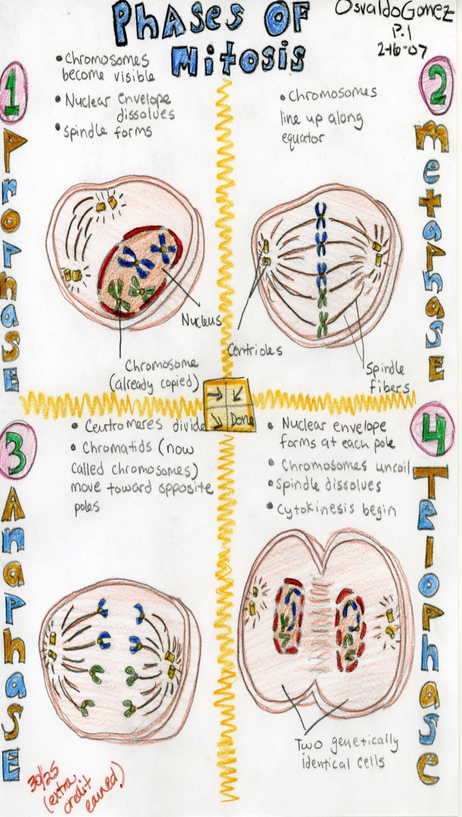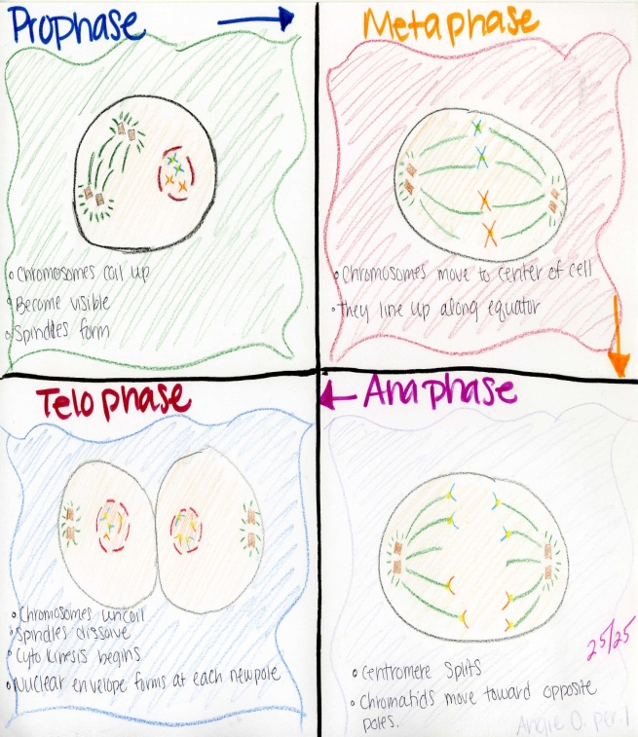

1. Sperling, Jill (2008).Mitosis Drawings. *Kingsburg High School Agriculture Department*.