Name___________________

Date____________________

# Boar Semen: Who’s the Better Daddy?

**Purpose**

The purpose of this lab is to evaluate boar semen and determine the performance ability in the areas of motility, morphology and acrosome integrity.[1]

**Procedure**

**Materials**

1. Boar semen (2 different samples)
2. Pipettes
3. Slides
4. Slide covers
5. Microscopes ( must be capable of 100x and 400x)
6. Eosin-nigrosin stain
7. Acrosome stain
8. Saline
9. Microscope immersion oil
10. Clean Dry beakers of test tubes

**Sequence of Steps**

1. Define the following terms prior to starting this lab:
   1. Motility:
   2. Morphology
   3. Acrosome Integrity
2. *Your Dilemma:* You are a supplier of boar semen to be distributed for AI (artificial insemination). The problem is that you just bought three big time champion boars and you only have room for two of them. You decide that there are two boars that you may be able to part with but you are unsure of which one you should send down the river. One thing that you pride yourself in is the quality of product that you distribute, so you decide the boar that is producing the best quality of semen is the boar that you will keep.
3. C:\Users\Angela\AppData\Local\Microsoft\Windows\Temporary Internet Files\Content.IE5\DRP2N1IJ\MCj04242300000[1].wmfReview the examples of visual abnormalities. Follow the procedures and record your data for each sample. Then you will have to decide who the better producer is.
4. C:\Users\Angela\AppData\Local\Microsoft\Windows\Temporary Internet Files\Content.IE5\DRP2N1IJ\MCj04242300000[1].wmfBegin by filling in the sire names across the top of the Data Table.
5. C:\Users\Angela\AppData\Local\Microsoft\Windows\Temporary Internet Files\Content.IE5\DRP2N1IJ\MCj04242300000[1].wmfObserve the ejaculate and record observations.
6. Determine the volume of the semen.
7. **Motility**
   1. Prepare a 1:10 dilution of semen with semen extender (not needed if using bottled semen).
   2. Gently rotate the semen.
   3. Remove a small sample (5 to 10 ml) and place in a clean glass test tube.
   4. If, necessary, warm it to 36 to 37 degrees centigrade (body temperature).
   5. Place a small drop on a pre-warmed slide and gently place a cover slip over the drop.
   6. C:\Users\Angela\AppData\Local\Microsoft\Windows\Temporary Internet Files\Content.IE5\DRP2N1IJ\MCj04242300000[1].wmfImmediately examine the sample at 100x and then at 400x.
   7. C:\Users\Angela\AppData\Local\Microsoft\Windows\Temporary Internet Files\Content.IE5\DRP2N1IJ\MCj04242300000[1].wmfCount the # of sperm in each field that are progressively moving forward. Count the number of sperm found in each cell for 10 cells in 5 different fields. Record each count in the chart.
   8. Determine the average number of sperm with good motility in each sample and record.
8. **Morphology**
   1. After the motility estimate is complete, allow the slide to cool. Motility will slow or stop and individual sperm cells can be observed. OR Prepare a stained semen sample-using step 9a, with a mixture (1:1) of morphology stain (Eosin-nigrosin stain) and formal saline.
   2. C:\Users\Angela\AppData\Local\Microsoft\Windows\Temporary Internet Files\Content.IE5\DRP2N1IJ\MCj04242300000[1].wmfSwitch to the 400x objective and observe individual cells in 5 fields.
   3. Determine the percentage of "normal" cells. *HINT: It is usually easier to count the # of abnormal sperm.*

|  |
| --- |
| % of normal cells = # of normal cells/ total # of cells |

1. **Acrosome Integrity**
   1. Prepare a 1:1 dilution of semen and a mixture (1:1) of formal saline and Acrosome stain on a glass slide.
   2. Place 1-2 drops of semen and 1-2 drops of the stain mixture on a glass slide and mix gently with the tip of the pipette. Use the edge of a second slide to draw the mixture across the flat slide to produce a thin layer. Allow the slide to air dry.
   3. C:\Users\Angela\AppData\Local\Microsoft\Windows\Temporary Internet Files\Content.IE5\DRP2N1IJ\MCj04242300000[1].wmfPlace a drop of microscope immersion oil under the slide and view first at 10x to focus, and then switch to either 40x or 100x and view individual cells. (Be sure that you don't get oil on non-oil lens)
   4. C:\Users\Angela\AppData\Local\Microsoft\Windows\Temporary Internet Files\Content.IE5\DRP2N1IJ\MCj04242300000[1].wmfRepeat step 8c to determine the percentage of cells that are "normal". (see example pictures for normal vs. abnormal)
2. Review ideal values for boar semen and answer observation questions.

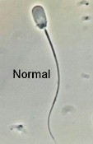**Examples of Visual Abnormalities**

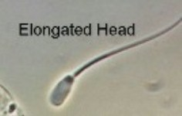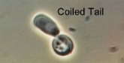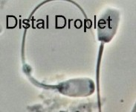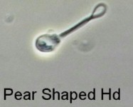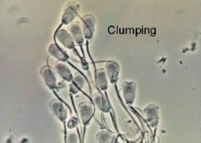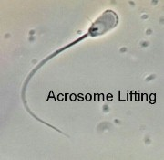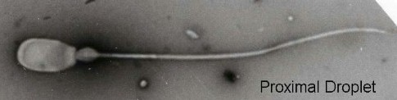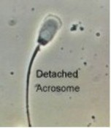

**Ideal Values for Boar Semen**

|  |  |  |
| --- | --- | --- |
| Ejaculate Characteristic[2][3][4] | Normal Value | Limit Value |
| Ejaculate Volume | 100-500ml | 50ml |
| Total Sperm per Ejaculate (x 109) | 10-100 | 10 |
| Progressive Motility | 70-95% | 62% |
| Clumping (% coverage of microscopic field) | 0-10% | 25% |
| Curled Tails | 1-2% | 10% |
| Morphological Abnormalities | 5-10% | 30% |
| Acrosome Abnormalities | 5-10% | 49% |
| Cytoplasmic Droplets | <5% | 15% |

C:\Users\Angela\AppData\Local\Microsoft\Windows\Temporary Internet Files\Content.IE5\DRP2N1IJ\MCj04242300000[1].wmf

**Data Table**

|  |  |  |
| --- | --- | --- |
| Sire Name |  |  |
| Visual of ejaculate (evaluate color, and consistency) |  |  |
| Determine semen volume |  |  |
| Motility |  |  |
| # of sperm in each field progressively moving forward. |  |  |
| Average sperm count with good motility. |  |  |
| Morphology |  |  |
| % of normal sperm cells. |  |  |
| Acrosome Integrity |  |  |
| % of normal sperm cells. |  |  |

**Observations**

1. Did sire A meet the limit requirements? If not which values did it not pass? (Use the chart on the previous.)
2. Did sire B meet the limit requirements? If not which values did it not pass?
3. Was sire A in the normal range? If not which values were out of the range?
4. Was sire B in the normal range? If not which values were out of the range?
5. Which boar did you cull from your herd? WHY?

**Teacher Notes**

For those who do not have a boar to collect semen from, it is fairly inexpensive to buy semen from a distributor. This could be an advantage for class as it is already extended and you could get a sample from more than one boar. Differences can be studied between breeds, boars, ages, etc. One dose should be more than enough for about 4 groups to do all three of the evaluation procedures. You can purchase one dose of boar semen for as little as $15. Top Cut Showpig Sires http://www.topcutsires.com/ is just one possible supplier for boar semen. Do some research online as most genetics companies offer inexpensive sires.

1. Severtson, M. (2008). Boar Semen. *Student,* *California Polytechnic State University, San Luis Obispo*.
2. Data from Larsson K: Current Therapy in Theriogenology, 2nd ed. P.972.
3. Pork Industry Handbook no. 136. Semen collection, evaluation, and processing in the boar.
4. Flowers, 1998.