Name___________________

Date____________________

# Codon Bingo

**Purpose**

The purpose of this exercise is to practice using a codon table to translate mRNA into its associated amino acids.[1]

**Procedure:**

**Materials**

1. Blank Bingo cards
2. Codon table
3. Bingo chips, pennies, or other small marking items.

**Sequence of Steps**

1. Get one blank bingo card and put your name on it.

2. Fill in each of the blanks with an **amino acid** from the codon table.   
3. The teacher will call out three bases (A, T, G, or C)

4. Find the amino acid that is associated with the codon and place a marker on that bingo square.

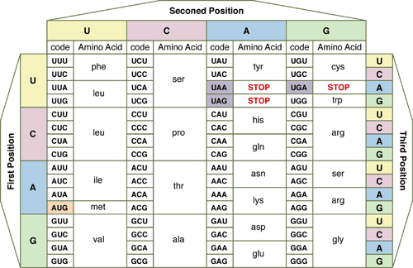

BIOLOGY BINGO

|  |  |  |  |  |
| --- | --- | --- | --- | --- |
|  |  |  |  |  |
|  |  |  |  |  |
|  |  |  |  |  |
|  |  |  |  |  |
|  |  |  |  |  |

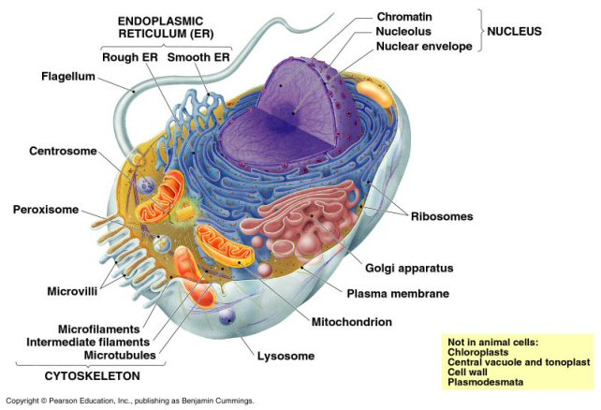

1. Opfergelt, H (2008).Codon Bingo. *Firebaugh High School Agriculture Department*.