Name___________________

Date____________________

# Edible DNA

**Purpose**

The purpose of this exercise is to build and manipulate a model of DNA in order to investigate structure and replication.[1] [2]

**Procedure:**

**Materials**

1. Spice gum drops (four colors minimum)

2. Orange slices (candy type or some other soft candy larger than gum drops)

3. Plain flat toothpicks

4. Paper towels

**Sequence of Steps**

**Part I: Building a DNA Model**

1. Use a diagram of DNA and the key below to build four different nucleotides

(Figure 1): See below

Orange slice = deoxyribose sugar Purple gum drop = Thymine nitrogen base

White gum drop = phosphate group Yellow gum drop = Cytosine nitrogen base

Plain toothpicks = chemical bonds Red gum drop = Adenine nitrogen base

Green gum drop = Guanine nitrogen base

Figure 1: A DNA nucleotide

Phosphate group

Nitrogen Base (G, C, A, or T)

Deoxyribose (sugar)

1. Repeat step 1. Now, combine the nucleotides to start forming a DNA molecule. DNA has the shape of a twisted ladder or spiral staircase. The geometric shape is called a **double helix**. You will make a "ladder" that has 4 "rungs" or steps. Remember, Adenine combines with Thymine and Guanine combines with Cytosine. Combine the nucleotides using the example below (figure 2): See below

Figure 2: Two nucleotides bonded together between the nitrogen bases (a "step")

1. Continue to build the "ladder" combing nucleotides as in step 3.
2. Once you have built the "ladder" that has used all 8 nucleotides made in steps 1

and 2, show the DNA molecule to the teacher.

**Part II: DNA Replication (copying)**

1. DNA must make a copy of itself before one cell splits into two cells. Special molecules called enzymes help DNA replicate or copy itself. First, an enzyme "unzips" DNA as if it were a zipper. Use your hands to pull apart the toothpicks that hold together your nucleotides (right up the middle like a zipper).

2. Next, an enzyme attaches new nucleotides to the two original strands that were separated. You will have to make 8 new nucleotides that pair up to the nucleotides on the original strands. Remember the nitrogen base pairing rules, A with T and G with C!

3. When you are finished, you should have two DNA molecules that are identical. Show your results to the teacher and ask him/her if you can eat your results!

4. Clean up your work area.

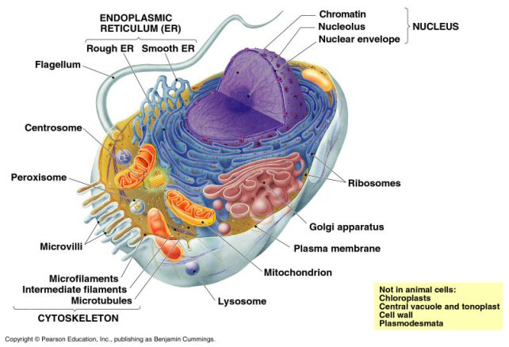

1. Opfergelt, H (2008).Edible DNA. *Firebaugh High School Agriculture Department*.
2. Edible DNA! Retrieved January 19, 2009, from Power to Learn Web site: http://www.powertolearn.com/teachers/lesson_activities/index.shtml