Name___________________
Date____________________

Pathogens: Officer Retreat Investigation!
Purpose
The purpose of this exercise is to investigate the cause of a hypothetical outbreak of illnesses.
Scenario
Imagine that the four members of your group are the FFA officers of your Chapter. You organized a weekend retreat to Lake Superior for your 40 Greenhand members. The buses arrived at the cabins in time for dinner on Friday night. On Saturday night, eight of the members became ill. They all had high fevers, chills, severe abdominal pains, vomiting and diarrhea. Within the next 24 hours, four other students had these symptoms. Only the members who went on the retreat became ill. Your objective, as the leaders of the trip, is to investigate the cause of this outbreak of illnesses.

Procedure
Materials
- Pen/Pencil
- Handout from your instructor

Sequence of Steps
- Your class will be organized into groups of four. Each of you will be expected to volunteer as an FFA officer. You will be read a scenario about a Greenhand retreat wherein many of the members fell ill. It is your task as the FFA officers to investigate the cause of the illness.
Each of you will be responsible for directing some segment of the investigation. Please follow the format and do not rush through this lab. The president will begin the narrative.
- Identify the members of your group and determine the office for each team member.
  - President _________________________________________
  - Vice President _____________________________________
  - Secretary _________________________________________
  - Treasurer _________________________________________
Conclusions
- What are three possible causes of the Greenhand retreat weekend illness?
  - _____________________________________________________________________
  - _____________________________________________________________________
  - _____________________________________________________________________
- List illnesses that could be ruled out.
  - _____________________________________________________________________
  - _____________________________________________________________________
  - _____________________________________________________________________
  - _____________________________________________________________________
  - _____________________________________________________________________
- What possible causes of illnesses can you probably eliminate?
- _____________________________________________________
- _____________________________________________________
- Why do you think the incubation time for chemicals or poisons is shorter than for bacteria or viruses?

__________________________________________________________________________________ __________________________________________________________________________________
- For each of the possible causes, what are some ways that the illness could have spread?
  - ____________________________________________________________________
  - ____________________________________________________________________
  - ____________________________________________________________________
  - ____________________________________________________________________
- What possible modes of transmission can we eliminate?
  - ____________________________
  - ____________________________
- Does the pattern in Table III suggest personal contact as the means of disease transmission?
  - The pattern _____________________ suggest personal contact.
  - Does the pattern in Table IV suggest personal contact as the means of disease transmission? Why or why not?

__________________________________________________________________________________ __________________________________________________________________________________

  - Which method of transmission seems to be the most likely at this point? (look at Table II)

__________________________________________________________________________________ __________________________________________________________________________________

- What food might have made us ill?
  - __________________________________________
  - __________________________________________
  - __________________________________________

- Now what food(s) do you suspect?
  - ___________________________________________

- Why is the coconut cream pie more suspicious than the roast beef dinner?

__________________________________________________________________________________ __________________________________________________________________________________

- Is there anything in the dessert data, which contradicts, or makes you uncertain about your conclusion? What?

__________________________________________________________________________________ __________________________________________________________________________________

- How does this information about Jack and Jill help you interpret the dessert data?

__________________________________________________________________________________ __________________________________________________________________________________

- Jill ordered pie, but didn’t get sick. How could you explain this?

__________________________________________________________________________________ __________________________________________________________________________________

SECRETARY
- Most high schools have light microscopes. Which are larger a bacterium (singular for bacteria) or virus? Would it be possible to observe a virus using a compound light microscope?

__________________________________________________________________________________ __________________________________________________________________________________

__________________________________________________________________________________ __________________________________________________________________________________

- Approximately how much bigger is a bacterium than a virus?
  - ______________________________________________________________________
- How can we tell if viruses are present or the cause of the illness?
  - Step 1 – _______________________________________________________________ ______________________________________________________________________
  - Step 2 - _______________________________________________________________ ______________________________________________________________________ ______________________________________________________________________ ______________________________________________________________________ ______________________________________________________________________
  - Step 3 – _______________________________________________________________ ______________________________________________________________________ ______________________________________________________________________
  - Step 4 – _______________________________________________________________ ______________________________________________________________________ ______________________________________________________________________
- If the pie contained virus particles, would they be in test tube A or B?
  - _______________________________________
- From Figure II, which mice remained healthy and which became ill?
  - ______________________________________________________________________ ______________________________________________________________________

- How could she find out if something in the pie, other than bacteria or viruses, caused the illness? What is this process called?
  - ____________________________________________________________________ ____________________________________________________________________
  - ____________________________________________________________________
- What is an experimental control supposed to do?
  - ____________________________________________________________________ ____________________________________________________________________
- In Figure II, what should be drawn in the box labeled ‘control’ to complete the diagram?
  - ____________________________________________________________________
- What can you conclude from this experiment? What are organisms called that cause disease?
  - ____________________________________________________________________
  - ____________________________________________________________________
- Would you expect to find bacteria in food you eat every day? Do all bacteria cause disease? What are bacteria called that do not cause disease?
  - _____________________________________________________________________
  - _____________________________________________________________________
  - _____________________________________________________________________
- What are some possible ways to distinguish one kind of bacteria from another?
  - _____________________________________________________________________
  - _____________________________________________________________________
  - _____________________________________________________________________
  - _____________________________________________________________________

- How many basic shapes do bacteria have? Draw each shape and label, and then draw each group and label with its prefix.
  - ___________________

- Can you tell by the shape or arrangement whether or not all of these bacteria cause disease?
  - _____________

TREASURER
- In steps 1 and 2, why would it be necessary to get a ‘pure’ culture?
  - ____________________________________________________________________ ____________________________________________________________________ ____________________________________________________________________

- In steps 3 and 4, the mice given the streptobacillus got sick. The mice given the cocci did not get sick. Can you conclude from this that the streptobacillus made them sick?
  - __________________
- How can you challenge the hypothesis that something else killed them?
  - ____________________________________________________________________ ____________________________________________________________________ ____________________________________________________________________ ____________________________________________________________________
- Think about our symptoms we heard about or experience on the Greenhand retreat, the laboratory data, and the health bulletin. What type of bacteria do you think caused our weekend illness?
  - _______________________________

DAY 2 PRESIDENT
- What should we do first?
  - _____________________________________________________________________ _____________________________________________________________________
- If we used a light microscope, what should make us think we have just one type of bacteria in a blood sample? (It may help to look at Figure III).
  - _____________________________________________________________________ _____________________________________________________________________
- In Figure III, which pictures might represent the blood bacterium?
  - _______________
- By observing with a microscope, how would we know there are many types of bacteria in the feces?
  - ______________________________________________________________________ ______________________________________________________________________
- There are Diplococci in the sample of feces. What do Diplococci look like?
  - ______________________________________________________________________
- We also see Diplobacilli. What do they look like?
  - _______________________________________________________________________
- There are also Bacilli. Can we tell by their size and shape if they are pathogenic?
  - _____________________
- Which bacterium from the sick hen is most likely to be the cause of the disease?
  - _____________________________________________________________________

- How would we test whether or not the bacterium from the blood is the cause? (Hint-look at Figure IV).
  - _____________________________________________________________________ _____________________________________________________________________

DAY 2 VICE PRESIDENT
- How could we kill a pure sample of the bacteria we found in the chicken blood?
  - ____________________________________________________________________
- List two ways to explain the results.
  - ______________________________________________________________________ ______________________________________________________________________ ______________________________________________________________________
  - ______________________________________________________________________ ______________________________________________________________________ ______________________________________________________________________
- This is why we need a control in the experiment. The control should allow us to rule out the chance that the original bacteria changed. Can you think of a control?
  - ______________________________________________________________________ ______________________________________________________________________
- What can we conclude?
  - ______________________________________________________________________ ______________________________________________________________________
- What was the control in Experiment 2?
  - ______________________________________________________________________ ______________________________________________________________________
- How did it help us with our conclusion?
  - ______________________________________________________________________ ______________________________________________________________________ ______________________________________________________________________

DAY 2 SECRETARY
- How can cooks at home and in restaurants make food safer to eat? Some ways include:
- ______________________________________________________________________ ______________________________________________________________________
- ______________________________________________________________________ ______________________________________________________________________
- ______________________________________________________________________ ______________________________________________________________________
- ______________________________________________________________________ ______________________________________________________________________
- ______________________________________________________________________ ______________________________________________________________________
- ______________________________________________________________________
______________________________________________________________________
- At what temperature do most bacteria multiply fastest? At the temperature of:
  - ______________________________________________________________________
- Do boiling temperatures kill all forms of bacteria so they won’t grow again? What might be an exception?
  - ______________________________________________________________________ ______________________________________________________________________
  - ______________________________________________________________________
- Salmonella is killed at high temperatures. And the coconut pie was cooked. How did the Salmonella survive?
  - ______________________________________________________________________ ______________________________________________________________________ ______________________________________________________________________

STUDENT NARRATIVE HANDOUT
Pathogens: Officer Retreat Investigation!

FFA PRESIDENT
- You will begin the lab. Ask your fellow officers the questions below. Questions are written in bold; the answers are in italics. The underlined parts of the answer of this narrative are the key words or phrases that you and your team will write on your answer sheet.
- After reading the question, discuss the ‘guesses’ made by each officer. Call on everyone to offer an answer before you read the correct answer.
Read to your group the following question:
- What are three possible causes of the Greenhand retreat weekend illness?
Read the answer (you also need to write the answer).
chemical poisoning
infection with bacteria
viruses
- List illnesses that could be ruled out.
Read aloud: An allergy is an individual reaction to a specific substance. It would not be an ‘epidemic’ type of reaction in most groups. Car sickness, lack of sleep, homesickness, and over-eating can also cause illness. But they are not likely to affect so many people at one time.

- Have your officers analyze and discuss Table 1.
- What possible causes of illnesses can you probably eliminate?
After some discussion read the answer: You can probably eliminate chemical poisoning because students were not ill until Saturday night. Also, high fevers rarely occur with chemical poisoning. Protozoa can also be ruled out. Symptoms would not occur by Saturday. The time factors and symptoms make bacteria and viruses possible causes.
- You and your officer team will want to discuss this next question at length before reading the answer.
- Why do you think the incubation time for chemicals or poisons is shorter than for bacteria or viruses?
It takes a lot of viruses or bacteria to make you sick. Usually only a few viruses or bacteria are taken into the body but they multiply rapidly. A hundred bacteria can become a million in eight hours! The incubation period is the time when the bacteria or viruses are multiplying inside your body until there are enough to make you sick. Bacteria and viruses multiply. Chemicals don’t multiply. If you take in enough, they affect the body as soon as they are absorbed in the digestive system. This is why chemicals cause illness faster than bacteria or viruses.
- For each of the possible causes, what are some ways that the illness could have spread?
‘Germs’ in the water you drink, the air you breathe, and the food you eat can spread sickness. Personal contact, such as talking with someone at close range; holding hands; kissing; and sharing personal items, can spread germs. Insect bites also can spread germs.

- Have your officers examine table II. Discuss question 6 before answering the question.

- What possible modes of transmission can we eliminate?
The disease is probably not airborne. Victims did not show any nose or lung symptoms. No mention was made of skin breaks or evidence of insect bites.

- Have your officers examine table III. Discuss question 7 before answering the question.
- Does the pattern in Table III suggest personal contact as the means of disease transmission?
The pattern does not suggest personal contact. We would have expected many of the roommates to have the disease and not just one or two to of the students in each room.
- Have your officers examine table IV. Discuss question 8 before you answer the question.

  - Does the pattern in Table IV suggest personal contact as the means of disease transmission? Why or why not?
No. In three pairs, only one person was sick.
  - Which method of transmission seems to be the most likely at this point? (look at table II)
Our hypothesis at this time is that viruses or bacteria caused the illness, and these germs were ‘caught’ when the students ate or drank something.
- Thank you Mr./Mdm. President – You may now turn the meeting over to the Vice President.

FFA VICE PRESIDENT
- You are the FFA Chapter Vice President. You will continue the investigation where the President left off. You will ask questions of the other officers and discuss answers before actually reading the answer.
- Ask your fellow officers the questions below. Questions are written in bold; the answers are in italics. The underlined parts of the answer of this narrative are the key words or phrases that you and your team will write on your answer sheet.
- After reading the question, discuss the ‘guesses’ made by each officer. Call on everyone to offer an answer before you read the correct answer.
- Have your officers study Table V. (READ aloud) “Table V is a copy of the dinner menu that the members of our group ate on Friday night. The Treasurer and I were the only ones who became ill. Maybe we can get a clue as to the cause by looking at what we ate”.
  - What food might have made us ill?
The fried fish, French fries, and cream pie are suspicious. Both people ate them. The healthy people did not.
- Look at table VI. Table VI has additional information.
  - Now what food(s) do you suspect?
The cream pie looks very suspicious. Almost everyone who ate it became ill.
  - Why is the coconut cream pie more suspicious than the roast beef dinner?
Most of the people who ate the coconut pie got sick. Only a small group of those who ate the roast beef became sick.
  - Is there anything in the dessert data, which contradicts, or makes you uncertain about your conclusion? What?
Yes, one person who ate the cake became sick, and one person who ate the pie did not get sick.
- I got to thinking about this and asked around. We all know that Jack and Jill have been seeing each other for six months. Well, they both had the fish dinner. But Jack ordered chocolate cake and Jill had the coconut cream pie. Then they decided to share. So each had half of each kind of dessert. I couldn’t find anyone else who tasted both desserts.

  - How does this information about Jack and Jill help you interpret the dessert data?
This can explain how the one person who ordered the cake became ill. That person was Jack.
  - Jill ordered pie, but didn’t get sick. How could you explain this?
Not everyone who is exposed will become ill. People have different levels of resistance to various diseases. Jill could be immune. With disease like mumps, chicken pox, and rubella, you get the disease once and never again. With intestinal viruses and food poisoning bacteria, immunity may last from a month to a year or so. Maybe Jill had the germ before, or maybe she had a cast-iron stomach.

- It is logical to think that a type of bacteria or virus in the coconut cream pie caused the epidemic. Our next detective work is to decide if we had a bacterial or viral infection. I will now pass the chairmanship to the Secretary.

SECRETARY
- You are the class Secretary. You will continue the investigation where the Vice President left off.
- Ask your fellow officers the questions below. Questions are written in bold; the answers are in italics. The underlined parts of the answer of this narrative are the key words or phrases that you and your team will write on your answer sheet.
- After reading the question, discuss the ‘guesses’ made by each officer. Call on everyone to offer an answer before you read the correct answer.
- Read to your group the following question:
- “We don’t know if bacteria or viruses caused the sickness. So I got some outside help for us. My sister works in a biology laboratory at the university. She examined several samples of the leftover pie under a compound light microscope. She didn’t see anything like amoebas, but she did see different types of bacteria”.
- Have your officers look at Figure 1.
- Most high schools have light microscopes. Which are larger a bacterium (singular for bacteria) or virus? Would it be possible to observe a virus using a compound light microscope?
No. A light microscope can’t even show much detail in bacteria. A virus is much smaller than a bacterium. Viruses can only be seen with an electron microscope.
- Approximately how much bigger is a bacterium than a virus?
There are many sizes of bacteria and viruses. On the average, a bacterium is about 10 times the length of a virus. You can compare the virus and bacterium magnified 7,500 times.
- My sister could observe bacteria from the pie, but she doesn’t have access to an electron microscope. She couldn’t see viruses even if they were present. What a problem.
- How can we tell if viruses are present or the cause of the illness?
- Have the officers study Figure II.
- Figure II shows the idea of what my sister did. Follow the diagrams as I explain.
  - Step 1 – she made an extract from some of the coconut cream pie
  - Step 2 - she poured the extract into a very fine filter, like a coffee filter. Viruses can go through the tiny pores. Bacteria are too big, and they stay on the filter just as coffee grounds do.
  - Step 3 – she poured the material trapped by the filter into test tube A. The substances that drained through the filter paper went into test tube B. (Add step 4 below to your answer sheet)
  - Step 4 – My sister fed material from test tube A to one group of mice. Another group of mice were fed the liquid from test tube B.
- If the pie contained virus particles, would they be in test tube A or B?
If there were viruses, they would be in test tube B. Small virus particles would pass through the holes in the filter. Bacteria would not.

- From Figure II, which mice remained healthy and which became ill?
Mice fed from test tube A became sick. Mice fed from test tube B remained healthy.
- My sister thought she was close to an answer. But she could not be sure that bacteria were the cause. Maybe something else in the pie, like the coconut, could make mice sick. Pie might make mice sick even if it didn’t contain germs.
- How could she find out if something in the pie, other than bacteria or viruses, caused the illness? What is this process called?
She could feed another group of mice an extract from a fresh coconut cream pie. It would be made from the same recipe as the suspicious pie. This is called a CONTROL in the experiment.
- What is an experimental control supposed to do?
An experimental control is a part of an experiment designed to invalidate one of several possible explanations. From steps 3 and 4 in the experiment, you concluded that something from cream pie extract that couldn’t go through the filter caused the illness. This could have been the bacterium, or it could have been something else. The control allows us to rule out the ‘something else’ from the item in question, like the cream pie.
- In Figure II, what should be drawn in the box labeled ‘control’ to complete the diagram?
A piece of fresh coconut cream pie.
- What can you conclude from this experiment? What are organisms called that cause disease?
Apparently, bacteria from the pie made the mice ill. We call bacteria and other organisms that cause disease PATHOGENIC. Either there were no pathogenic viruses, or the mice were resistant. The evidence suggests that bacteria in the pie caused the epidemic.
- Would you expect to find bacteria in food you eat everyday? Do all bacteria cause disease? What are bacteria called that do not cause disease?
Yes, very small numbers of bacteria. Bacteria are practically everywhere. Most bacteria do not cause disease and are called non-pathogenic. Large numbers of some kinds of bacteria cause food poisoning. Bacteria can multiply rapidly in cream pie, especially if it’s not kept cold. Bacteria multiply faster when they are warmed to room or body temperature. This is why refrigeration is so important.
- So far we know that bacteria probably made the students sick. We don’t know what kind of bacteria. Other people in my sister’s lab got into the act. They found three different kinds of bacteria in the pie.
- What are some possible ways to distinguish one kind of bacteria from another?
Bacteria differ in shape, grouping of cells, and size. Another way would be to stain them with certain dyes.

- How many basic shapes do bacteria have? Draw each shape and label, and then draw each group and label with its prefix.
- The pie contains one kind of bacteria that has round cells in chains. These are Stretococcus because they are arranged in chains. There are two other shapes of bacteria. One is rod-shaped. The rod-shaped bacteria are Bacilli (the plural for Bacillus). The third is spiral in shape and called Spirillum. So, there are three basic shapes of bacteria, some are arranged in pairs, others in clusters, or chains.

- Can you tell by the shape or arrangement whether or not all of these bacteria cause disease?
No. We can look up the names of bacteria when we know their shape, size, arrangement, how they grow, and how they stain. But we can’t tell just by size and shape if they are pathogenic.
- I will now turn the meeting over to the Treasurer.

TREASURER
- I really got into this because I wanted to know how much the laboratory work was going to cost us. The money from the last car wash is almost gone. At the lab, I learned about a man named Koch (pronounced ‘coke’).
- Looking at Figure IV we see that many different types of bacteria can be found in the body of a sick animal or person. Dr. Robert Koch, a German physician, devised a scientific way to find out if particular bacteria caused a specific disease. This happened in the late 1800s. The steps are named after Koch.
- Each one of us will read aloud one of each of the steps. I will begin with number 1.
- In the laboratory, it is possible to separate the different types of bacteria. You can grow each type separately. This provides billions of identical bacteria in one test tube. This test tube then contains what is called a pure culture.
- In steps 1 and 2, why would it be necessary to get a ‘pure’ culture?
A mixture of bacteria would show that bacteria caused the disease, but you wouldn’t know which type of bacteria was pathogenic. Most bacteria are not harmful. In fact, some types of bacteria live in our intestines and help us digest food. Other bacteria help keep the environment clean by decomposing dead plants and animals.
- In steps 3 and 4, the mice given the streptobacillus got sick. The mice given the cocci did not get sick. Can you conclude from this that the streptobacillus made them sick?
No. It’s possible something else made the mice sick. For example, some other bacteria could have gotten into their food or water.
- How can you challenge the hypothesis that something else killed them?
In the fourth step you can take the bacteria from the sick animal. Then you show it is the same as the bacteria you took from the pure culture in step 2.
- We have just looked at an example of Koch’s postulates. Let’s see how we can use them to solve the Greenhand retreat illness outbreak. Look again at Figure III. Three types of bacteria were found in test tube A from the pie. The bacteria were: Escherichia coli – a rod (pronounced esh-er-I-she-ah co-lie); Salmonella – a rod – (pronounced sal-mow-nell-ah); Streptococcus faecalis – a chain of spheres – (pronounced strep-toe-kok-us fee-kal-is). Each bacterium was grown in pure culture and given to healthy mice. Only the mice given the Salmonella became ill. Salmonella could be re-isolated from the sick mice.
- Let’s read the Health bulletin – Figure V.
- Think about our symptoms we heard about or experience on the Greenhand retreat, the laboratory data, and the health bulletin. What type of bacteria do you think caused our weekend illness?
Salmonella. Diarrhea was a symptom, and eggs and milk products were in the pie. Salmonella made the mice ill.
- I believe we have determined the cause of the weekend retreat illness. And I am happy to report that the lab didn’t charge us. They enjoyed working on the mystery and said that both, the FFA and the lab are not-for-profit organizations. Mr./Mdm. President you will begin the second investigation.

DAY 2 PRESIDENT
- The last time we met we solved the question of the Greenhand retreat illness in a very scientific way. Today we will take the ideas a little further. I will begin our discussion. You may not believe it, but I have been thinking a lot about Koch’s postulates. I work on my Uncle’s poultry ranch as my work experience SAE. He is having a problem with his birds. The chickens in one of his hen houses are dying. They have a disease that produces diarrhea. I think we could use Koch’s postulates to find out what is causing the disease. We will first use Figure IV to organize our steps in identifying the cause of the poultry disease.
- What should we do first?
We need samples of feces and blood from sick and health birds.
- We start with the blood. We don’t touch it directly with our hands. We look at it under the microscope. We think we have only one type of bacteria in the sick hen’s blood. We don’t see any bacteria in the healthy hen’s blood.
- If we used a light microscope, what should make us thinK we have just one type of bacteria in a blood sample? (it may help to look at Figure III).
All the bacteria in the blood would be the same size, shape, and arrangement.
- In Figure III, which pictures might represent the blood bacterium?
Any of the pictures in Figure III might represent the blood bacterium. Each picture represents a single type of bacteria.
- We think we have many different types of bacteria from the feces of both the healthy and sick hens.
- By observing with a microscope, how would we know there are many types of bacteria in the feces? We would see bacteria in a variety of sizes, shapes, and arrangements.
- There are Diplococci in the sample of feces. What do Diplococci look like?
Diplo means a group of two; cocci tells the cells, so these are round cells grouped in pairs.
- We also see Diplobacilli. What do they look like? They are pairs of rods.
- There are also Bacilli. Can we tell by their size and shape if they are pathogenic? No
- Which bacterium from the sick hen is most likely to be the cause of the disease?
The bacterium from the sick hen’s blood, because it is different from the bacteria in a normal hen’s blood.
- How would we test whether or not the bacterium from the blood is the cause? (hint-look at Figure IV).
Steps 1 and 2, take the bacteria from the blood and grow a pure culture in a test tube. Step 3, feeds this culture to healthy hens and to see if the hens get sick with diarrhea. Step 4, takes blood from these ‘sick’ hens and sees if blood contains bacteria of the same size, shape, and arrangement as those in the blood of the original sick animal. We then do some chemical tests as well to be sure the bacteria are the same. In essence, we would follow Koch’s postulates.
- We follow these steps and discover the culprit. It is the bacteria we found in the sick hen’s blood.
- Now let’s hear from the Vice President.

DAY 2 VICE PRESIDENT
- What a small world it is! My SAE is to work for an avian veterinarian after school. Dr. Moe is the same veterinarian who is trying to cure the sick hens on the ranch for which you work. I have cleaned the hen houses and the equipment over and over. But the hens are still sick. A famous French scientist, Louis Pasteur (pronounced pas-tour), found that he could prevent infection by giving an injection. He made a pure culture of pathogenic bacteria. Then he killed the culture. Next he injected the dead bacteria into healthy animals. The animals that got the shot were protected from the diseases.
- Maybe we could kill the bacteria from the hen’s blood and inject them into our chickens?
- How could we kill a pure sample of the bacteria we found in the chicken blood?
Boiling kills many bacteria.
- In our Ag Biology class we boiled a pure culture of the hen pathogen. The veterinarian supervised us as we did three experiments to see if the killed bacteria worked like a vaccine. A ‘vaccine’ is what is injected. It protects an animal or person from a specific disease. For example, most of us have had vaccinations against polio.
- A scientist does a lot of the work before and after he or she actually does an experiment. We did a lot of planning. Then we did the experiment and collected data. Now we have to try to interpret our results.
- I am going to read step 1 on Figure VI, the Secretary will read step 2, the Treasurer will take step 3, and the President will read step 4. Then we will take a look at diagrams of Experiment 1.
- List two ways to explain the results.
A first thought is that the chickens stayed healthy because we made a good vaccine. But they also could be healthy because the pathogenic bacteria changed in some way. For example, maybe the bacteria died. The experiment isn’t designed well enough to let us rule out either explanation.
- This is why we need a control in the experiment. The control should allow us to rule out the chance that the original bacteria changed. Can you think of a control?
Feed the un-boiled bacteria to normal, unvaccinated hens, and see if they get sick.

- We did experiment 2. This included feeding unboiled bacteria to unvaccinated chickens. This part of the experiment is a control.
- What can we conclude?
Our vaccine made from boiled bacteria protected the hens from the disease.
- What was the control in Experiment 2?
Feeding live bacteria to unvaccinated chickens was the control part of the experiment.
- How did it help us with our conclusion?
The unvaccinated chickens got sick. That means the bacteria were pathogenic. The only difference between the two groups of chickens was the injection of the vaccine. The vaccine must have protected the chickens from the pathogenic bacteria.
- Our use of scientific knowledge and methods has saved the chicken farm. We can also use this scientific method of investigation to make our own lives better. Mr./Mdm. Secretary please take over the rest of this meeting.

SECRETARY
- I was sick on our Greenhand retreat trip. I don’t want to be that sick ever again. I’ve been looking at ways to avoid food poisoning.
- How can cooks at home and in restaurants make food safer to eat?
Some ways include:
- Discard food which smells bad or appears discolored;
- don’t use damaged or swollen canned goods;
- wash your hands before preparing food;
- use only clean utensils for preparing food;
- cook food at recommended temperatures;
- keep food refrigerated or frozen;
- don’t’ leave stuffing in a lift-over turkey.
- We know that bacteria can multiply very quickly. They multiply by dividing in two. How many new bacteria form depends on temperature and food supply. Safe food handling keeps the growth rate of bacteria low.
- At what temperature do most bacteria multiply fastest? At the temperature of:
A) a refrigerator, 4ºC;
B) a room, 22ºC;
C) A live human body, 37ºC;
D) Boiling water, 100ºC.
- At human body temperature bacteria divide rapidly. In a refrigerator they divide slowly.
- Do boiling temperatures kill all forms of bacteria so they won’t grow again? What might be an exception?
Most bacteria are killed at boiling temperature. However, some bacteria make ‘spores’. The spores are like seeds. Boiling does not kill spores. When the temperature comes back down, the spores can turn into bacteria and grow again. Botulism food poisoning results from bad canning. It is caused by a spore-forming bacterium. Salmonella food poisoning is caused by a bacterium that can be killed by boiling.
- Salmonella is killed at high temperatures. And the coconut pie was cooked. How did the Salmonella survive?
In most Salmonella outbreaks, the bacteria are in the cream. The cream is usually added after the other ingredients have been cooked, so its bacteria are not killed. In the refrigerator, bacteria multiply very slowly and usually there aren’t enough to cause disease. Bacteria in pies kept at room temperature can multiply enough to make people sick.

- This ends the introduction to pathogens.

TABLES AND FIGURES HANDOUT
Table I
Symptoms Associated with Possible Causes of Illness
Causative | Incubation |  | Vomiting |  | Nausea |  | Muscle |  |  | Fever/
Agent | Time |  |  |  |  |  | Weakness |  |  | Chills
Bacteria | 8-48 hrs |  | yes |  | yes |  | Sometimes |  |  | Usually
Virus | 24-48 hrs |  | often |  | often |  | Sometimes |  |  | Usually
Protozoa | 6 or more days |  | often |  | often |  | Sometimes |  |  | Usually
Chemicals/Poisons | 1-6 hrs |  | yes |  | usually |  | Sometimes |  |  | Usually
* The incubation time is the time from swallowing the agent (for example, bacteria)
until the person starts to feel sick.

Table II
Symptoms Associated with Various modes of Transmission
Airborne |  | Agents that enter the body through the nose or mouth often
 |  | causes irritation of the air passageways or lungs.
Skin Lesions |  | Agents that enter through breaks in the skin (cuts, abrasions)
 |  | often produce redness, swelling, or pus.
Insect Bites |  | Itching and swelling often occur at the site of the bite.
Ingested with |  | Agents carried by food or water produce a variety or symptoms
Food or |  | such as nausea, vomiting, fever, and chills.
Water
Personal |  | Viruses and bacteria can be spread directly from one person
contact |  | to another and enter body openings. For example, some
 |  | infections are spread by a sick person who gets viruses on
 |  | his/her hands while blowing his/her nose or going to the
 |  | bathroom, then touches someone else's hand. The second
 |  | person might touch his nose, rub his/her eyes, or put his/her
 |  | finger in his/her mouth, and infect himself. Cold and flu
 |  | symptoms result. Sexual contact can directly spread diseases
 |  | like gonorrhea, syphilis, and AIDS. Symptoms include sores,
 |  | irritation, and discharge at the point of contact.
Table III | Student Room Assignments
There were four students assigned to every room.
The rooms were not co-ed.
 | Room |  |  | Number | Number
 | number |  |  | in each | who
 |  |  |  | Room | became ill
 | 1 |  |  | 4 | 0
 | 2 |  |  | 4 | 1
 | 3 |  |  | 4 | 1
 | 4 |  |  | 4 | 0
 | 5 |  |  | 4 | 3
 | 6 |  |  | 4 | 1
 | 7 |  |  | 4 | 2
 | 8 |  |  | 4 | 1
 | 9 |  |  | 4 | 2
 | 10 |  |  | 4 | 1
Table IV Illness in Boyfriend/Girlfriend Pairs
Number of girlfriend/boyfriend pairs on the trip |  |  |  |  |  |  |  | 5
Number of pairs in which both were ill |  |  |  |  |  |  |  | 1
Number of pairs in which one was ill |  |  |  |  |  |  |  | 3
Number of pairs in which neither was ill |  |  |  |  |  |  |  | 1

Table V | Dinner Menus of Our Group
Group Member |  | Foods Eaten
President |  | Chicken with rice, green beans, ice cream
Vice President |  | Fried fish, French fries, green beans, coconut cream pie
Secretary |  | Roast beef, mashed potatoes, corn, chocolate cake
Treasurer |  | Fried fish, French fries, cole slaw, coconut cream pie

Table VI | Dinner Foods Eaten By Other 36 Students
Main Course |  | # of students | # of students
 |  | ordering | ill
Chicken, rice, green |  | 7 | 2
beans
Roast beef, mashed |  | 15 | 4
potatoes, corn
Fried fish, French |  | 14 | 4
fries, cole slaw
Ice cream |  | 10 | 0
Coconut cream pie |  | 10 | 9
Chocolate cake |  | 16 | 1

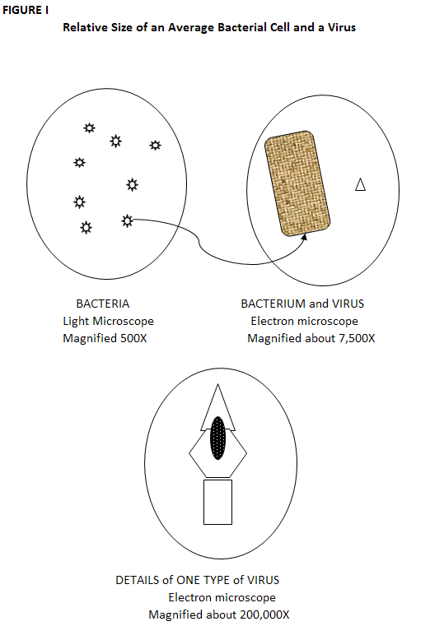
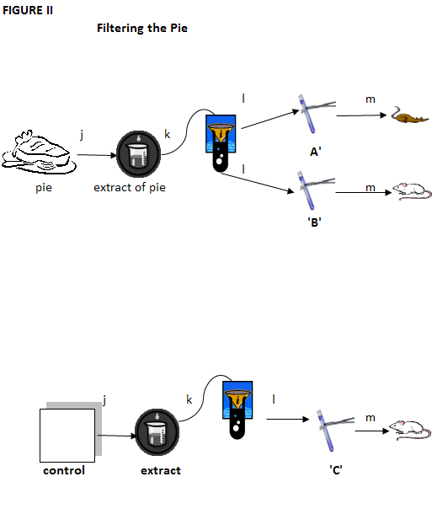

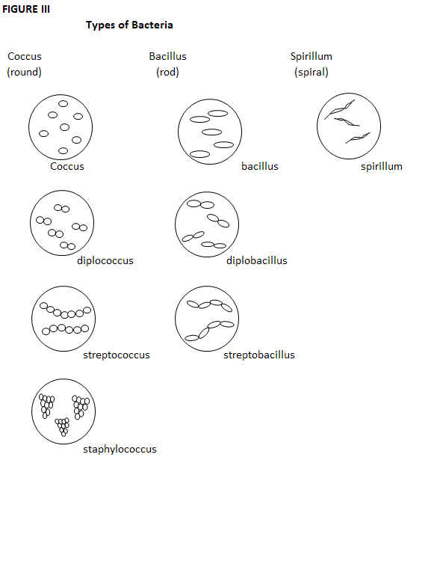

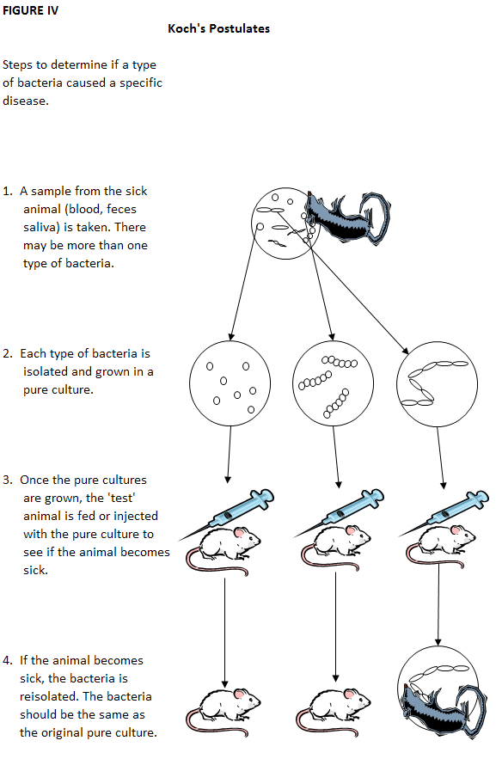
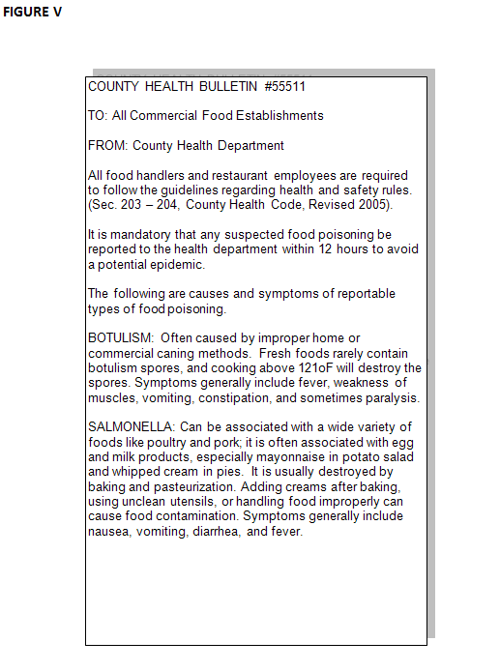

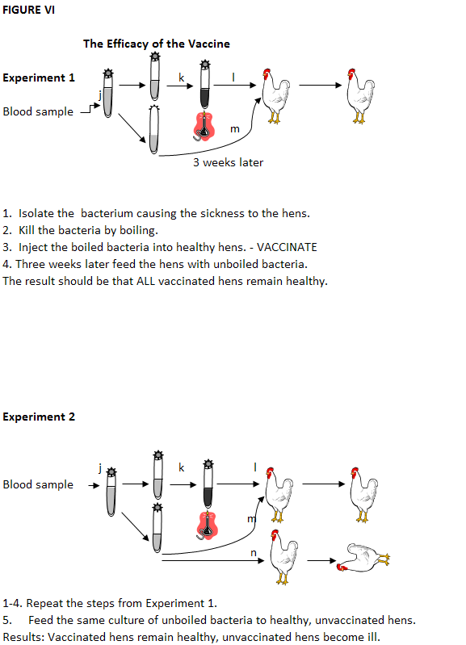

TEACHERS RESOURCE GUIDE

Pathogens: Officer Retreat Investigation!
Time: 2-3 days
Materials needed:
Pen/pencil
Handouts
Background: This exercise explains the differences between bacteria and viruses and introduces the students to Dr. Robert Koch and Louis Pasteur. The scenario is that the FFA officers have organized a retreat for the Greenhand members. Many of them become ill after eating dinner. Day 2 investigates a disease at a poultry ranch.
The exercises are very self-explanatory. Your job will be to monitor the discussion. Groups of students may find it easier to simply give each other the underlined answers in each narrative instead of discussing what they might know about the question first.
Procedure:
Divide the class into groups of four students. Each student needs to receive a packet with the Tables and Figures and the lab sheet so they can record their answers. Each president needs a copy of his/her narrative; the vice president his/her narrative; the secretary his/her narrative; and the treasurer his/her narrative. Each student will be expected to volunteer for one of the four FFA officer positions. The instructor will read the scenario, which is provided on the lab sheet. The scenario is based on a Greenhand retreat wherein many of the members become ill. It is the task of the FFA officers to investigate the cause of the illness.
Each member of the lab group will be responsible for directing some segment of the investigation. The president will begin the narrative.
Below are the answers to the questions asked in the narrative.
- What are three possible causes of the Greenhand retreat weekend illness?

chemical poisoning

infection with bacteria

viruses
- List illnesses that could be ruled out.
- an allergy
- car sickness
- lack of sleep
- homesickness
- over eating
- What possible causes of illnesses can you probably eliminate?
  - chemical poisoning
  - Protozoa
- Why do you think the incubation time for chemicals or poisons is shorter than for bacteria or viruses?

Bacteria and viruses multiply. Chemicals don’t’ multiply
- For each of the possible causes, what are some ways that the illness could have spread?
    - Talking with someone at close range.
    - Holding hands
    - Kissing
    - Sharing personal items
- What possible modes of transmission can we eliminate?
  - Airborne
  - Insect bites
- Does the pattern in Table III suggest personal contact as the means of disease transmission?
  - The pattern not suggest personal contact.
- Does the pattern in Table IV suggest personal contact as the means of disease transmission? Why or why not?
  - No. In three pairs, only one person was sick.
- Which method of transmission seems to be the most likely at this point? (look at table II)
  - When the students ate or drank something
- What food might have made us ill?
  - Fried fish
  - French fries
  - Cream pie
- Now what food(s) do you suspect?
  - The cream pie
- Why is the coconut cream pie more suspicious than the roast beef dinner?
  - Most of the people who ate the coconut pie got sick. Only a small group of those who ate the roast beef became sick.
- Is there anything in the dessert data, which contradicts, or makes you uncertain about your conclusion? What?
  - Yes, one person who ate the cake became sick, and one person who ate the pie did not get sick.
- How does this information about Jack and Jill help you interpret the dessert data?
  - This can explain how the one person who ordered the cake became ill.
- Jill ordered pie, but didn’t get sick. How could you explain this?
  - People have different levels of resistance to various diseases.

SECRETARY
- Most high schools have light microscopes. Which are larger a bacterium (singular for bacteria) or virus? Would it be possible to observe a virus using a compound light microscope?
  - A virus is much smaller than a bacterium.
  - Viruses can only be seen with an electron microscope.
- Approximately how much bigger is a bacterium than a virus?
  - a bacterium is about 10 times the length of a virus.

- How can we tell if viruses are present or the cause of the illness?
  - Step 1 – she made an extract from some of the coconut cream pie
  - Step 2 - she poured the extract into a very fine filter, like a coffee filter. Viruses can go through the tiny pores. Bacteria are too big, and they stay on the filter just as coffee grounds do.
  - Step 3 – she poured the material trapped by the filter into test tube A. The substances that drained through the filter paper went into test tube B. (Add step 4 below to your answer sheet)
  - Step 4 – My sister fed material from test tube A to one group of mice. Another group of mice were fed the liquid from test tube B.
- If the pie contained virus particles, would they be in test tube A or B?
  - Test tube B
- From Figure II, which mice remained healthy and which became ill?
  - Mice fed from test tube A became sick. Mice fed from test tube B remained healthy.
- How could she find out if something in the pie, other than bacteria or viruses, caused the illness? What is this process called?
  - She could feed another group of mice an extract from a fresh coconut cream pie.
  - A control in the experiment.
- What is an experimental control supposed to do?
  - The control allows us to rule out the ‘something else’ from the item in question, like the cream pie.
- In Figure II, what should be drawn in the box labeled ‘control’ to complete the diagram?
  - A piece of fresh coconut cream pie.
- What can you conclude from this experiment? What are organisms called that cause disease?
  - Bacteria from the pie made the mice ill.
  - PATHOGENIC.
- Would you expect to find bacteria in food you eat every day? Do all bacteria cause disease? What are bacteria called that do not cause disease?
  - Yes
  - Most bacteria do not cause disease
  - non-pathogenic.
- What are some possible ways to distinguish one kind of bacteria from another?
  - Shape
  - grouping of cells
  - size
  - stain them with certain dyes.
- How many basic shapes do bacteria have? Draw each shape and label, and then draw each group and label with its prefix.
  - Three

spirillum
bacillus
coccus

diplobacillus
diplococcus

streptobacillus
streptococcus

staphylococcus

- Can you tell by the shape or arrangement whether or not all of these bacteria cause disease?
  - No.

TREASURER
- In steps 1 and 2, why would it be necessary to get a ‘pure’ culture?
  - A mixture of bacteria would show that bacteria caused the disease, but you wouldn’t know which type of bacteria was pathogenic.
- In steps 3 and 4, the mice given the streptobacillus got sick. The mice given the cocci did not get sick. Can you conclude from this that the streptobacillus made them sick?
  - No.
- How can you challenge the hypothesis that something else killed them?
  - In the fourth step you can take the bacteria from the sick animal. Then you show it is the same as the bacteria you took from the pure culture in step 2.
- Think about our symptoms we heard about or experience on the Greenhand retreat, the laboratory data, and the health bulletin. What type of bacteria do you think caused our weekend illness?
  - Salmonella

DAY 2 PRESIDENT
- What should we do first?
  - We need samples of feces and blood from sick and health birds.
- If we used a light microscope, what should make us think we have just one type of bacteria in a blood sample? (It may help to look at Figure III).
  - All the bacteria in the blood would be the same size, shape, and arrangement.
- In Figure III, which pictures might represent the blood bacterium?
  - Any
- By observing with a microscope, how would we know there are many types of bacteria in the feces?
  - We would see bacteria in a variety of sizes, shapes, and arrangements.
- There are Diplococci in the sample of feces. What do Diplococci look like?
  - round cells grouped in pairs.
- We also see Diplobacilli. What do they look like?
  - pairs of rods
- There are also Bacilli. Can we tell by their size and shape if they are pathogenic?
  - No
- Which bacterium from the sick hen is most likely to be the cause of the disease?
  - The sick hen’s blood
- How would we test whether or not the bacterium from the blood is the cause? (hint-look at Figure IV).
  - We would follow Koch’s postulates

DAY 2 VICE PRESIDENT
- How could we kill a pure sample of the bacteria we found in the chicken blood?
  - Boiling kills many bacteria.
- List two ways to explain the results.
  - A first thought is that the chickens stayed healthy because we made a good vaccine. But they also could be healthy because the pathogenic bacteria changed in some way. For example, maybe the bacteria died. The experiment isn’t designed well enough to let us rule out either explanation.
- This is why we need a control in the experiment. The control should allow us to rule out the chance that the original bacteria changed. Can you think of a control?
  - Feed the unboiled bacteria to normal, unvaccinated hens, and see if they get sick.
- What can we conclude?
  - Our vaccine made from boiled bacteria protected the hens from the disease.
- What was the control in Experiment 2?
  - Feeding live bacteria to unvaccinated chickens was the control part of the experiment.
- How did it help us with our conclusion?
  - The unvaccinated chickens got sick. That means the bacteria were pathogenic. The only difference between the two groups of chickens was the injection of the vaccine. The vaccine must have protected the chickens from the pathogenic bacteria.
- How can cooks at home and in restaurants make food safer to eat?
Some ways include:
- Discard food which smells bad or appears discolored;
- don’t use damaged or swollen canned goods;
- wash your hands before preparing food;
- use only clean utensils for preparing food;
- cook food at recommended temperatures;
- keep food refrigerated or frozen;
- don’t’ leave stuffing in a lift-over turkey.
- At what temperature do most bacteria multiply fastest? At the temperature of:
  - A live human body, 37ºC
- Do boiling temperatures kill all forms of bacteria so they won’t grow again? What might be an exception?
  - Most bacteria are killed at boiling temperature
  - Boiling does not kill spores.
- Salmonella is killed at high temperatures. And the coconut pie was cooked. How did the Salmonella survive?
  - The cream is usually added after the other ingredients have been cooked, so its bacteria are not killed.

Dickson, Chris (2008).Pathogens. North High School, Bakersfield, Agriculture Department.

