Name___________________

Date____________________

# Heart Dissection

**Purpose**

The purpose of this exercise is to identify the components of the heart and the flow of blood.[1]

**Procedure**

**Materials**

1. Porcine heart(s)
2. Dissection pans and pins
3. Arrows to label direction

**C:\Users\Angela\AppData\Local\Microsoft\Windows\Temporary Internet Files\Content.IE5\DRP2N1IJ\MCj04242300000[1].wmfSequence of Steps**

1. Read background information and answer Pre-Lab Questions.
2. Working in a group, gather lab materials including 1 heart.
3. Carefully go through the following steps to dissect your pig heart. [2]
   1. Make the first incision along the right ventricle, allowing you to see inside the right side of the heart. (You can tell which side is the right ventricle by squeezing the heart. The right side is much softer than the left.) **Label the right ventricle, tricuspid valve, and the right ventricular outflow tract including the pulmonary valve.**
   2. Before you move to the left side of the heart, find the coronary arteries. The coronary arteries are attached to the aorta. Blood that is pumped out of the aorta returns to the heart muscle through the coronary arteries. **Label the coronary arteries.**
   3. Look down at the top of your heart sample. Make a small incision in the Superior vena cava and view this opening. Identify the Pulmonary Artery, which curls around the aorta. It has a thin wall and is less stiff than the aorta. **Label the Superior vena cava and the Pulmonary Artery.**
   4. Make an incision in the left atrium, which stores blood temporarily as it comes back to the heart from the lungs. Carefully look for the left ventricular outflow. Blood moves from the left side of the heart by moving between one of the mitral leaflets and the septum (the part that separates the two sides of the heart.) **Label the left atrium and left ventricular outflow.**
   5. Find the aortic valve, and view from the outflow side. **Label the aortic valve.**
   6. Carefully make 1 incision horizontally, cutting your heart sample in half to view the inner tissues. Use caution! Do not disturb the parts of the heart you have already labeled!
4. Show your labeled heart to the instructor and answer the Observation Questions.
5. Clean your lab area.

**C:\Users\Angela\AppData\Local\Microsoft\Windows\Temporary Internet Files\Content.IE5\DRP2N1IJ\MCj04242300000[1].wmf**

**Background Information[3]**

*Blood Supply of the Heart*

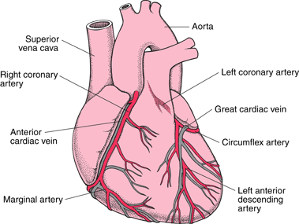Like all organs, the heart needs a constant supply of oxygen-rich blood. A system of arteries and veins called the coronary circulation supplies the heart muscle (myocardium) with oxygen-rich blood and then returns oxygen-depleted blood to the right atrium. The right coronary artery and the left coronary artery branch off the aorta (just after it leaves the heart) to deliver oxygen-rich blood to the heart muscle. These two arteries branch into other arteries, including the circumflex artery, that also supply blood to the heart. The cardiac veins collect blood from the heart muscle and empty it into a large vein on the back surface of the heart called the coronary sinus, which returns the blood to the right atrium. Because of the great pressure exerted in the heart as it contracts, most blood flows through the coronary circulation only while the heart is relaxing between beats (during diastole).

*Supplying the Heart with Blood*

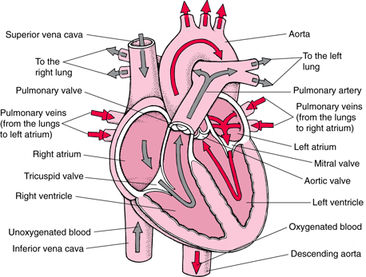Like any other tissue in the body, the muscle of the heart must receive oxygen-rich blood and have waste products removed by the blood. The right coronary artery and the left coronary artery, which branch off the aorta just after it leaves the heart, deliver oxygen-rich blood to the heart muscle. The right coronary artery branches into the marginal artery and the posterior interventricular artery, located on the back surface of the heart. The left coronary artery branches into the circumflex and the left anterior descending artery. The cardiac veins collect blood containing waste products from the heart muscle and empty it into a large vein on the back surface of the heart called the coronary sinus, which returns the blood to the right atrium.

*(This cross-sectional view of the heart shows the direction of normal blood flow.)*

**Pre-Lab Questions**

1. Why are pig hearts used to study the anatomy of the human heart?
2. How can you tell which side of the heart is the ventral surface?
3. How many chambers are found in the mammalian heart? What other group of organisms would have this same number of chambers?
4. What is the advantage in having this number of chambers compared to organisms with

fewer number of chambers?

1. What is the purpose of heart valves?
2. Name & compare the heart valves found between the upper & lower chambers of the right and left sides of the heart.
3. Vessels that carry blood away from the heart are called _____________, while ______________

carry blood toward the heart.

1. Which artery is the largest and why?
2. What is the purpose of the coronary artery and what results if there is blockage in this

artery?

1. Use the diagram of the heart above to trace blood flow through the heart.

**Observations**

1. What is the heart?
2. What is the main function of the heart?
3. How does the nervous system affect the rate of the heart?
4. Where does oxygenation occur?
5. What is the medical term for heart?
6. What do the red blood cells carry?
7. What part of the heart does the blood flow to first?
8. Does blood flow in or out of the pulmonary artery?
9. Where does blood from the aorta flow?
10. Can you live without a heart?
11. What is it called when you have to have an organ to live?

**Teacher’s Notes:**

There are great resources on the internet to review prior to doing this lab. Take time to review the porcine heart dissection at http://heartlab.robarts.ca/dissect/dissection.html . This has great pictures as you walk though the dissection step by step. If you have computer access for your students, have them review this site prior to the dissection as well.

1. Noga, Theresa (2008). Heart Dissection. *Arcata High School*
2. Boughner, M.D., PhD, D. (1997, July, 25). University of Western Ontario, The Heart Valve Lab. Retrieved July 31,

   2009, from What does a real heart look like? Web site: http://heartlab.robarts.ca/dissect/dissection.html
3. Tanser, MD, P (2006). Heart. Retrieved May 14, 2009, from Merck Web site:

   http://www.merck.com/mmhe/sec03/ch020/ch020b.html