Name___________________

Date____________________

# Sea Floor Spread

**Purpose**

The purpose of this lab is to utilize the age and position of rock formations associated with the Mid Atlantic Ridge to evaluate the hypothesis of sea floor spreading. The sea floor spreading hypothesis presents the idea that new crust is continually being formed at the center of a mid-ocean ridge, which is causing the sea floor to spread apart. This may have caused the tectonic plates to move. [1]

**Procedure**

**Materials**

1. Metric ruler
2. Six different colored pencils

**Sequence of Steps**

1. C:\Users\Angela\AppData\Local\Microsoft\Windows\Temporary Internet Files\Content.IE5\DRP2N1IJ\MCj04242300000[1].wmfUsing the map Figure 1. Sea Floor Spread, color the various rock formations associated with both the Mid Atlantic Ridge and East Pacific Ridge systems. Create a color key indicating the color associated with each specific rock age.
   1. For more information on the Mid Atlantic Ridge, and a map of the location, visit:

<http://www.platetectonics.com/oceanfloors/africa.asp>

* 1. For more information on the East Pacific Ridge, and a map of the location, visit: <http://www.platetectonics.com/oceanfloors/andreas.asp>

1. Calculate the average spreading rate associated with each ridge. Show all work for full credit! To calculate the average spreading rate for the Mid Atlantic Ridge, use the following procedure:
   1. Measure the distance in centimeters (cm) from the Mid Atlantic Ridge to the interface between rock sequence 4 and 5 (where they meet) in three different places on your map. Record your answers below.

Measurement 1: _________cm

Measurement 2: _________cm

Measurement 3: _________cm

* 1. Determine the average distance of the three measurements to the nearest 10th of a centimeter. Show your work and record your answer below.

Average distance for 4 & 5 ridge: __________cm

* 1. Convert your average measurement in centimeters to kilometers by using the map scale (1cm = 500km). This is done by multiplying the average distance in cm by 500km. Record your answer to the nearest 10th of a kilometer.

Average distance: __________km

* 1. Knowing that the age of the interface between rock sequences 4 and 5 is approximately 118 million years old, calculate how far the rocks have moved in kilometers per year. This is done by dividing your average distance in kilometers by 118 million years. Record your answer below.

Distance rock moved per year: __________km/year

* 1. Now, determine the distance the rock moved in centimeters. This can be done by multiplying the distance the rock moved in km/year (Step d) by 1000,000. Record your answer below.

Distance rock moved per year on map scale: __________cm/year

* 1. Finally, determine the rate of sea floor spread associated with the Mid Atlantic Ridge by multiplying the distance moved in centimeters per year by 2. This determines the rate of sea floor spread because new rock is created on **both** sides of the ridge and is pushed outward. Record your answer below.

Rate of sea floor spread for the Mid Atlantic Ridge per year: __________ cm/year

1. To calculate the average spread rate for the East Pacific Ridge, use the following procedure. Show all work for full credit!
   1. Measure the distance in centimeters from the East Pacific Ridge to the interface between rock sequence 3 and 4 in three different places on your map. Record your answers below.

Measurement 1: __________cm

Measurement 2: __________cm

Measurement 3: __________cm

* 1. Determine the average distance of the three measurements to the nearest tenth of a centimeter. Show your work and record your answer below.

Average distance for 3 & 4 ridge: __________cm

* 1. Convert your average measurement in centimeters to kilometers by using the map scale (1cm = 500km). This is done by multiplying the average distance in centimeters by 500km. Record your answer to the nearest tenth of a kilometer.

Average distance: __________ km

* 1. Knowing that the age of the interface between rock sequence 3 and 4 are approximately 56 million years old, calculate how far the rocks have moved in kilometers per year. This is done by dividing your average distance in kilometers by 56 million years. Record your answers below.

Distance rock moved per year: __________ km/year

* 1. Now, determine the distance the rock moved in centimeters. This can be done by multiplying the distance the rock moved in kilometers per year (Step d) by 100,000. Record your answer below.

Distance rock moved per year on map scale: __________ cm/year

* 1. Finally, determine the rate of sea floor spread associated with the East Pacific Ridge by multiplying the distance moved in centimeters per year by 2. This determines the rate of sea floor spread because new rock is created on **both** sides of the ridge and is pushed outward. Record your answer below.

Rate of sea floor spread for the East Pacific Ridge per year: __________ cm

C:\Users\Angela\AppData\Local\Microsoft\Windows\Temporary Internet Files\Content.IE5\DRP2N1IJ\MCj04242300000[1].wmf

**Observations**

1. Describe how the mapping of rocks ages on the ocean floor helps to support the theory of continental drift and sea floor spreading.
2. Briefly explain how the rate of sea floor spreading can be determined in both the Atlantic and Pacific Oceans.
3. Is the average rate of sea floor spreading the same in both Atlantic and Pacific Oceans? If not, how do the compare?
4. Explain how the discovery of sea floor spreading has helped the theory of continental drift.
5. Using your textbook, internet, or other available resources, investigate 5 agricultural commodities produced/harvested off the coast of California in the Pacific Ocean and list them below.
6. Determine if any animals you listed in answer 5 are domesticated or non-domesticated. Hint: Domesticated animals are primarily raised in confinement and bred or produced for a specific purpose.
7. Identify 3 agricultural jobs connected to the ocean and production of ocean commodities. List the jobs below.

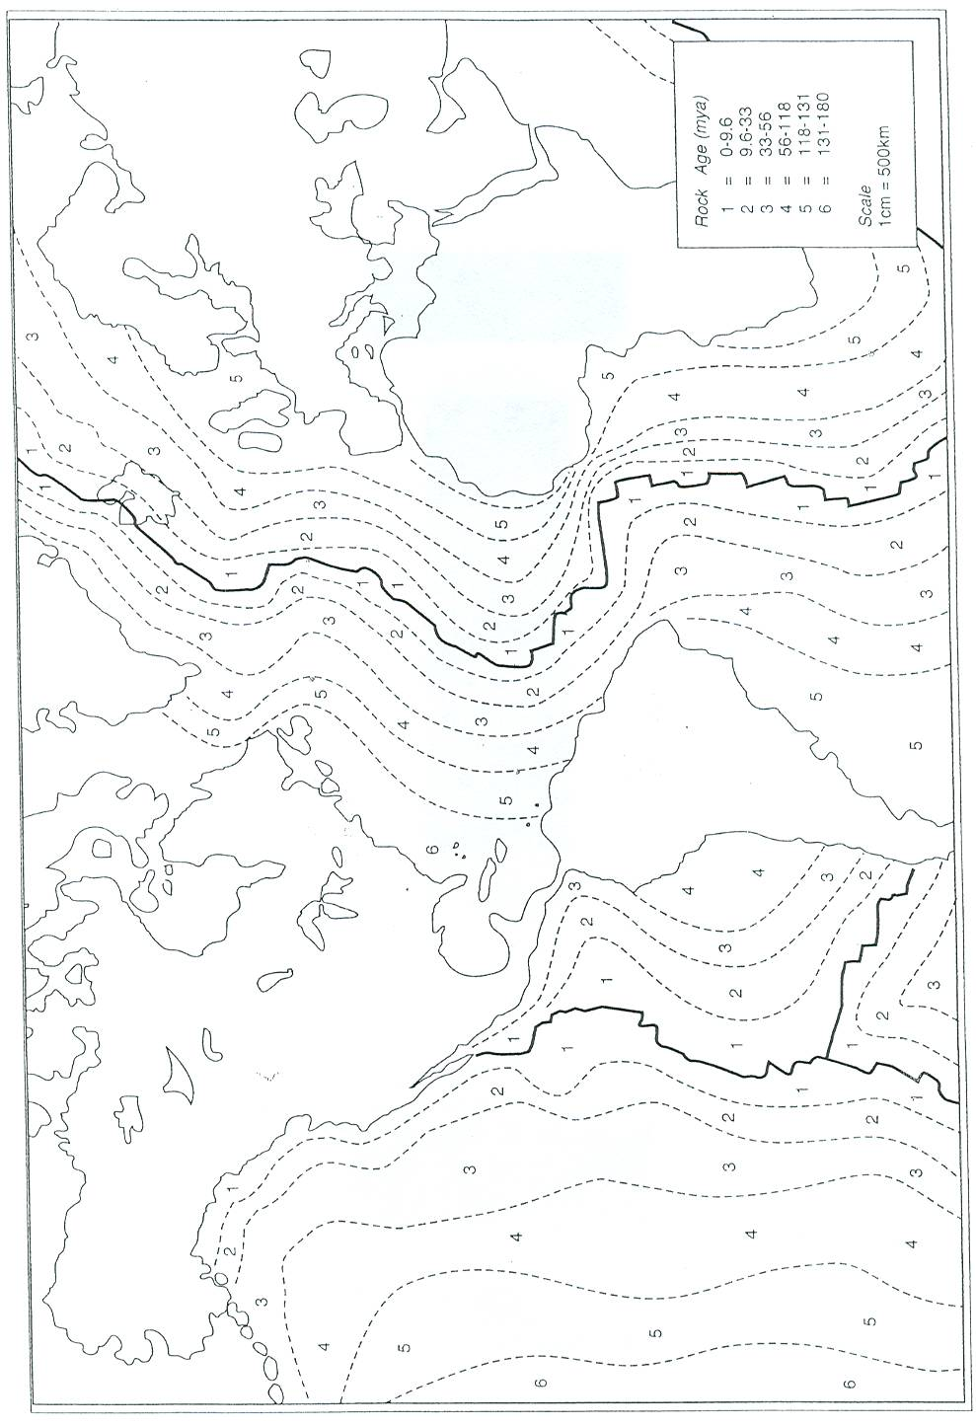

Figure 1. Sea Floor Spread

1. Prescott, Diane (2008). *Sea Floor Spread, Lab*. Atwater High School.