Name___________________

Date____________________

# Snack Tectonics

**Purpose**

The purpose of this lab is to visualize the interactions at plate boundaries. [1]

**Procedure**

**Materials**

1. Fruit by the Foot candy 5. Plastic knife
2. Graham crackers 6. Wax Paper
3. Frosting 7. Plastic cup
4. Water

**Sequence of Steps**

*Before jumping into Part I below, read* ***Background Information*** *provided. Highlight key concepts and important points to remember.*

*ALL MEMBERS OF THE LAB GROUP, THOROUGHLY WASH AND DRY HANDS!

*MAKE SURE YOUR LAB STATION IS CLEAN AND DRY!

*DO NOT EAT ANY MATERIALS UNTIL YOU ARE COMPLETELY FINISHED WITH THE LAB!

**Part I: Divergent Plate Boundary**

1. Place a large dollop of frosting on the wax paper. This will represent the fluid, middle mantle or asthenosphere. Notice that it is not fluid like water, but is thick and sticky. However, the asthenosphere can still move or flow.
2. Spread the frosting to an approximate thickness of 0.5 cm with the plastic knife.
3. Place the two oceanic plates (fruit by the foot) on the frosting so that the long edges are touching.
4. Gently press down along the entire edges that are touching (to simulate the density of the plates) and spread the plates about 0.5 cm apart. (Continue pushing down slightly as you spread the plates apart.)
5. C:\Users\Angela\AppData\Local\Microsoft\Windows\Temporary Internet Files\Content.IE5\DRP2N1IJ\MCj04242300000[1].wmfIn “observations” draw a side view of what you see happening (oceanic plates and asthenosphere.)

C:\Users\Angela\AppData\Local\Microsoft\Windows\Temporary Internet Files\Content.IE5\DRP2N1IJ\MCj04242300000[1].wmf(This is what it would look like if you brought your eyes down to the level of the plates and looked at the ends of both plates.)

1. In “observations” draw a top view of what you see happening.

(This is what it would look like if you were in an airplane flying over the top and looking down.)

1. Remove one of the oceanic plates and set it aside to use later. **DO NOT EAT IT!**

**Part II: Convergent Plate Boundaries**

*Continental-Oceanic Plate Boundary*

1. Smooth out the asthenosphere (frosting.)
2. Gently place one of the continental plates (graham cracker) on the asthenosphere so that it is touching the long edge of the oceanic plate.
3. Push the two plates together.
   1. Push the continental plate from the back and do not push down (to simulate that continental plates are not very dense.)
   2. Push down on the entire length of the oceanic plate that is touching the continental plate.
4. C:\Users\Angela\AppData\Local\Microsoft\Windows\Temporary Internet Files\Content.IE5\DRP2N1IJ\MCj04242300000[1].wmfDraw a side view of what you see happening.
5. Draw a top view of what you see happening.
6. Remove the oceanic plate and set it aside to use later. **DO NOT EAT IT!**

*Continental-Continental Convergent Plate Boundary*

1. Smooth out the asthenosphere (frosting.)
2. Fill the plastic cup with water. Submerge 1 cm of each of the continental plates (graham crackers) for 1-2 seconds. BE CAREFUL, if you leave the plates in the water too long, this part will not work.
3. Gently place the continental plates on the asthenosphere so that the entire **wet edges are touching**.
4. Without pushing down, slowly push the plates together from the back.
5. C:\Users\Angela\AppData\Local\Microsoft\Windows\Temporary Internet Files\Content.IE5\DRP2N1IJ\MCj04242300000[1].wmfDraw a side view of what you see happening.
6. Draw a top view of what you see happening.
7. Remove the continental plates and set aside for later on a paper towel. **DO NOT EAT THEM!** Make sure that the edges opposite the wet edges stay dry!

*Oceanic-Oceanic Convergent Plate Boundary*

1. Smooth out the asthenosphere (frosting.)
2. Place both pieces of oceanic crust on the asthenosphere so that the long edges are touching.
3. Gently press down along the entire edges that are touching and push the plates together. Continue pushing down slightly as you push the plates together.
4. . (Remember, you are trying to show how both plates will sink into the mantle.)
5. C:\Users\Angela\AppData\Local\Microsoft\Windows\Temporary Internet Files\Content.IE5\DRP2N1IJ\MCj04242300000[1].wmfDraw a side view of what you see happening.
6. Draw a top view of what you see happening.
7. Set the two oceanic plates aside for later. **DO NOT EAT THEM!**

**Part III: Transform Plate Boundary**

1. Smooth out the asthenosphere (frosting.)
2. Gently place the two pieces of continental crust on the asthenosphere so that the **dry edges are touching**.
3. Hold the two continental plates from the back and very gently push them together as you slide one plate towards you and one plate away from you.
4. C:\Users\Angela\AppData\Local\Microsoft\Windows\Temporary Internet Files\Content.IE5\DRP2N1IJ\MCj04242300000[1].wmfDraw a side view of what you see happening.
5. Draw a top view of what you see happening.
6. **You are now done with the activity and may eat any of the food you wish.**
7. Clean up your lab station according to your teacher’s instructions.

C:\Users\Angela\AppData\Local\Microsoft\Windows\Temporary Internet Files\Content.IE5\DRP2N1IJ\MCj04242300000[1].wmf

**Observations**

*Complete a drawing as described in the Sequence of Steps for each plate boundary. Include arrows to show the direction the plates are moving.*

PART I – DIVERGENT PLATE BOUNDARY

|  |  |
| --- | --- |
| SIDE VIEW | TOP VIEW |

PART II – CONVERGNET PLATE BOUNDARY

1 – continental-oceanic convergent plate boundary

|  |  |
| --- | --- |
| SIDE VIEW | TOP VIEW |

2 – continental-continental convergent plate boundary

|  |  |
| --- | --- |
| SIDE VIEW | TOP VIEW |

3 – oceanic-oceanic convergent plate boundary

|  |  |
| --- | --- |
| SIDE VIEW | TOP VIEW |

PART III – TRANSFORM PLATE BOUNDARY

|  |  |
| --- | --- |
| SIDE VIEW | TOP VIEW |

**ANALYSIS: (Answer with complete sentences, using actual data.)**

1. When plates move, which type will float higher on the asthenosphere? Explain.
2. Why is it important to know what types of plates are interacting at convergent plate boundaries, but not at divergent or transform? Explain.
3. Draw a picture showing the direction of plate movement and convection in the asthenosphere for a divergent plate boundary. Next to the drawing explain with words, why plates diverge.
4. Draw a picture showing the direction of plate movement and convection in the asthenosphere for a convergent plate boundary. (This can be a simple picture and does not need to represent a specific type of convergent plate boundary.) Next to the drawing explain with words, why plates converge.
5. Draw a picture showing the direction of plate movement at a transform plate boundary. (Do not show convection in the asthenosphere.)
6. How has plate movement throughout history created natural resources which help agricultural production, as well as natural resources which hinder agricultural production? Provide at least two examples for each.

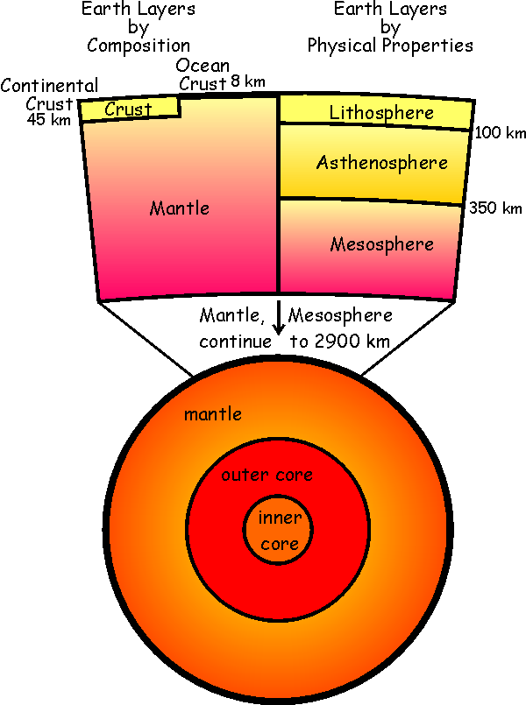**Background Information: Snack Tectonics**

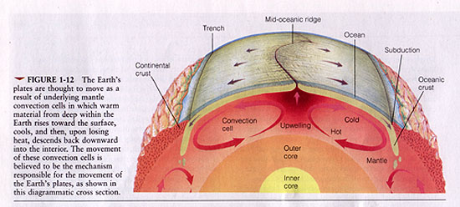 The crust and upper mantle taken together are called the lithosphere. The lithosphere is broken into sections called plates. These plates are rigid (hard and easily breakable) and float around on the middle of the mantle, called the asthenosphere. Just like a boat or raft adrift on the ocean moves in whatever direction the water under it moves, a plate will move in whatever direction the asthenosphere below it moves. When the edges of two plates interact (touch), a plate boundary is created. Depending on the way the two plates move relative to each other, different types of plate boundaries are created. There are three main types of plate boundaries: divergent, convergent, and transform.

**1** – **Divergent Plate Boundary** – The word “diverge” means to spread apart or go in opposite directions. What ***causes*** plates to diverge is material in the asthenosphere rising to the surface. As the material rises to the surface, it cools, and turns. When the asthenosphere turns, it drags the plates with it, thus pulling them apart. The gap left is filled with rising lava, which ultimately cools, and forms new rock.



**2 – Convergent Plate Boundary** – The word “converge” means to come together. This situation is created when molten material in the asthenosphere sinks below the boundary. The material that is sinking pulls the plates together as it sinks. Since oceanic plates are different than continental plates, the result of the plates coming together differs depending on which types of plates are converging.

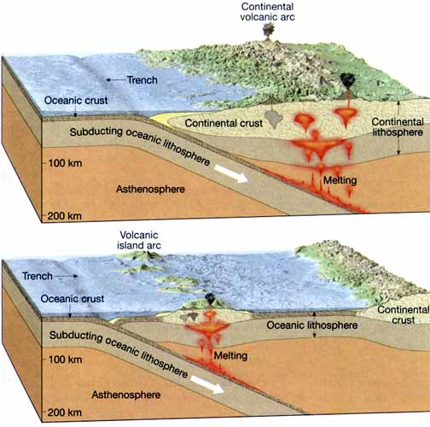**A** – **Continental-Oceanic Convergent Plate Boundary** – Continental plates are very thick (that is why they stick up out of the ocean) and are not very dense. Therefore, continental plates float very high on the asthenosphere. Oceanic plates, however, are very thin (that is why we have oceans) and are very dense. Oceanic plates float lower in the asthenosphere. When a thick, not dense continental plate collides with a thin, dense oceanic plate, the oceanic plate sinks under the continental plate and is forced lower in the mantle. This creates a subduction zone and we can say that the oceanic plate subducts below the continental plate.

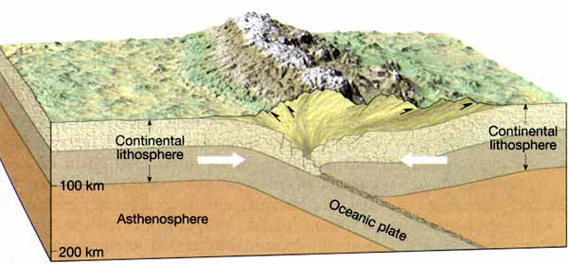

**B** **– Continental-Continental Convergent Plate Boundary** – When two thick, not dense continental plates come together, neither will sink into the mantle. Instead, both will crumble and push upwards.



**C - Oceanic-Oceanic Convergent Plate** **Boundary** – When two thin, dense oceanic plates come together, both will sink into the mantle. This creates an ocean trench as the plates are pulled lower into the mantle.

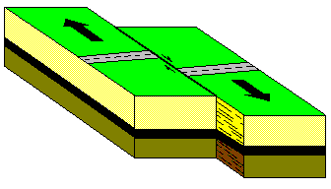**3 – Transform Plate Boundary** – Very complex interactions of convection currents in the mantle create a transform plate boundary. Therefore, we will not discuss exactly how transform plate boundaries are created, only that a transform plate boundary is a location where two plates are sliding horizontally past each other.

**HYPOTHESIS**: If plate interaction is modeled, then the types of plate boundaries can be visualized.

1. Looper, Jim (2008).Snack Tectonics, Lab. *Sheldon High School Science Dept.*