Name___________________

Date____________________

# Wave Motion

**Purpose**

In this investigation you will simulate wave motion to observe how energy generates wave motion in water. You will also observe the properties of waves. [1]

**Procedure**

**Materials**

1. Graph paper
2. Large sheet of paper
3. 3 colored pencils
4. Marker
5. Meter stick
6. Slinky

**C:\Users\Angela\AppData\Local\Microsoft\Windows\Temporary Internet Files\Content.IE5\DRP2N1IJ\MCj04242300000[1].wmfSequence of Steps**

1. In “observations” read background information and complete pre-lab questions.
2. On the large sheet of paper, use the meter stick to draw a grid that is 2 meters long and 1 meter wide. Mark the grid in increments of 6 inches (½ a foot).
3. Place the sheet of paper on the floor and line up the slinky at one end of the 2 meter line on your grid. Have one person hold the slinky at each end of the paper and do not let go.
4. Quickly move the slinky causing it to make waves along the line of the grid.
5. Two people will be on either end of the paper, controlling the slinky movement. One person will mark on the paper, where the **crest** of a wave hits. Another person will mark on the paper, where a **trough** of a wave hits.
6. On the graph paper, make a line graph with wavelengths on the horizontal axis and wave height on the vertical axis. Plot a wave, labeled A, which represents the wave that you observed in Step 5. Begin at 0 in the middle of the graph, and plot the height and length. Indicate the direction of the wave’s motion.
7. Continue the investigation by changing the speed of your slinky toss. Repeat steps 5 and 6, using a different colored pencil to draw your plot. Try to generate small waves and large waves labeling them B and C.
8. On your graph, you should have the plots of three waves. Label a crest and trough on each of the waves that you plotted.

What are the wavelengths of the three waves that you plotted?

A._______ B._______ C._______

What are their wave heights? A._______ B._______ C._______

9. Using the formula in the prelab preparation, calculate the wave speeds of the three waves represented on the graph if each wave period is six seconds.

A.______________ B.______________ C.______________

**C:\Users\Angela\AppData\Local\Microsoft\Windows\Temporary Internet Files\Content.IE5\DRP2N1IJ\MCj04242300000[1].wmf Observations**

**Background Information:** The source of wave movement in water is energy, which is generated primarily from wind. To a person standing on a beach and watching the waves come in to the shore, it may not be easy to understand that wind is the primary energy source of waves. Waves appear to move forward because of the actual movement of the water. However, only the energy of the waves moves forward; the water moves very little.

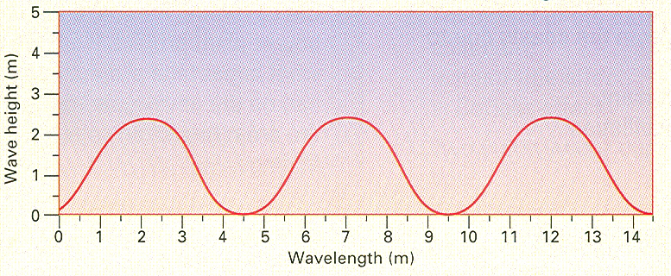**Pre-Lab Questions:**

1. Study the graph on the right. Identify the wave crests and wave troughs. The wavelength is the distance between two successive crests or troughs.

What is the wavelength? __________

What is the wave height? __________

1. The wave period is the time required for two successive crests or troughs to pass a certain point. Wave speed can be calculated using the following formula:

Wave Speed = Wavelength

Wave Period

What is the speed of waves shown in the graph if the wave period is five seconds? __________

**Post-Lab Questions:**

1. How do the wave motions differ on your graph?
2. If these were real water waves, what might be the cause(s) of the different motions?
3. How is the action of the slinky similar to wave movement in water?
4. The commercial fishing industry is an important part of the California Agriculture industry and contributes to California’s economy. Why is an understanding of wave motion important to fishermen?
5. Application: Using the internet or other available resources, investigate how much the commercial fishing industry contributes to the state economy.

1. Prescott, Diane (2008).Wave Motion, Lab. *Atwater High School*.