Name___________________

Date____________________

# Ocean Currents and Climate

**Purpose**

The purpose of this lab is to visualize ocean current movement based on temperature, salinity and wind.[1]

**Procedure**

**Materials**

1. Baby food jars (4) 3. Salt 5. Stirring Rod 7. Triple beam balance
2. Index card 4. Food Coloring 6. Tray

**Sequence of Steps**

C:\Users\Angela\AppData\Local\Microsoft\Windows\Temporary Internet Files\Content.IE5\DRP2N1IJ\MCj04242300000[1].wmf

1. C:\Users\Angela\AppData\Local\Microsoft\Windows\Temporary Internet Files\Content.IE5\DRP2N1IJ\MCj04242300000[1].wmfRead background information in “observations”.
2. Develop your hypothesis and record in “observations”.
3. Fill two baby food jars completely full with water. (The water should be “bubbled up” over the top.)
   1. Add a drop of red food coloring.
   2. These jars will represent fresh water.
4. Fill two baby food jars ¾ full with water.
   1. Dissolve 10 g of salt in two of the jars.
   2. Add a drop of blue food coloring.
   3. These jars will represent salt water.
   4. C:\Users\Angela\AppData\Local\Microsoft\Windows\Temporary Internet Files\Content.IE5\DRP2N1IJ\MCj04242300000[1].wmfAdd water to make certain all jars are completely full. (The water should be “bubbled up” over the top.)
5. Predict what will happen when you invert the salt water over the fresh water. Record in “observations” by coloring what you think the result will be.
6. DO THE NEXT PART OVER THE TRAY.
   1. Place an index card on top of the salt water.
   2. C:\Users\Angela\AppData\Local\Microsoft\Windows\Temporary Internet Files\Content.IE5\DRP2N1IJ\MCj04242300000[1].wmfHolding the card against the top of the jar, turn the jar over and place it on top of the fresh water.
   3. Have a lab partner carefully remove the card. Record results by coloring what you see.
   4. If the layers mixed or inverted, indicate that in your observations.
   5. LEAVE THESE JARS STACKED IN THE TRAY FOR LATER.
   6. C:\Users\Angela\AppData\Local\Microsoft\Windows\Temporary Internet Files\Content.IE5\DRP2N1IJ\MCj04242300000[1].wmfBE CAREFUL NOT TO KNOCK THEM OVER.
7. Predict what will happen when you invert the fresh water over the salt water. Record by coloring what you think the result will be.
8. DO THE NEXT PART OVER THE TRAY.
   1. Place an index card on top of the fresh water.
   2. Holding the card against the top of the jar, turn the jar over and place it on top of the salt water.
   3. C:\Users\Angela\AppData\Local\Microsoft\Windows\Temporary Internet Files\Content.IE5\DRP2N1IJ\MCj04242300000[1].wmfHave a lab partner carefully remove the index card. Record results by coloring what you see.
   4. If the layers mixed or inverted, indicate that in your observations.
   5. LEAVE THESE JARS STACKED IN THE TRAY FOR THE NEXT PART OF THIS ACTIVITY.
   6. C:\Users\Angela\AppData\Local\Microsoft\Windows\Temporary Internet Files\Content.IE5\DRP2N1IJ\MCj04242300000[1].wmfBE CAREFUL NOT TO KNOCK THEM OVER.
9. Predict what will happen if you turn both sets of jars horizontal (sideways.) Record by coloring what you thing the result will be.
10. Carefully and slowly turn both sets of jars so that they are horizontal.
    1. C:\Users\Angela\AppData\Local\Microsoft\Windows\Temporary Internet Files\Content.IE5\DRP2N1IJ\MCj04242300000[1].wmfDO NOT ALLOW THE JARS TO SEPARATE. (You will need to hold the jars the entire time.)
    2. Record your observations by coloring what you see. If the layers mixed or inverted, be sure to indicate that in your observations.
11. Clean up by pouring all water down the drain and thoroughly rinsing out all jars, so that all salt has been washed away.
12. Dry all materials and clean up according to your teacher’s instructions.

**C:\Users\Angela\AppData\Local\Microsoft\Windows\Temporary Internet Files\Content.IE5\DRP2N1IJ\MCj04242300000[1].wmf Observations**

**\begin{figure}
\end{figure}Background Information**: Due to the nature of water, warm water carries with it a lot of energy. Warm water will release some of its thermal energy and warm the air above it. Therefore, where there is warm water, there is warm air. The movement of warm water and warm air help to distribute heat around the earth. Ocean currents are the second major factor affecting climate, after latitude. Water in the upper part of the ocean (at the surface) moves somewhat independently from the water in the deeper part of the ocean. However, both have some affect on climate.

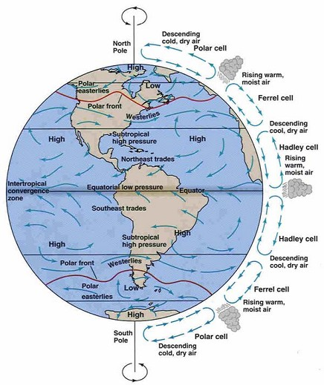SURFACE CURRENTS – Surface ocean currents are generated when global winds blowing over the water for a long period of time, causes the water to move in the same direction. Observe the two pictures below: one of global wind patterns and the other of surface ocean currents. Notice how the two are similar.

**Global Winds**

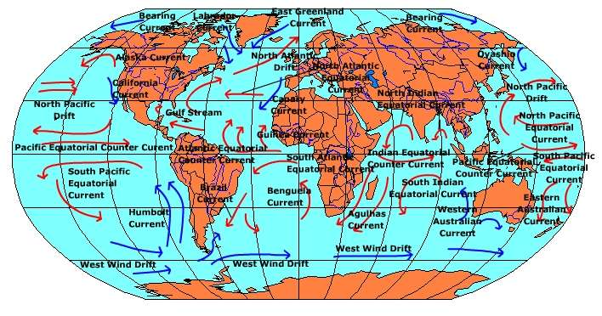**Ocean Surface Currents**

Notice that the global wind patterns and currents on the surface of the ocean are very similar, but not exactly alike. The differences are caused by the continents. Wind in the atmosphere can continue to blow right over the land, but the water in the oceans has to turn when it hits the land.

Surface ocean currents adjust the climate of an area only slightly. For example, if you look at the western coast of North America (near California), you will see that the California Current is brining water from the nearer the pole towards the equator. This means that cold water and cold air are moving by the California coast. This will adjust the climate and make it a little more cool and a little more dry than it otherwise would be based on latitude alone. Conversely, on the eastern coast of North America (near Florida, etc.), the Gulf Stream is brining water from nearer to the equator towards the pole. This means that warm water and warm air are moving by the east coast of the United States. This will adjust the climate and make it a little more warm and a little more wet (humid) than it otherwise would be based on latitude alone. Therefore, even though Sacramento, California and Washington, D.C are at approximately the same latitude (38o North latitude), the two cities have slightly different climates. Sacramento will be a little cooler and drier, while Washington, D.C. will be a little warmer and wetter.

DEEP OCEAN CURRENTS – The Global Conveyer Belt

Deep ocean circulation based on density is called thermohaline circulation. *Thermo* meaning heat and *haline* meaning salinity (saltiness.) It is easy to presume that all ocean water has the same salinity. That is, the same amount of salt is dissolved in all ocean water. However, this is not true.

Water near the equator is warmed by the sun. As this water is warmed, some of it evaporates. The salt does not evaporate and so stays in the water. This causes the warm water near the equator to increase in salinity (become more salty.) Although the density increases due to the increase in salinity, the water is still has a very low density because it is so warm. The warm water will then move away from the equator towards the poles.

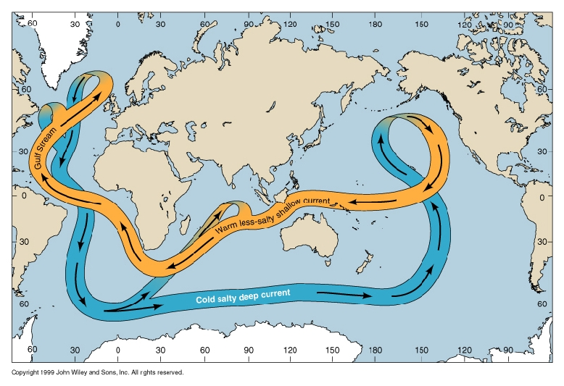Water near the poles is very cold and some of it even freezes. However, when the water freezes, the salt does not, and so stays in the water. Now, the water near the poles is very cold and very salty, making it very dense. This water will sink and move back towards the equator.

This whole cycle is called the global conveyer belt and is very important both in the cycling of nutrients and in regulating global temperatures. This cycle, although in constant motion, can take a thousand years to complete.

**HYPOTHESIS**: If ocean water is cool and salty, then it will have a ____________ density and will _____________.

**RESULTS**:

SALINITY AND DEEP OCEAN CURRENTS

**Salt water over fresh water.**

Prediction (color what you think the result will be): Observations (color what you see and describe):

**Fresh water over salt water.**

Prediction (color what you think the result will be): Observations (color what you see and describe):

**Salt water over fresh water turned horizontal.**

Prediction (color what you think the result will be): Observations (color what you see and describe):

**Fresh water over salt water turned horizontal.**

Prediction (color what you think the result will be): Observations (color what you see and describe):

**ANALYSIS**: (Answer using complete sentences and actual data.)

1. Is salt water or fresh water more dense? Explain how you know and why you think this is.
2. Taking into account, only salinity, where would you expect the most dense water to be? Explain.
3. Taking into account only temperature, where would you expect the most dense water to be? Explain.
4. Taking into account both salinity and temperature, where would you expect the most dense water to be? Explain.
5. Do you think it is possible for the direction of deep ocean currents to be reversed? Explain.

**Application to Agriculture**

*“An estuary is a partially enclosed body of water along the coast where freshwater from rivers and streams meet and mix with salt water from the ocean. Estuaries are protected from the full force of ocean waves, winds, and storms by barrier islands or peninsulas.*

*Estuaries are very productive environments! They create more organic matter each year than comparably sized areas of forest, grassland, or agricultural land. They support unique communities of plants and animals, specially adapted for life at the margin of the sea.”[2]*

Using this information and your own knowledge, describe the advantages and challenges of using an estuary for production agriculture.

1. Looper, Jim (2008). *Ocean Currents and Climate, Lab*. Sheldon High School.
2. National Estuary Program; About Estuaries. Retrieved December 4, 2008, from United States Environmental Protection Agency Web site: http://www.epa.gov/nep/about1.htm