Name___________________

Date____________________

# Element Project

**Purpose**

An element is a substance that cannot be broken down into simpler; stable substances by chemical means. [1] California is rich in many elements, and it is important to understand how elements are categorized using the periodic table. The purpose of this lab is to create a class Periodic Table of the elements, with each student generating one element. [2]

**Procedure**

**Materials**

1. 8 ½ x 11” piece of blank white paper
2. Colored writing pens or pencils
3. Periodic Table for reference in text book or poster

**Sequence of Steps**

1. Work with your instructor to select an element from the periodic table.
2. On a blank piece of white paper, create your portion of the periodic table for your element including:
   1. Element symbol d. Atomic mass
   2. Element name e. Diagram of atomic structure
   3. Atomic number

**1**

*Example:*

Element Name

Atomic Number

**H**

**Hydrogen**

**1.00794**

Atomic Mass

Element Symbol

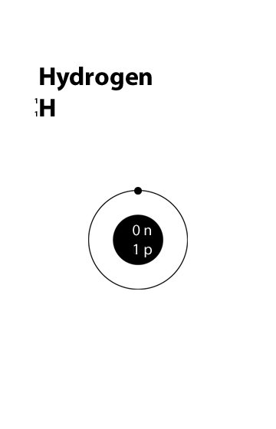

Atomic Structure

# 100.100

C:\Users\Angela\AppData\Local\Microsoft\Windows\Temporary Internet Files\Content.IE5\DRP2N1IJ\MCj04242300000[1].wmf

**Observations and Conclusion**

1. What evidence do scientists have, which indicates that all elements with an atomic number greater than that of lithium have been formed by nuclear fusion in stars?
2. Identify three elements and indicate their major economic importance to California.

Element:

Element:

Element:

1. Looking at the completed periodic table, make 3 observations relating to the organization and information included in the periodic table.
2. Agriculture Application: What are the symptoms of an excess supply or limited supply of your element in plants or animals?

1. (2007). *Earth Science*. Holt, Rinehart and Winston: Harcourt Education.
2. Galan, Daniel (2008). *Element Project, Lab*. Calexico High School.