Text Resources
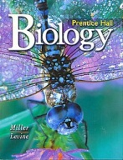
Agricultural Biology:
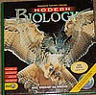

Modern Biology Biology
Holt, Rinehart and Winston Prentice Hall
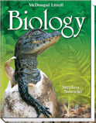
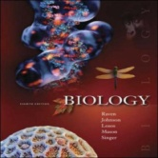

Biology Biology
McGraw-Hill McDougal Littell
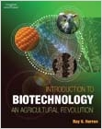
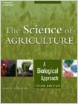

The Science of Agriculture, A Biological Approach Introduction to Biotechnology,
An Agricultural Revolution
Thomson Delmar Learning Thomson Delmar Learning
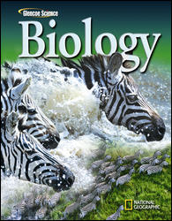

Biology
Glencoe Science

Agricultural Earth Science:
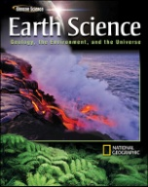
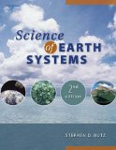

Science of Earth Systems Earth Science: Geology, the Environment, and the Universe Student Edition©2008
Delmar McGraw-Hill
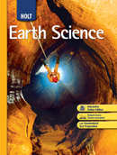
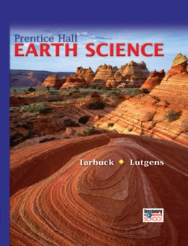

Earth Science Earth Science
Prentice Hall Holt, Rinehart, Winston
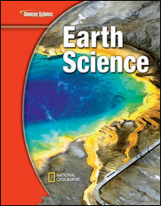

Earth Science
Glencoe Science

