Lesson # 8

Egg Processing

Core Area: Animal Science

Unit: Poultry Industry

Lesson # 8: Egg Processing

California CTE Standards (Agriculture):
D12.4 Understand how non-meat products (such as eggs, wool, pelts, hides, and by-products) are harvested and processed.
FS 4.6 Differentiate among, select, and apply appropriate tools and technology.
FS 8.1 Know major local, district, state, and federal regulatory agencies and entities that affect industry and how they enforce laws and regulations.
FS 11.0 Demonstration and Application.

California Academic Standards.
2.0 Reading Comprehension (Grades 9-10)

2.1 Analyze the structure and format of functional workplace documents, including the graphics and headers, and explain how authors use the features to achieve their purposes.

Investigation and Experimentation
1a Select and use appropriate tools and technology (such as computer-linked probes, spreadsheets, and graphing calculators) to perform tests, collect data, analyze relationships, and display data.

Student Learning Objectives. Instruction in this lesson should result in students achieving the following objectives:

- To provide students with an understanding of egg processing, egg packaging, and egg labeling.

List of Resources.
- The United Egg Producers (UEP) – http://www.unitedegg.org/
- The United States Department of Agriculture (USDA) Egg Grading Manual – http://www.ams.usda.gov/AMSv1.0/getfile?dDocName=STELDEV3004502)
- The Pacific Egg and Poultry Association (P.E.P.A.) – http://www.pacificegg.org

List of Equipment, Tools, Supplies, and Facilities.

- Eggs for student activities
- Hydrometer for shell thickness testing
- Buckets
- Salt
- Candling Light
- Digital Egg Scale
- Haugh Unit Measurement System
- Power Point Presentation

Terms. The following terms are presented in this lesson (shown in bold italics):

- Satellite Ranches
- Conveyor System
- Blood Spots
- Loose Packaging
- Flat
- Carton
- Specialty Designer Eggs
- Internal Temperature
- Processing Plant

Interest Approach.
- A visual example of the difference age makes when comparing fresh eggs to eggs left at room temperature for a week. Both the fresh eggs and the aged eggs could be viewed for differences in air cell size and then cracked open and observed for differences in viscosity. A diagram is available later in the lesson plan that portrays the differences in egg grades according to how closely the egg holds together (Haugh Unit Score).
- An egg shell thickness test could also be performed by mixing several buckets of water and salt to different specific gravities using a hydrometer. Eggs could then be dunked into each subsequent bucket until the egg does not sink or float but is buoyant in the solution. This correlates to a specific gravity for the egg.

SUMMARY OF CONTENT AND
TEACHING STRATEGIES

Objective 1: Egg Processing Systems

Anticipated Problem: Why are there different processing systems?

I. In-Line Processing (Figure 1)
- Egg processing occurs at the same location as the egg production facility.
  - This processing method is the most efficient egg collection and processing of eggs available. Eggs are delivered from the egg production facility to the egg processing facility.
  - Egg handling and processing is performed with automated equipment.

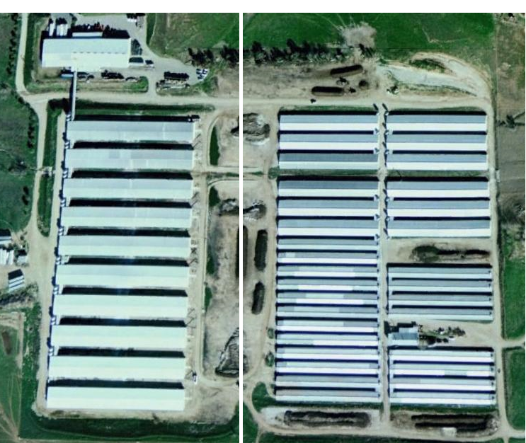
Figure 1. In-line egg processing. Figure 2. Off-line egg processing.

II. Off-Line Processing (Figure 2)
- Egg processing occurs separate from the egg production facility.
- This processing method utilizes satellite ranches. Satellite ranches are egg production facilities that are located at a different location from the egg processing facility.
- Eggs produced at satellite ranches must be gathered daily (Figure 3) and delivered to the egg processing facility.
- Egg handling and gathering is performed with automated equipment.

Figure 3. Egg gathering.

III. Care of eggs on the farm
- Regardless of on-line or off-line processing, steps are taken to maintain egg quality on the farm.
- These include, but are not limited to, egg collection occurring several times daily, careful egg handling procedures, egg cooling, egg cleaning, and use of clean packaging materials.

Teacher note: Refer to the “Egg Laying Hens” lesson plan for further explanation of how eggs are produced.

Objective 2: Processing Functions

Anticipated Problem: Why do eggs need to be processed?

I. Cleaning the Eggs
A. All eggs in the United States are washed in temperature controlled water with a mild detergent and pH adjustments in order to remove any contaminants (manure, grease, blood, yolk, etc.) before they are sold for human consumption.
B. Eggs are dried to remove an excess moisture prior to packaging.
C. Removal of contaminants prevents egg spoilage by bacteria.
D. Eggs that are not cleane or contain defects are removed from the processing line and are not packaged for shell egg sale, are sent to further processing, including pasteurization .
II. Grading
- Grading refers to the process of grouping eggs according to similar characteristics, such as quality and weight.
- Quality assurance is performed by company employees.
- The USDA has a stringent set of requirements for the grading of fresh shell eggs.
- Egg grading is dependent upon examination of internal quality factors (e.g., condition of the egg white and yolk, air cell size). Examples are shown in Figure 4.

Figure 4

- Internal quality factors are determined by candling (Figure 5).
- Candling involves holding the egg to a concentrated light source for visual inspection of internal defects, such as blood spots, double yolks or air cell size.

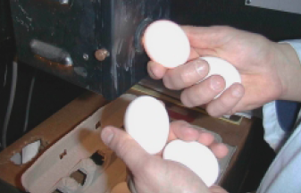
Figure 5

- Egg grading is also dependent upon external quality factors (e.g., shape, texture, cleanliness, and soundness of the shell). An USDA egg grading diagram showing differences in external quality factors is shown in Figure 6.

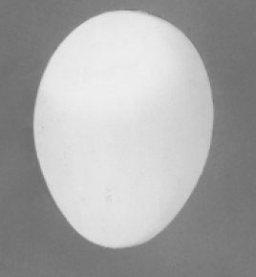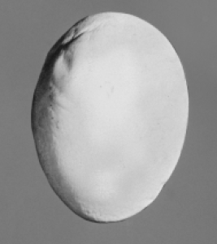
Figure 6A. Ideal egg shape. Figure 6B. Abnormal egg shape.

    - External quality can be determined by candling for illumination and detection of egg shell cracks, or checks.

- An egg with a AA grade contains the most desirable characteristics while an egg with a B grade contains the least desirable characteristics. USDA specifications for egg shell, air cell, egg white, and egg yolk characteristics are shown in Figure 7.

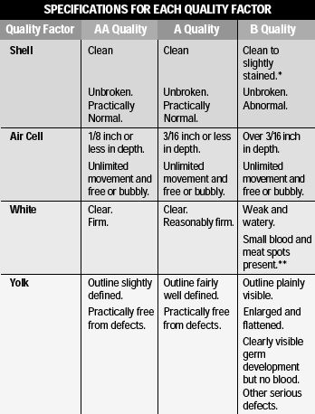
Figure 7

III. Size Determination
- Sizes are determined by weight. There are six different weight categories: peewee, small, medium, large, extra large, and jumbo. Each size category receives a different price on the farm as well as at the retail level.
Minimum Average Weight for one dozen eggs
Peewee: 15 ounces
Small: 18 ounces
Medium: 21 ounces
Large: 24 ounces
Extra Large: 27 ounces
Jumbo: 30 ounces
IV. Packaging
- Eggs are packaged into all sorts of containers designed for safe shipment of and product appearance for the consumer.
- Loose packaging is a simple way of moving large quantities of eggs in an efficient but also plain fashion. Loose packaging usually refers to either a thirty egg large or extra large flat, or a twenty egg jumbo flat. Loose sales mostly consist of sales to restaurants or other food service consumers.
- In retail settings, eggs are often packaged in cartons containing either one dozen or eighteen eggs. This packaging method is designed to be handled by first hand consumers and is therefore usually designed to be quite appealing. There are several different varieties of eggs available to the consumer, which are called specialty or designer eggs by the industry.

Teacher notes: Refer to the “Egg Laying Hens” lesson plan, objective 8 – discussing types of eggs purchased at the grocery store.

Objective 3: Care and Handling of the Product

Anticipated Problem: How do eggs need to be handled?

I. Refrigeration
A. Eggs must be cooled to an internal temperature of 45 ˚F.
B. All graded eggs being transported must be hauled in a refrigerated trailer so that the core temperature is held above freezing but below 45 ˚F.
II. Mechanical Handling
- Eggs are moved using conveyor systems between the production facility and the processing plant. Egg flow is normally managed with computerized flow control systems.
B. The processing machinery is fully mechanical and most of the equipment on commercial farms works to wash, dry, sort by weight and quality, and package the eggs into specified packaging.
C. Once eggs are consolidated to pallets, fork lifts are used to handle the
product.

Objective 4: Labeling

Anticipated Problem: Why do eggs need to be labeled?

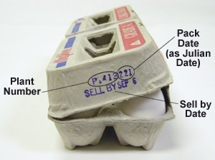
Figure 8
I. Sell by Date
- Every individual package of eggs processed must contain a sell by date that is set from the date of processing.
II. Julian Date
- This is the three digit day number relative to the day in the year the eggs were processed. This date is calculated with January 1 as 001 and December 31 as 365.
III. Grade
- Both the size of the eggs and the level of quality are printed on the carton, the quality is signified by an A or AA grade on almost all fresh shell eggs.
IV. Plant Code
- A code is printed on every carton produced in a processing plant. Each plant has its own individual code so that if there is a need to find the origin of the finish product, it can be traced all the way back to the processing plant.
V. Nutritional Facts
- Nutritional information is printed on every package for retail sale. This information varies slightly depending on the egg size and also the type of egg (designer eggs).
VI. “Keep Refrigerated”
- All egg packages are labeled with a cautionary “keep refrigerated” label. The reasoning for this warning pertains to the effort to reduce growth of salmonella if present.
VII. U.E.P. “Animal Care Certified”
- Nationwide, >80% of egg farmers have voluntarily joined the United Egg Producers (UEP), which sets a score of regulations to ensure the overall welfare of chickens being used for egg production. When a farm becomes “Animal Care Certified”, this label can be used to let the consumer know how the product they are purchasing was produced.

Review/Summary. Focus the review of the lesson around the student learning objectives. Ask students to explain the content associated with each objective. Use their responses as the basis for determining any areas that need to be covered again.

Application. Application can involve student activity with the provided labs.

Evaluation. Evaluation should focus on student achievement of the objectives for the lesson. Various techniques can be used, such as a written test. A sample test is attached.

Answers to Sample Test:

Part One: Matching

D | 1. Satellite ranches
F | 2. Conveyor system
H | 3. Meat and blood spots
A | 4. Loose packaging
G | 5. Flat
I | 6. Carton
B | 7. Specialty designer eggs
C | 8. Internal temperature
E | 9. Processing plant

Part Two: T / F

1. T 6. F

2. F 7. T

3. T 8. T

4. T 9. F

5. T 10.T

Part Three: Matching

F | 1. Grading
C | 2. Shell Eggs
B | 3. Internal quality factors
A | 4. Candling
E | 5. External quality factors
G | 6. AA grade
D | 7. B grade

Part Four: Egg Packaging Details

Sell by Date Grade Julian Date

Plant Code Nutritional Facts Keep Refrigerated

