Notes to the Teacher

Title: State & Local Production
Lesson: California Agriculture Collage
Classroom Activity

Purpose:

The purpose of this activity is to introduce you to the major products produced in the eight agriculture regions of California and to the top ten California agriculture commodities.

Activity Directions:

Your teacher has provided a large map of California that has been divided into the eight California regions. Your class will be divided up into eight groups. As a group, you will be assigned one of those eight regions and be responsible for providing pictures of agricultural commodities from that region. You can find these pictures in magazines and newspapers.

In class, your group will present your information to the class. The pictures will be attached to the collage during your groups presentation.

Also, be familiar with California's top ten commodities. Does your region contain any of these commodities?

Materials Needed:

1. Map of California divided into the eight agriculture regions.
2. Magazines, newspapers.
3. Tape.
4. Lecture notes.

Notes to teacher:

On the next page is a map of California divided into its agricultural regions. You may wish to enlarge it onto butcher paper for this activity. It can also be used as a transparency or handout for your students. 111.T1 (map) is also available for your use in this activity. This map contains all of California's counties.

In class you will probably have already taught California's top ten commodities. This activity can reinforce the importance of these ten commodities and the numerous other commodities grown in California. Students can gain an appreciation for California's diversity.

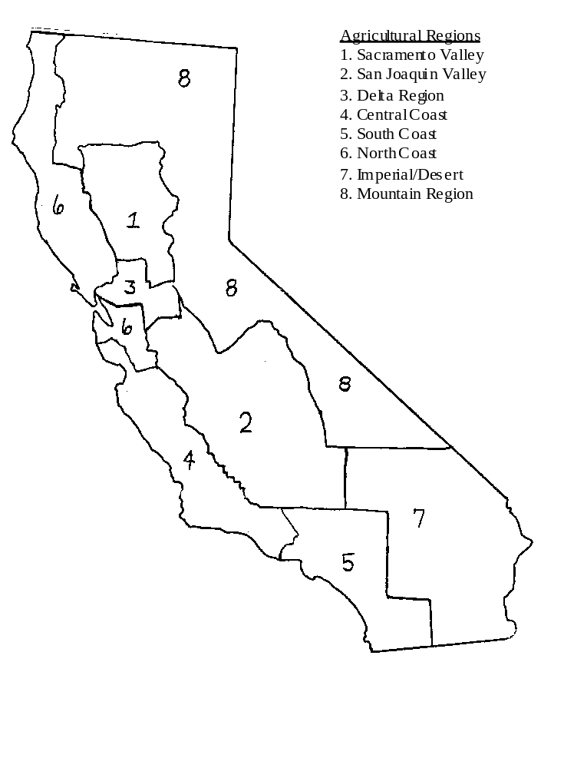
Name:__________________
Date:___________________

Title: State & Local Production
Lesson: California Agriculture Collage
Classroom Activity

Purpose:

The purpose of this activity is to introduce you to the major products produced in the eight agriculture regions of California and to the top ten California agriculture commodities.

Activity Directions:

Your teacher has provided a large map of California that has been divided into the eight California regions. Your class will be divided up into eight groups. As a group, you will be assigned one of those eight regions and be responsible for providing pictures of agricultural commodities from that region. You can find these pictures in magazines and newspapers.

In class, your group will present your information to the class. The pictures will be attached to the collage during your groups presentation.

Also, be familiar with California's top ten commodities. Does your region contain any of these commodities?

Materials Needed:

1. Map of California divided into the eight agriculture regions.
2. Magazines, newspapers.
3. Tape.
4. Lecture notes.
Lesson: State & Local Production
Bank of Questions

1. Question: California is made up of _______ agricultural regions? Name all of them.

Answer: 1. Eight
2. North Coast, Mountain, San Joaquin, Sacramento, Delta, Central
Coast, South Coast, Imperial and Desert

2. Question: What are the top ten commodities grown if California?

Answer: 1. Milk and cream
2. Grapes
3. Cattle and calves
4. Nursery products
5. Cotton lint
6. Flowers and foliage
7. Almonds
8. Head lettuce
9. Hay
10. Strawberries
The above statistics are from a 1992 poll. Therefore, the answers
may change in the future.

3. Question: It is important for you to be familiar with the commodities grown in your county. Write down the name of the county you live in and what commodities are grown in your county?

Answer: The answer will be different for each county.

4. Question: What are the top five agricultural commodities grown in your county?

Answer: The answer will be different for each county.

5. Question: What are the top five commodities grown in the United States?

Answer: 1. Cattle and calves
2. Milk and cream
3. Corn
4. Soybean
5. Hay
These answers may change in the future.

