Common Electrical Circuits
Name: ___________________________

“Loop” Circuits
For electricity to flow a “loop” path must be established in the conductor (wire). In a simple direct current (DC) circuit this is easy to see as the power source is usually a battery.
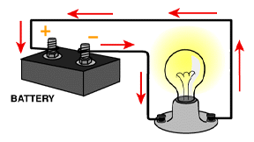
Think about how a flashlight works. Can you see the “loop”?
In alternating current (AC) circuits the “loop” is harder to see since the power source is usually a power station located many miles from the load (ex. light bulb). However, the loop still exists.
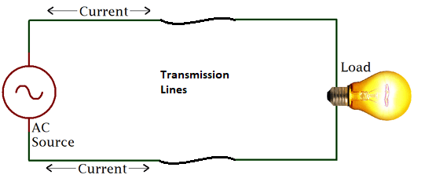
To control the flow of electricity (current) we install switches and other devices to interrupt the loop.

Directions:
Symbol Key
Silver Screw
Brass Screw
Each device is assumed to be in a box. All wire connections must be made in a box. Determine which box will be the “source” of power. Draw in the wires and label with colors. Only one wire may be placed under a screw. Show connections made with wire nuts with a solid dot. White wires connect to silver screws, black (or red) wires connect to the brass screws.

Example: Two Duplex Receptacles
Power source will be the left box.
Duplex
Receptacle
Duplex
Receptacle
Can you identify the “loop” in this circuit?

Three Duplex Receptacles
Power source will be the center box.
Duplex
Receptacle
Duplex
Receptacle
Duplex
Receptacle

Switched Lamp #1
Source of power will be the lamp box.
Switch
Lamp

Switched Lamp #2
Source of power will be the switch box.
Switch
Lamp

Switched Lamp with Duplex Receptacle #1
Source of power will be the Duplex Receptacle.
Switch
Lamp
Duplex
Receptacle

Switched Lamp with Duplex Receptacle #2
Source of power will be the Lamp box.
Switch
Lamp
Duplex
Receptacle

3 Way Switch #1
Power source will be the left switch. This is a typical configuration found in hallway lighting.

3 Way Switch #2
3 way
Switch
3 way
Switch
Lamp
Power source will be the left switch (middle box). This is a typical scenario found with exterior lighting with switches at the doors.
3 way
Switch
3 way
Switch
Lamp

