Non-Metallic Cable Wiring Board
A simple board for wiring projects using NM cable. NM cable is widely used in residential wiring. Conduit is used in commercial applications and uses single conductors. The circuits for both types of wiring are the same. NM cable provides some additional challenges since conductor’s colors in the cable are pre-determined. For some wiring problems conductors must be marked with tape to properly identify the use of the conductor. Boards may be built with two or three boxes depending on the complexity of the assignments desired.

Materials:
- 2x4x28”
- 2 or 3 nail on single gang boxes

Directions:
- Mark the edge of the 2x4 with the box locations. Leave at least 6” between the boxes.
- Nail on the boxes using the ½” tabs as a guide (this is the standard spacing for ½” sheetrock walls.

Devices:
For each board a selection of devices to be wired should be purchased. The following would be needed for the projects listed below.
- Toggle switch
- 3 way switch (2)
- Duplex Receptacle (2)
- Lamp Holder
- Lamp
If you wish to test the project (connect to power), then have a few cords (pigtails) that can be connected to the projects with wire nuts. A good source of these are old computer/monitor cables. Just cut off the computer end. It is recommended if the pigtail uses stranded wire to solder the wire so it does not become frayed.

Supplies:
The following supplies will be consumed as students wire the boards.
- 14-2 NM Cable (estimate 5’ per 3 box project)
- Yellow Wire Nuts (these can be reused to some extent)
- NM Staples. These are required by code and can be placed between each box.
- 6-32 screws. These will be needed to attach the devices to the box. A small box should be plenty, and they should be re-used.

Projects
Many different combinations of projects can be completed with even a 2 box board. They will demonstrate different skills depending on how the devices are placed. IMPORTANT: Many devices can be wired by simply inserting 14 gauge wire into the hole in the back. This saves labor for electricians but is not easily removed. An important skill is to learn how to form an eye in the wire and connect it to a screw terminal. Do not use the push in connection. The projects below practice circuits that are commonly found in home wiring.

1 Box Project
Project | Notes
Power > DR | A simple project that demonstrates use of screw terminals and color coding.

2 Box Projects
Project | Notes
Power > Switch>Lamp Holder | A project that demonstrates use of screw terminals and color coding, use of wire nuts, and switch the hot wire.
Power > Switch>DR | A project that demonstrates use of screw terminals and color coding, use of wire nuts, and switch the hot wire.
Power > Lamp Holder > Switch | A project that demonstrates use of screw terminals and color coding, use of wire nuts, and switch the hot wire. Note this project adds the use of a white wire as a hot wire which is allowed as long as it is marked with electrical tape
Power > DR > DR | A simple project that demonstrates use of screw terminals and color coding, and use of the double terminals on the DR.

3 Box Projects
Project | Notes
Power > Switch>DR>Lamp Holder | A project that demonstrates use of screw terminals and color coding, use of wire nuts, and switch the hot wire. Note this project uses 14-3 (red wire is switched).
Power > Lamp Holder>DR>Switch | A project that demonstrates use of screw terminals and color coding, use of wire nuts, and switch the hot wire.
Power > Switch>Lamp Holder>DR | A project that demonstrates use of screw terminals and color coding, use of wire nuts, and switch the hot wire. Note this project uses 14-3 (red wire is switched).
Power > 3 way Switch>Lamp Holder>3 way Switch | A project that demonstrates use of screw terminals and color coding, use of wire nuts, and switch the hot wire. Note this project uses 14-3 (red wire is switched).
Power > 3 way Switch>3 way Switch>Lamp Holder | A project that demonstrates use of screw terminals and color coding, use of wire nuts, and switch the hot wire. Note this project uses 14-3 (red wire is switched).

General Rubric
The following can be used for each box:
- Color Code
- Screw Terminal (correct direction, proper stripping, 2/3 around the screw, neat)
- Grounding (ground wires connected, DR grounded). Note: In most cases switches are not required to be grounded.
- Proper use of wire nuts (tight and no bare wire showing)
- Wire length is cut to have at least 6” of conductor out of the box.
In addition the completed circuit should be graded.
For example for the two box project Power>Switch>Lampholder a rubric might look like:
Item | Possible | Score
Box 1 - Switch
6” free conductor | 5
Screw Terminals | 5
Color Coding | 5
Grounding (ground wires connected) | 5
Use of Wire Nuts | 5
Box 2 – Lamp Holder
6” free conductor | 5
Screw Terminals | 5
Color Coding | 5
Correct Circuit | 10
TOTAL | 50

For example for the three box project Power>Switch>DR>Lampholder a rubric might look like:
Item | Possible | Score
Box 1 - Switch
6” free conductor | 5
Screw Terminals | 5
Color Coding | 5
Use of Wire Nuts | 5
Grounding (ground wires connected) | 5
Box 2 – DR
6” free conductor | 5
Screw Terminals | 5
Color Coding | 5
Use of Wire Nuts | 5
Grounding (DR Grounded) | 5
Box 3 – Lamp Holder
6” free conductor | 5
Screw Terminals | 5
Color Coding | 5
Correct Circuit | 15
TOTAL | 80

Sample Worksheet:
Worksheets are useful to see if the students understand the circuit before they start actual wiring. You need to make the connection of the circuit on the worksheet to the physical wire, boxes, and devices. One way to do this is to demonstrate the project then have the students make the diagram.

Wiring Worksheet
Connect the black dots on the diagram below to illustrate how you will wire your project. Label each wire color. Lamp is controlled by the switch.
Switch
Lamp
DR
White
Black
Green

Wiring Worksheet (Completed)
Switch
Lamp
DR
White
Black
Green

Photos:
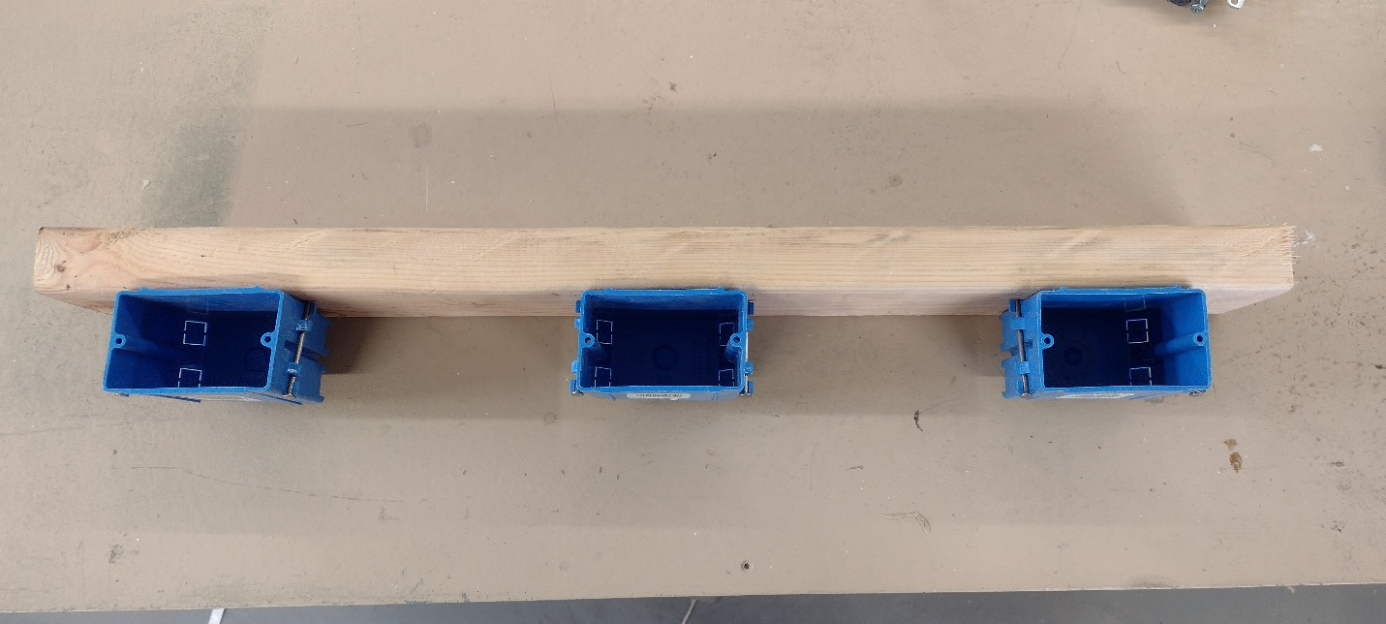
Board ready for wiring
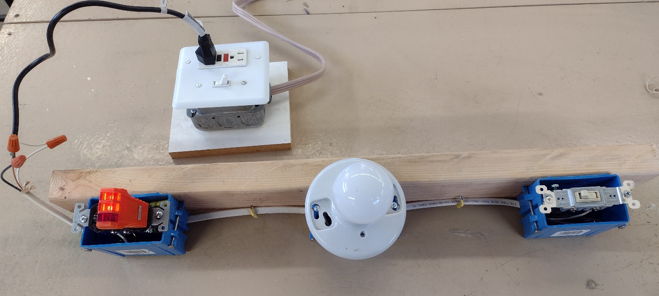
Wired board attached to the tester with a pigtail. Note the use of the tester in the DR to check for correct wiring. Devices are loosely installed in the box to prevent shorts and contact.
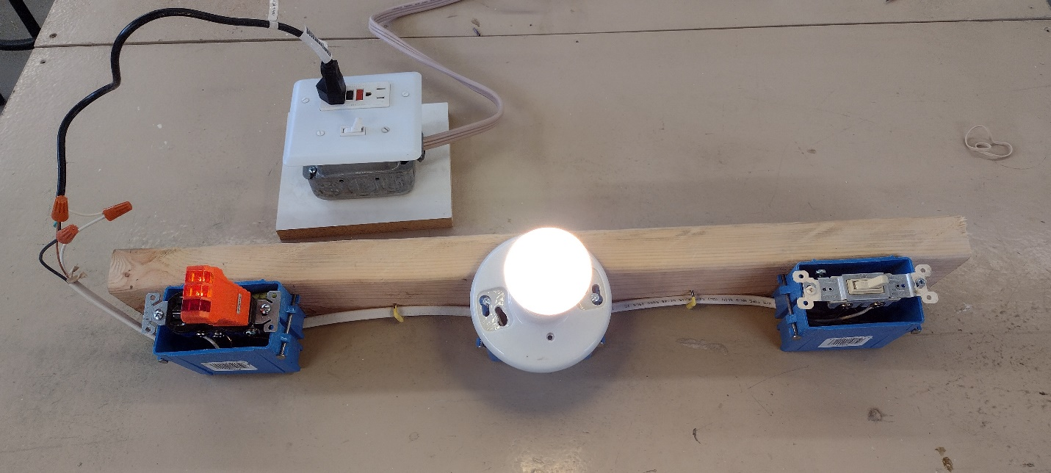
Board with lamp turned on.
Generalized Student Directions:
Wiring of the board can be accomplished using the generalized directions below. Note that ground wires can be connected using wire nut, but some counties may require a crimp connector. The staple is not really needed but is required by code and is good practice for the student. Staples are easily pulled by prying with a flat bladed screwdriver (holes can be re-used for the next project). When placing the devices in the box the student also can practice “folding” the wire.

Directions:
- Complete the circuit diagram and have your teacher check it.
- Following the diagram install wire in each box. The wire should stick out 6-8” from the top of the box. Install a piece of wire in the first box (for power). This wire should extend 6-8:” from the back of the box as well.
- Strip the ends of the wire. Cable covering should be removed well into the box.
- Connect ground (bare) wires first. If no device is to be grounded in the box, then neatly tuck the ground into the back of the box.
- Connect wires (other than ground) that are not attached to any device with wire nuts and tuck into the back of the box.
- Connect wires to the devices using the screw terminals. Wire should be pre-formed into an eye. The eye is attached in a clockwise direction. The screw should contact at least 2/3 of the wire. Be sure to follow the color coding on the devices (brass-hot, silver=neutral, green=ground)
- Check your circuit.
- Install the devices loosely with screws into the boxes.
- Using a piece of masking tape label the project with your name.
- Have your teacher test your project.
- After the project is graded, disassemble the project and put the parts away.

Illustrated Parts and Supplies
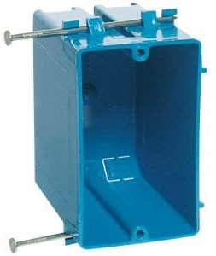  Electrical Box | 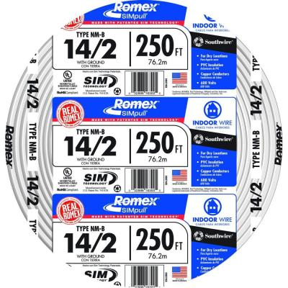  14-2 NM Cable
Toggle Switch | 3 way Toggle Switch
Duplex Receptacle | 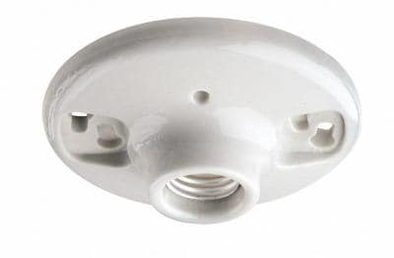  Lamp Holder
Wire Nuts | Wire Stripper (use with cable ripper)
Wire Stripper for NM cable (removes cable cover) | 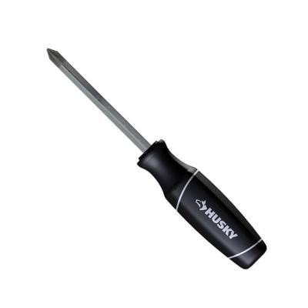  Phillips Screwdriver
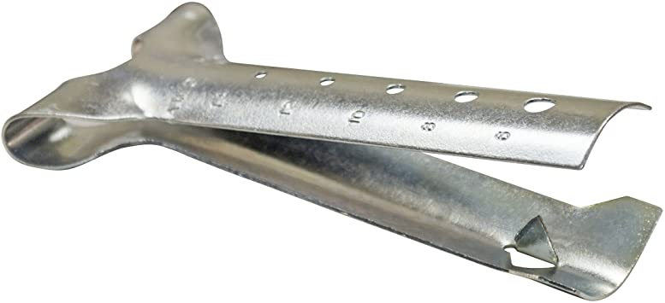  Cable Ripper | 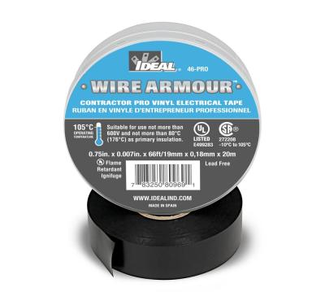  Electrical Tape for marking wire
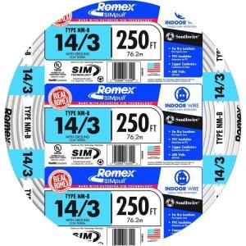  14-3 NM Cable (used for more complex projects) | 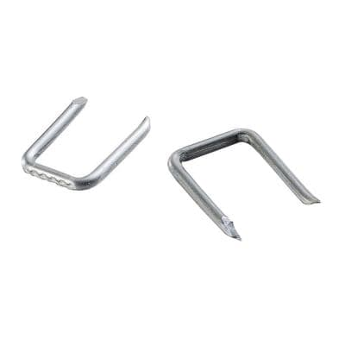  NM Cable Staples

