Conduit Wiring Board
A simple board for wiring projects using conduit. The board uses both PVC and EMT conduit to demonstrate the differences in grounding requirements. When PVC conduit is used a ground wire must be run between the boxes. All metal boxes must be grounded. Conduit is used in commercial applications and uses single conductors. The circuits for NM Cable and conduit wiring are the same. Boards may be built with two or three boxes depending on the complexity of the assignments desired.

Materials:
- 1”x4”x 21” pine board.
- 3 – “handy” boxes with ½” K.O.
- 2 – ½” PVC conduit male adapters
- 2 ½” Lock nuts
- 2 – ½ EMT Box connectors
- 2 – ½” NM Cable connectors
- 3” of 1/2” EMT
- 3” of ½” PVC conduit.
- 6 ¾” truss head screws
- 3 – Ground Screws

Directions:
- Cut the conduit to length.
- Cut the mounting board.
- Install the ground screws in the boxes.
- Install the box connectors as shown in the photo. Note: PVC conduit does not need to be glued.
- Use the truss head screws to attach the boxes to the board.

Devices:
For each board a selection of devices to be wired should be purchased. The following would be needed for the projects listed below.
- Toggle switch
- 3 way switch (2)
- Duplex Receptacle (2)
- Lamp Holder
- Lamp
If you wish to test the project (connect to power), then have a few cords (pigtails) that can be connected to the projects with wire nuts. A good source of these are old computer/monitor cables. Just cut off the computer end. It is recommended if the pigtail uses stranded wire to solder the wire so it does not become frayed.

Supplies:
The following supplies will be consumed as students wire the boards.
- 14 gauge THHN White, Black, Green and optionally another color like blue or red.
- Yellow Wire Nuts (these can be reused to some extent)
- 6-32 screws. These will be needed to attach the devices to the box. A small box should be plenty and they should be re-used.

Projects
Many different combinations of projects can be completed with even a 2 box board. They will demonstrate different skills depending on how the devices are placed. IMPORTANT: Many devices can be wired by simply inserting 14 gauge wire into the hole in the back. This saves labor for electricians but is not easily removed. An important skill is to learn how to form an eye in the wire and connect it to a screw terminal. Do not use the push in connection. The projects below practice circuits that are commonly found in wiring.
Two NM Cable clamps are provided for power sources. Varying the location of the power source changes the scenario and the wiring problem. To test the project stub out a piece of NM cable. These can be pre-made and reused. To test connect the stub to a Cord Cap connected to a short piece of SJ cord or a piece of NM cable with wire nuts.

1 Box Project
Project | Notes
Power > DR | A simple project that demonstrates use of screw terminals and color coding.

2 Box Projects
Project | Notes
Power > Switch>Lamp Holder | A project that demonstrates use of screw terminals and color coding, use of wire nuts, and switch the hot wire.
Power > Switch>DR | A project that demonstrates use of screw terminals and color coding, use of wire nuts, and switch the hot wire.
Power > Lamp Holder > Switch | A project that demonstrates use of screw terminals and color coding, use of wire nuts, and switch the hot wire.
Power > DR > DR | A simple project that demonstrates use of screw terminals and color coding, and use of the double terminals on the DR.

3 Box Projects
Project | Notes
Power > Switch>DR>Lamp Holder | A project that demonstrates use of screw terminals and color coding, use of wire nuts, and switch the hot wire.
Power > Lamp Holder>DR>Switch | A project that demonstrates use of screw terminals and color coding, use of wire nuts, and switch the hot wire.
Power > Switch>Lamp Holder>DR | A project that demonstrates use of screw terminals and color coding, use of wire nuts, and switch the hot wire.
Power > 3 way Switch>Lamp Holder>3 way Switch | A project that demonstrates use of screw terminals and color coding, use of wire nuts, and switch the hot wire.
Power > 3 way Switch>3 way Switch>Lamp Holder | A project that demonstrates use of screw terminals and color coding, use of wire nuts, and switch the hot wire.

General Rubric
The following can be used for each box:
- Color Code (wire and terminals)
- Screw Terminal (correct direction, proper stripping, ¾ around the screw, neat)
- Grounding (ground wires connected, DR grounded, box grounded). Note: In most cases switches are not required to be grounded, but grounding is not a deduction.
- Proper use of wire nuts (tight and no bare wire showing)
- Wire length is cut to have at least 6” of conductor out of the box.
- Neatness

In addition, the completed circuit should be tested and graded.

For example for the two box project Power>Switch>Lampholder a rubric might look like:
Item | Possible | Score
Box 1 - Switch
6” free conductor | 5
Screw Terminals | 5
Color Coding | 5
Grounding (ground wires connected) | 5
Use of Wire Nuts | 5
Box 2 – Lamp Holder
6” free conductor | 5
Screw Terminals | 5
Color Coding | 5
Correct Circuit | 10
TOTAL | 50

For example for the three box project Power>Switch>DR>Lampholder a rubric might look like:
Item | Possible | Score
Box 1 - Switch
6” free conductor | 5
Screw Terminals | 5
Color Coding | 5
Use of Wire Nuts | 5
Grounding (ground wires connected) | 5
Box 2 – DR
6” free conductor | 5
Screw Terminals | 5
Color Coding | 5
Use of Wire Nuts | 5
Grounding (DR Grounded) | 5
Box 3 – Lamp Holder
6” free conductor | 5
Screw Terminals | 5
Color Coding | 5
Correct Circuit | 15
TOTAL | 80

Sample Worksheet:
Worksheets are useful to see if the students understand the circuit before they start actual wiring. You need to make the connection of the circuit on the worksheet to the physical wire, boxes, and devices. One way to do this is to demonstrate the project then have the students make the diagram.

Wiring Worksheet
Connect the black dots on the diagram below to illustrate how you will wire your project. Label each wire color. Lamp is controlled by the switch.
Switch
Lamp
DR
White
Black
Green

Wiring Worksheet (Completed)
Switch
Lamp
DR
White
Black
Green

Photos:
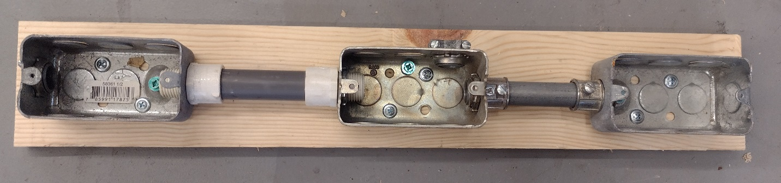
Board ready for wiring
Generalized Student Directions:
Wiring of the board can be accomplished using the generalized directions below. Note that ground wires can be connected using wire nut, but some counties may require a crimp connector. When placing the devices in the box the student also can practice “folding” the wire.

Directions:
- Complete the circuit diagram and have your teacher check it.
- Following the diagram install wire in each box. The wire should stick out 6-8” from the top of the box. Install a piece of NM cable in the box where power enters. This wire should extend 6-8:” from the back of the box as well.
- Connect ground wires first. Each box must be grounded.
- Connect wires to the devices using the screw terminals. Wire should be pre-formed into an eye. The eye is attached in a clockwise direction. The screw should contact at least 2/3 of the wire. Be sure to follow the color coding on the devices (brass-hot, silver=neutral, green=ground)
- Check your circuit.
- Install the devices loosely with screws into the boxes.
- Using a piece of tape label the project with your name.
- Have your teacher test your project.
- After the project is graded, disassemble the project and put the parts away.

Illustrated Parts and Supplies
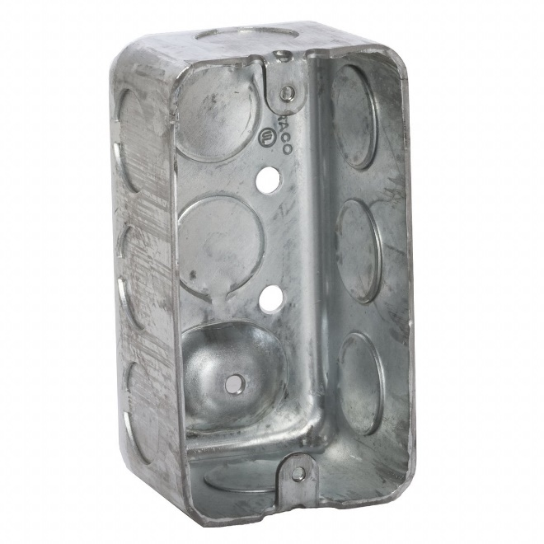  Electrical “handy” Box | 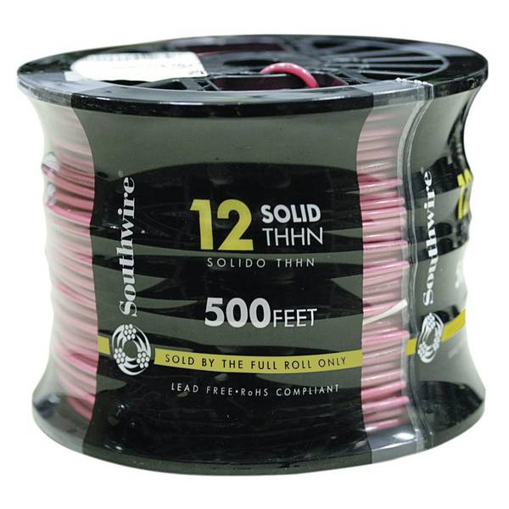  THHN Conductor
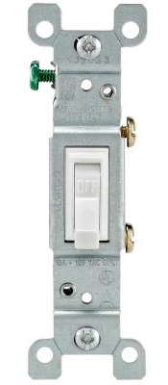  Toggle Switch | 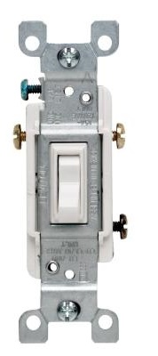  3 way Switch
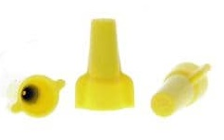  Wire Nuts | 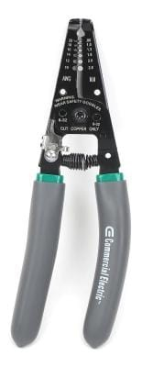  Wire Stripper (use with cable ripper)
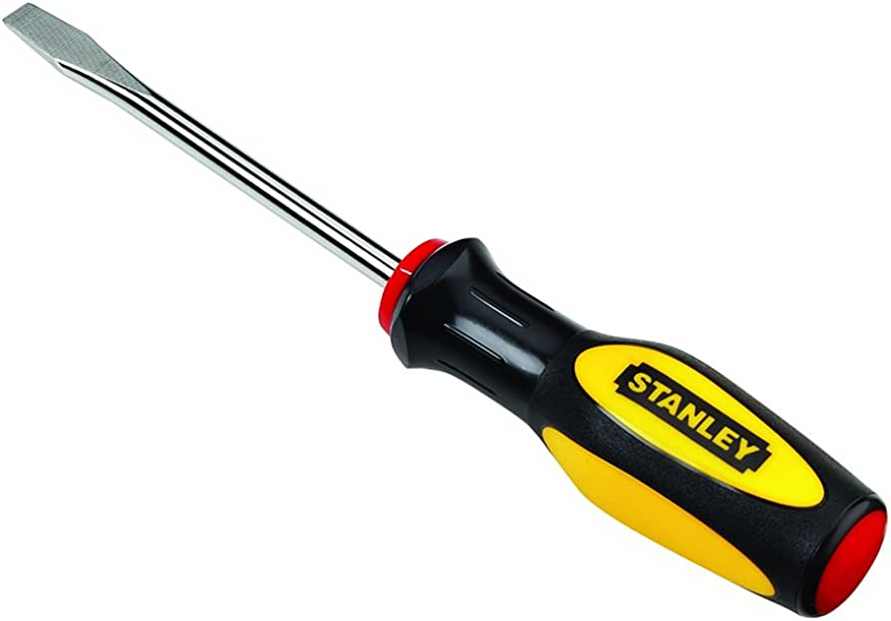  Flat or Standard Screwdriver | 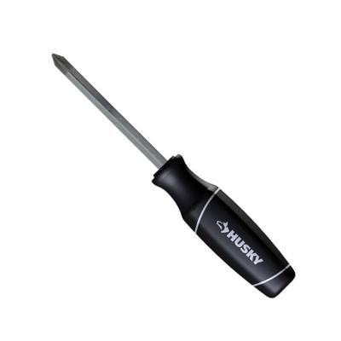  Phillips Screwdriver
EMT Box Connector | 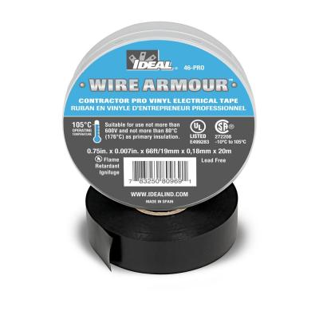  Electrical Tape for marking wire
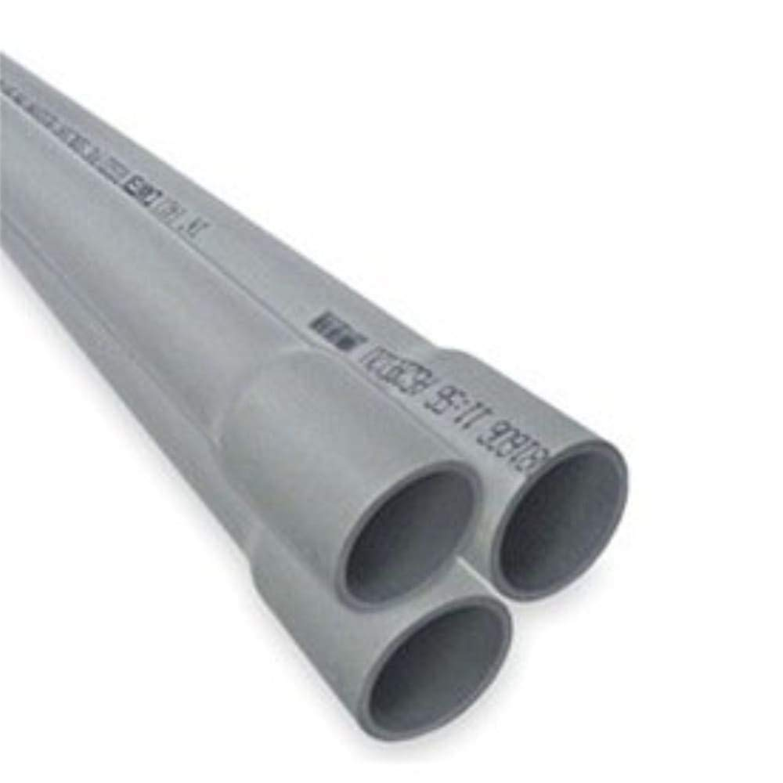  PCV Conduit | EMT Conduit
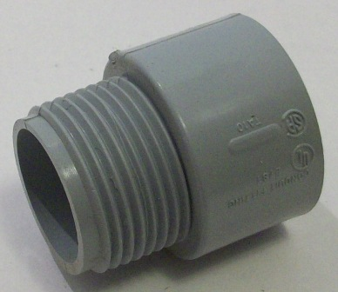  PVC Box Connector | Conduit Lock Nut
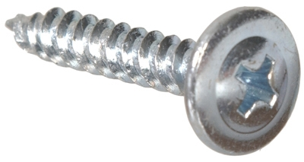  Truss head screws | 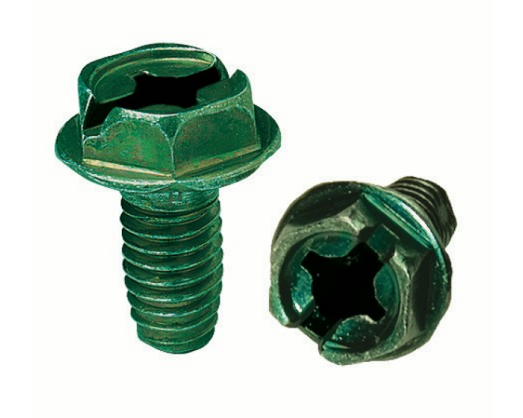  Ground Screws

