Electrical Project GFCI Tester
While not necessary, testing student electrical projects with live current adds an excitement for the students and makes it easy for the teacher to test the circuit. Testing also finds shorts to box and other wires. The trick is to do it safely. The Ground Fault Circuit Tester (GFCI) compares the current between the hot and neutral wires and trips when they are not equal. Unfortunately, the GCFI does not provide overload protection and the breaker will trip if the board has a short. A 15A power strip will trip before the breaker on a 20A circuit so this device is used with the GCFI. An overload protected power strip with a switch can be used alone as a tester but will not protect as well as the GFCI.

Materials:
4” square Box
½” 2 gang plaster ring
Switch (toggle or Decora style)
ground fault circuit interrupter or GCFI (one with an indicator light is best)
Cover to match switch and GFCI
NM Cable Connector or Cord Strain Relief (for round pigtail)
Pigtail (extension cord end). Hint: Cut off the end of a computer power cord, these are commonly tossed when a computer or monitor dies). These are commonly 16 gauge but will not fail before a 15A breaker trips.
Overload Protected Power Strip (3’ or 6’ cord)
Mounting board approximately 6” x 24”, fit to parts used
½” Truss Head screws for metal box
#6 x ½” RH screws for power strip
Wire Nuts

Directions to Build:
- Mount the box to the board with the screws.
- Install the NM cable connector
- Install the cord with about 6” of cord in the box
- Install the ground wire to the box.
- Wire the GCFI so the “LINE” connectors are switched.
- Install the devices into the box then install the cover.
- Mount the power strip. Note: Most power strips have a slide on mounting. To prevent the power strip from sliding off the screws, place a “stop” screw outside the power strip.

Use:
- Plug the tester into power. Be sure the power strip is on.
- Turn off the toggle switch.
- Secure at least loosely the devices in the student project boxes for safety.
- Connect the project to a pigtail with wire nuts. Be sure to observe proper hot-neutral-ground connections. Note if your pigtails use stranded wire you should solder the bare wire so it does not become frayed.
- Plug in the student project.
- Without touching the project turn on the switch. If the GCFI or breaker does not trip continue.
- If the project has a receptacle, plug in the outlet tester (see below) to see if it wired correctly.
- If the project has a switch device, then turn on the switch to see if it works properly.
- Turn off the toggle switch and disconnect.

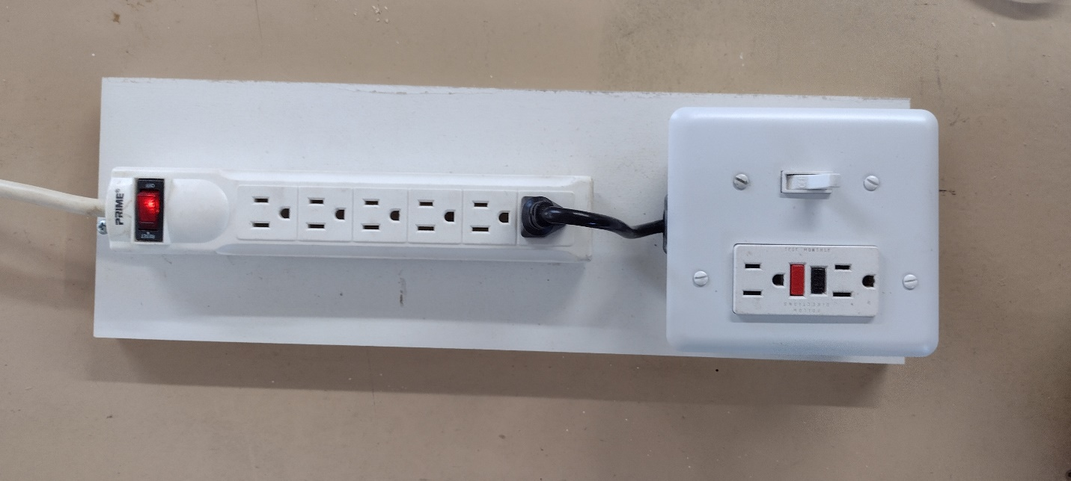
Completed Project Tester
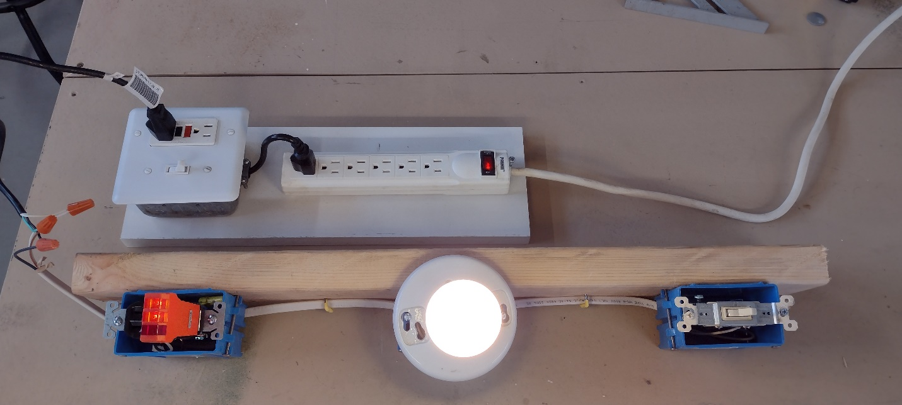
The Tester attached to a project.

Simple Outlet Tester. These testers indicate if the outlet (DR) is wired correctly by testing voltage between the hot-neutral-ground connections.

Parts:
Strain Relief Cord Connector | NM Cable Connector | GFCI Outlet
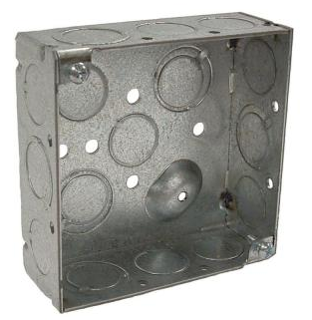  4” Square Box | 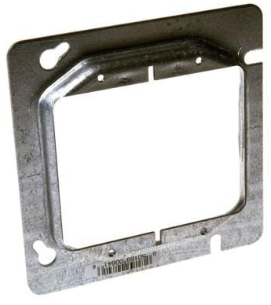  Plaster Ring | 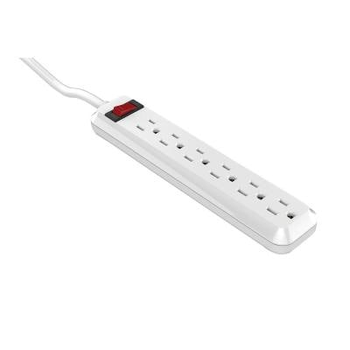  Typical Power Strip with Switch

