Electrical Troubleshooting Activities Stations & Key
Station | Tester
1 | Multi-meter
2 | Multi-meter
3 | Multi-meter
4 | Multi-meter
5 | Multi-meter
6 | Multi-meter
7 | Multi-meter
8 | Multi-meter
9 | Multi-meter
10 | DR Tester
11 | Induction
12 | Clamp-on
13 | Multi-meter
14 | Multi-meter

Station #1 – Resistance Testing of Lamps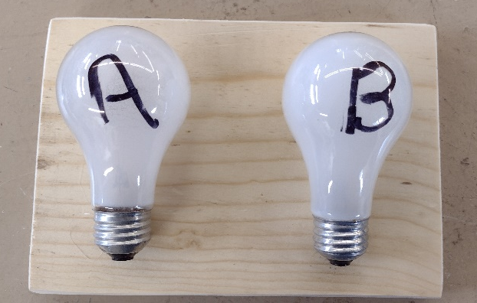
Lamp | Resistance (ohms) | Good/Bad
A | 0 | Bad
B | 16 | Good

Station #2 – Wiring Testing
Cable | Fault (circle) | Which Wire(s)
A | a. Shorted  b. Broken  c. No Fault | Black
B | a. Shorted  b. Broken  c. No Fault | White

Station #3 – Switch Testing
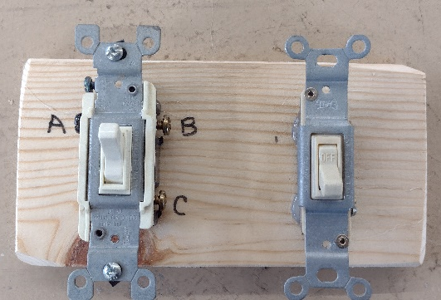
Toggle Switch: Is the switch working (Yes / No)

3 way Switch:
Switch Position | Circle connected terminals
1 (up) | A-B  A-C  B-C
2 (down) | A-B  A-C  B-C
C is common terminal

Station #4 – DC Voltage Testing
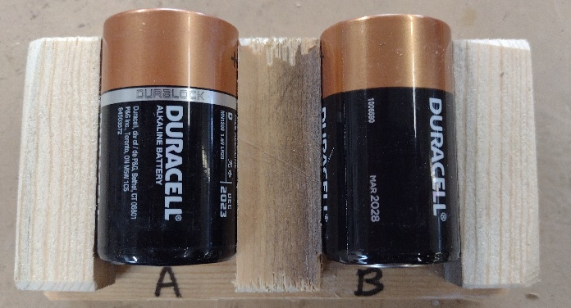
Battery | Voltage | Good/Bad
A | Depends | Good
B | Depends | Bad

Station #5 – DC Voltage Testing Lead Acid Battery
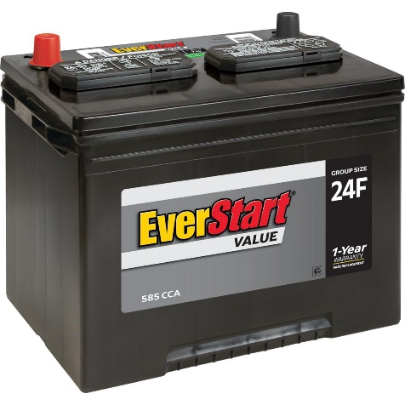
Test depends on battery condition.

Station #6 – Auto/Trailer Testing
Both filaments are good.

Station #7 – Wiring Testing
Cable | Fault (circle) | Which Wire(s)
C | a. Shorted  b. Broken  c. No Fault
D | a. Shorted  b. Broken  c. No Fault | Black Broken, Black shorted to Ground

Station #8 AC Voltage Testing

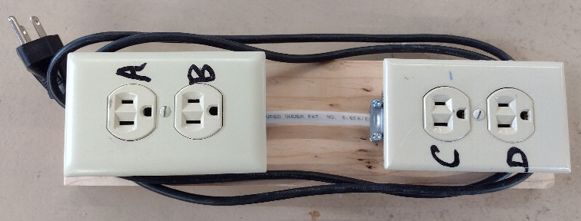
Outlet (DR) | Slot | Voltage Readings
A  Hot & Neutral Reversed | Neutral – Ground | 120
 | Neutral – Hot | 120
 | Hot - Ground | 0
B  Correct | Neutral – Ground | 0
 | Neutral – Hot | 120
 | Hot - Ground | 120
C  No grounding | Neutral – Ground | 0
 | Neutral – Hot | 120
 | Hot - Ground | 0
D  No Grounding | Neutral – Ground | 0
 | Neutral – Hot | 120
 | Hot - Ground | 0

- Is outlet #A wired correctly? Yes/No
- Is outlet #B wired correctly? Yes/No
- Is outlet #C wired correctly? Yes/No
- Is outlet #D wired correctly? Yes/No

Station #9 – Power Supply (Transformer)
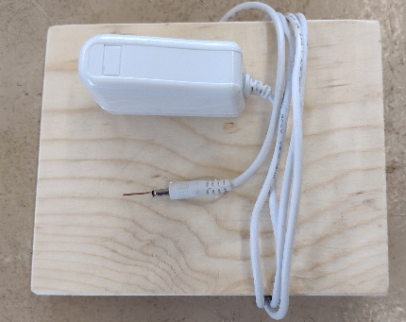
- Test the primary for resistance. Unplug first! The primary is the side with the plug. Is the primary good? Yes /No.
- Plug in the transformer and test for AC voltage. What is the voltage? ________0______
- Plug in the transformer and test for DC voltage. What is the voltage? ________5______

Station # 10 – Duplex Receptacle Tester
Outlet | Fault
A | Open Gnd
B | Open Gnd
C | Hot/Neutral Reversed
D | Correct

Station # 11 – Power Present
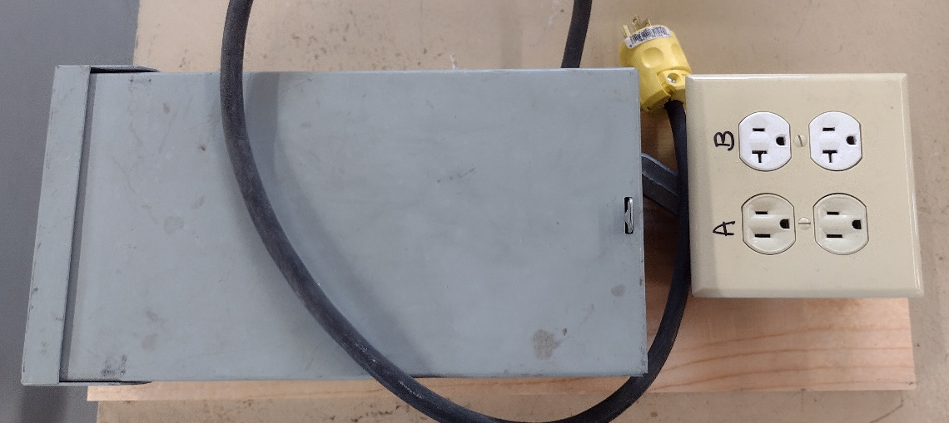Identify the two
Breaker | Outlet
15 A | A
20 A | B

Station # 12 – Current draw.
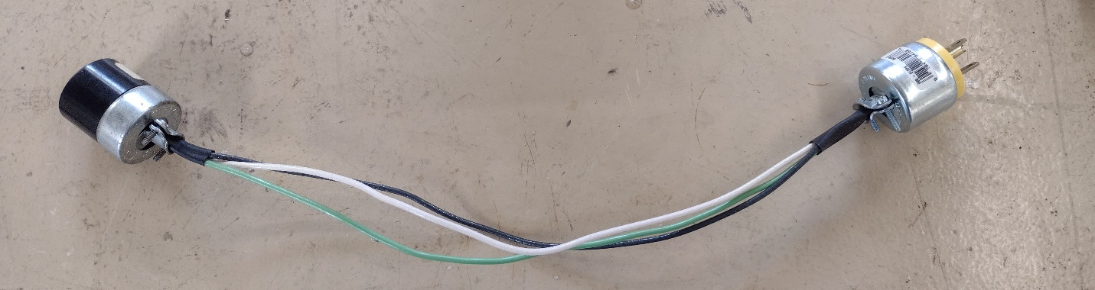
Start with the load off. What does each wire measure?
Wire | Current
Black | 0
White | 0
Bare or Green | 0
Now clamp the probe over the black wire and turn the load on. Observe the readings. With the load on measure the other two wires.
Wire | Current
Black | Depends on load
White | Depends on load
Bare or Green | 0
Can you explain the readings? No current when not on. Ground does not carry current. White/Black should be the same. If load is a motor then starting current is higher.

Station # 13 – Fuses
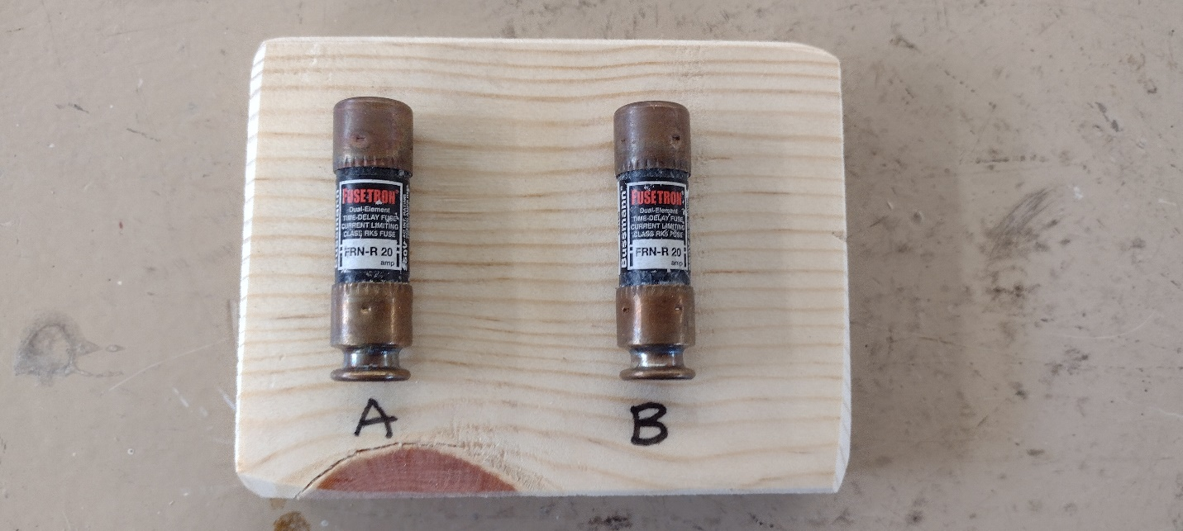
Fuse A is OK, Fuse B is blown.

Station #14 – Resistor
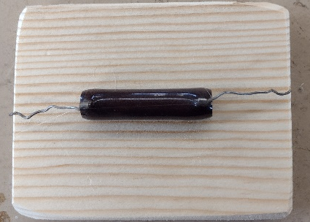
Resistance 220 Ohms.

