Non-Metallic Cable Wiring
Name ____________________

Tools and Supplies

Wiring Panel
Phillips and standard (flat) screwdrivers
Wire strippers
Cable ripper or utility knife
Diagonal cutter or lineman’s pliers

Duplex Receptacle (DR)
Lamp holder
Toggle switch
240V Receptacle
14/2 w/g NM Cable
12/2 w/g NM Cable
Wire nuts

Oregon Ag Mechanics CDE Project Panel
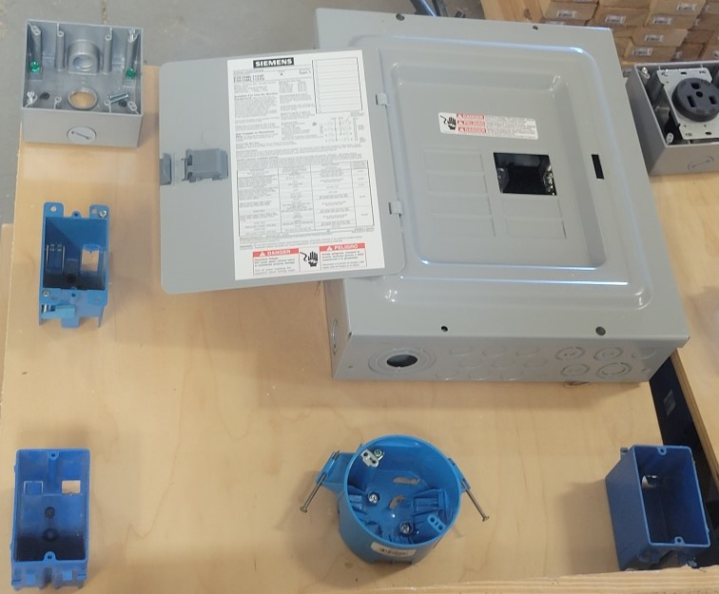
Wire the board as described below. See the diagram for box numbering. Choose the appropriate circuit breaker and wire size.
- Wire a 20A duplex receptacle in box A (sample of a kitchen circuit).
- Wire a lamp in box and a switch in box C. Power will be from box B. 15A circuit (a common lighting circuit)
- Wire a 20A 240V receptacle in Box D (sample of a stationary power tool.)

Panel

Box E

Box D

Box C

Box A

Box B
Board Diagram

Basic Rubric
A rubric for wiring projects will vary somewhat depending on the actual project but can be modeled from the example below. Each box is graded.
Criteria | Possible | Earned
Box
Grounding correct (grounds connected and device if need)
6” free conductor
Screw terminals correct (clockwise and ¾ turn, no overlap, no excess stripping)
Correct use of wire nuts (firm and no wire showing)
Wire and screw color coding correct
Panel
Correct wire size for each circuit
Wiring neat
Circuit(s) correct
Total

Create a rubric for circuit #2 above and use it to grade another teacher’s project.
Criteria | Possible | Earned
Box B
Box C
Panel
Correct wire size for each circuit
Wiring neat
Circuit(s) correct
Total

Other Wiring Scenarios
With NM cable wiring basic circuits can be varied simply by changing the source of power or the location of the device. Electrically the circuit may be the same but the physical wiring will change.
Some examples of other circuits are:
15 A circuits
- Wire a Duplex Receptacle (DR) in Box A on a 15A circuit.
- Wire a Lamp in Box B controlled by a switch in Box A. The power source will be in box A.
- Wire a Lamp in Box B controlled by a switch in Box C. The power source will be in box B.
- Wire a Lamp in Box B controlled by 3 way switches in Box A and Box C. The power source will be in Box B.
- Wire a lamp in Box B controlled by 3 way switches in Box C and Box D. The power source is Box C.
- Wire a lamp in box B controlled by a switch in box D. Wire DRs in box A and box C. Power enters in box A for this single circuit.
20 A Circuits
- Wire a DR in Box C on a separate circuit.
- Wire DR in Box C and Box D. The power source is Box C.
- Wire a 240v receptacle in Box C.

Simple NM Cable Wiring Board

