AG MECH SKILLS II NAME ___________________
SMAW
NOTES DATE ___________________

I. SMAW EQUIPMENT & SAFETY
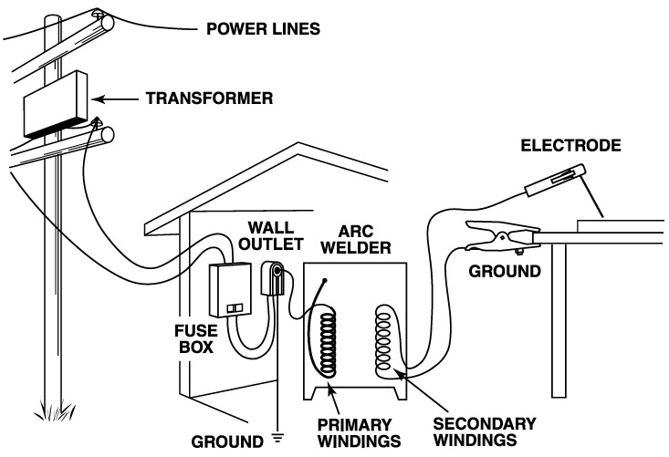
A. Introduction to SMAW
1. SMAW = Shielded Metal Arc Welding
- “Stick” Welding or “Manual” Welding
- Metal Rod Covered with Flux that Provides Shielding to Protect the Weld
- Uses Constant Current Power Sources
- Most Widely Used Arc Welding Process in the World

2. An arc welding machine joins two metals together by generating an electric arc between a coated metal electrode and a base metal. The heat of the electric arc melts the metal which mixes with the molten deposits of the coated electrode. The coating of the electrode produces a gas which shields the weld from the atmosphere and helps to maintain the weld shape. The slag coating over the weld insulates the hot weld from contaminants in the air during cooling.

B. Equipment Used in SMAW
1. Power Supply
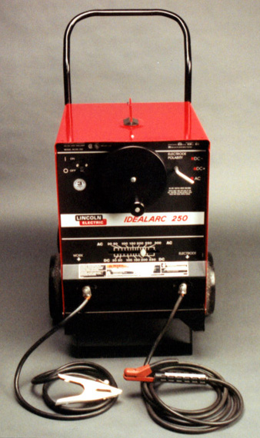
- Must maintain a constant current with only a slight change in voltage.
- Varying voltage and current will result in an uneven arc.
- Creates splatters and uneven welds.
- Three types of power supplies:
- Generator (Portable Welder)
- Produces low voltage, high amperage current (D/C)
- Expensive to purchase and operate
- Transformer (Buzz Box)
- Change high voltage, low amperage current (A/C), to low voltage, high amperage current (A/C)
- Cheapest to purchase and operate
- Rectifier
- Allows electricity to flow in one direction only (D/C)

2. Constant Current
- Welding Circuit Consists of Power Source, Electrode and Work Cables/Leads
- The Power Source Keeps the Current as Constant as Possible even when the Operator Varies the Arc Length
- Voltage is Proportional to Arc Length

3. Duty Cycle
a. The duty cycle of a power source is the percentage of a ten (10) minute period that it can operate at the rated output current setting.
Duty Cycle Amperes Time Available
30% 250 3 Min/10 Min
40% 225 4 Min/10 Min
50% 200 5 Min/10 Min
60% 190 6 Min/10 Min
70% 180 7 Min/10 Min
80% 170 8 Min/10 Min
90% 155 9 Min/10 Min
100% 140 10 Min/10 Min

5. Ground Clamp
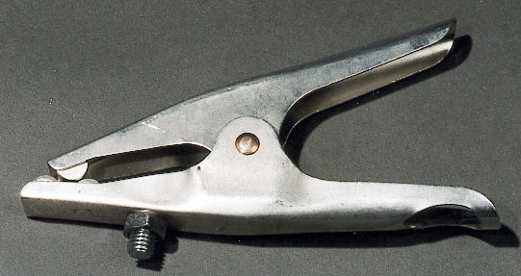
- Completes the full electrical circuit.
- Must be securely fastened to the base metal or to the bench (metal) you are working on.
- A bad connection will result in resistance build-up in the cables and connections.
- Resistance generates heat which can damage and/or melt parts.

6. Electrode Holder (Stinger)
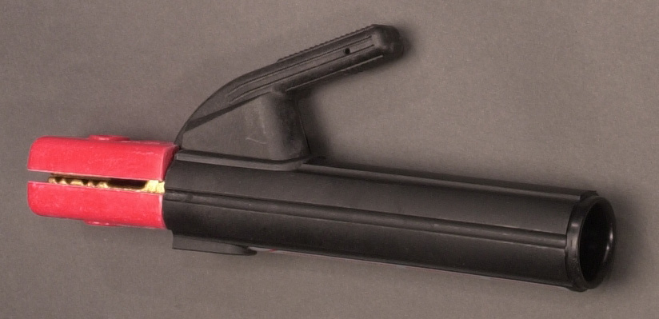
a. The stinger receives the amperage and directs it through the electrode to form the arc.
b. Should be well insulated & have a strong spring to hold the electrodes.

7. Cables
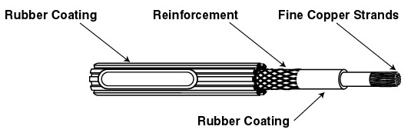
a. Allows the ground clamp and stinger to be mobile.
b. Should be well
insulated and protect from heat.

8. Electrode
a. Consists of a metal core coated with flux which shields the weld.
b. There are several types and sizes for different thicknesses and types of metal.
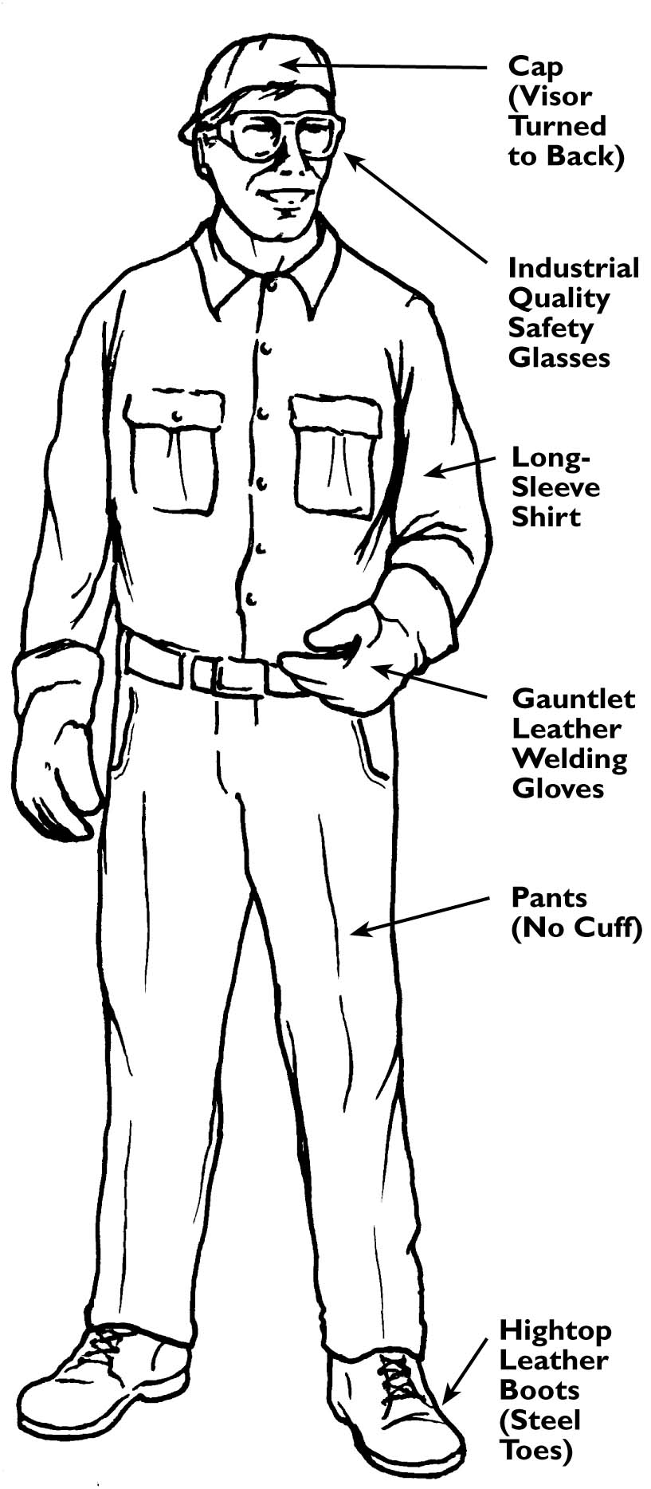

C. Safety
1. Protective Clothing
  - Must be worn at all times when welding. The heat created during arc welding creates flying molten sparks and ultraviolet and infrared rays that can burn the skin.

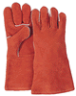
a. Leather Gloves
1) Gloves protect the hands from burns during welding.
2) Should be made of thick leather and have long cuffs to protect the wrist area from sparks and heat.
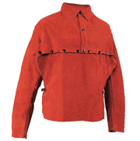
b. Sleeves
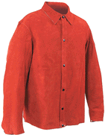
1) A nonflammable material must be worn on the arms to protect from burns, sparks, and ultraviolet light.
Leather Cape
Sleeves/Bib

c. Body Protection
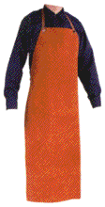
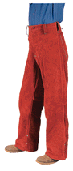
1) Leather clothing items are the best protection from heat and sparks. For light welding operations, coveralls work best but a work shirt will protect the body during arc welding.
2) Protective clothing should fit properly and be free of rips or other openings through which sparks can enter.
Leather Welding
Trousers
Leather Welding Apron
d. Footwear
1) Leather boots should be worn while welding

e. Eye Protection
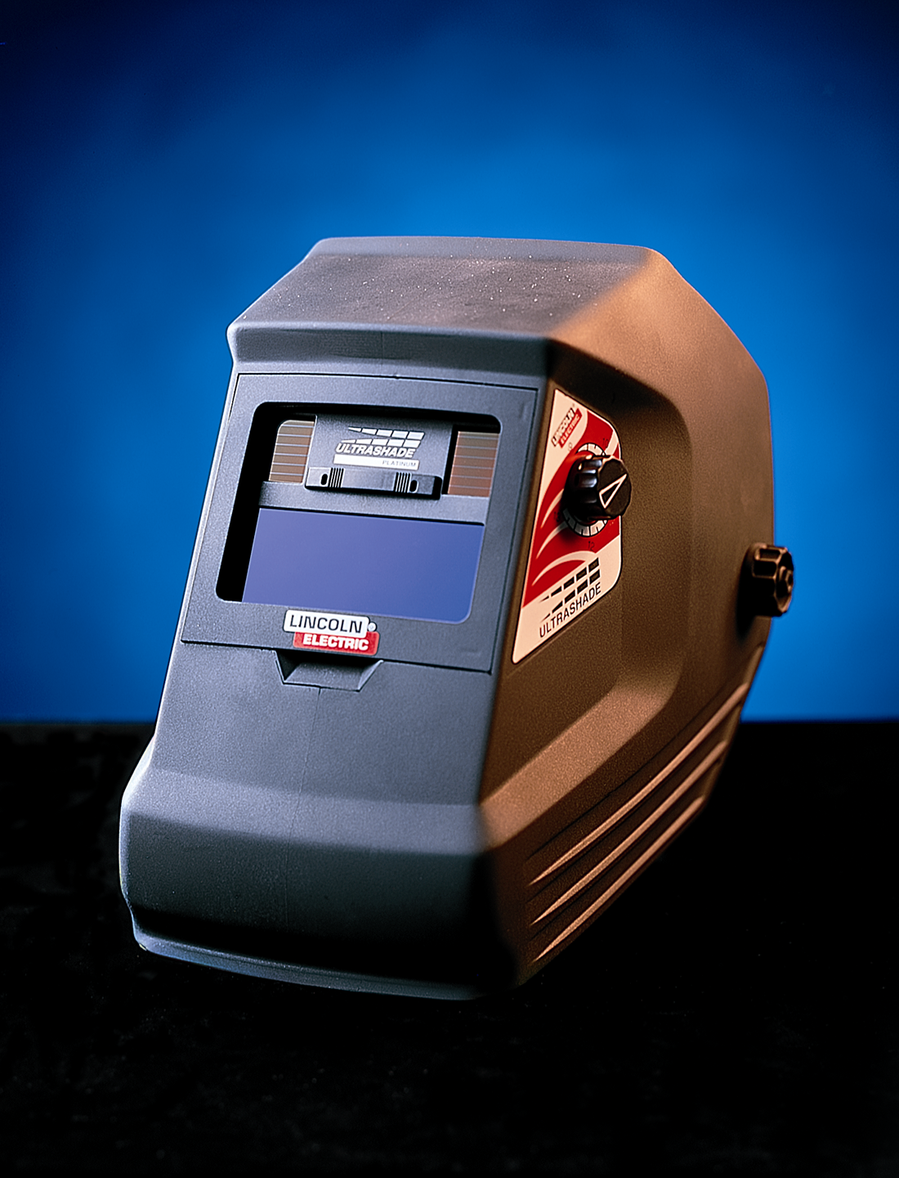
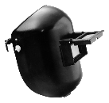
- The brilliant light given off by the electric arc produces invisible ultraviolet and infrared rays which can severely burn the eyes and skin. NEVER LOOK AT THE ARC WITH THE NAKED EYE!
Welding Helmets
f. Welding Helmet
1) Fits on the head using a plastic adjustable headband.
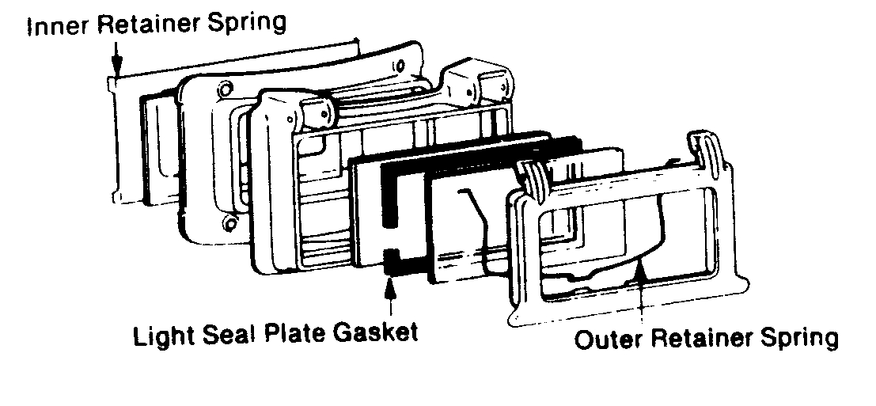
2) This leaves both hands free to weld and position materials.
3) Helmets have a clear cover lens to protect the filter lens and some have a clear lens underneath so the welder can chip slag.

g. Protective Lenses
Different types of welding use different amounts of voltage and current which determine the intensity of light and the amount of ultraviolet and infrared rays produced. Lens shades range from #5 (least protection) to #14 (most protection).
1) Shade 5 -Light spot welding
2) Shade 6&7 -Up to 30 amps
3) Shade 8 -30 - 70 amps
4) Shade 10 -75 - 200 amps
5) Shade 12 -200 - 400 amps
6) Shade 14 over 400 amps

h. Cover Lenses
Used to stop flying slag or metal which protects the filter lens.
1) Clear, unbreakable plastic is cheapest and lasts longest.

i. Care of Lenses
1) Must be changed if a crack or chip is found.
2) Periodic cleaning with soap and water is helpful.

2. Additional Welding Equipment
a. Tongs/Pliers
1) The heat of the arc will transmit to the metal being welded. Use pliers or tongs to grab or move hot metal.
b. Chipping Hammer
1) Used to remove slag from the weld
c. Steel Brush
1) Used to clean the weld if a second pass is going to be made.

C. Safety in Arc Welding
See Handout

