AG MECH NAME_______________

FUEL GASES DATE_______________

Oxy-fuel Gases
•Numerous gases are available for use in oxy-fuel operations.

•____________

•____________
•____________
•____________
•____________

Oxygen
•The presence of oxygen is _________to support any burning process.

•It is therefore necessary that oxygen be combined with a “_______” gas to produce the desired operating flame.

•Oxygen itself_____________________________.

•However, the presence of pure oxygen will _____________________ the speed and force with which burning takes place.

•Pure oxygen can turn a ______spark into a roaring flame.

•Is a __________________gas contained in the earth’s atmosphere

•When added to a fuel gas such as an acetylene flame, ______________________________________________________________________.

•Oxygen will _______________________in its natural state.

•Oxygen must NEVER be allowed to _________________
______________________________________________

•Oil and/or grease in the presence of oxygen becomes___________________________.

•Full oxygen cylinders are pressurized from _______pounds per square inch (PSI)

•Due to _____________under which oxygen is bottled and stored, cylinders must always be handled with great care.

Acetylene
•A colorless gas, with a ______________________smell.

•Is the __________________used fuel gas.

•Is _____________________when mixed with oxygen

•Produces one of the ______________________available – 5,600 degrees Fahrenheit.

•Used for________________________________________.

•Highly __________________________gas – burns rapidly.

•Acetylene gas is a combination of _______and ____________(C2H2).
•It is produced when _____________is submerged in water.

•The escaping gas from the acetylene generator is then trapped in a gas chamber to be compressed into cylinders or fed into piping systems.

•IMPORTANT- Acetylene is an “_______________” when compressed above_________.

•Therefore cannot be stored in a _____________under high pressure, for example the way oxygen is stored.

•Acetylene cylinders are filled with a _____________creating in effect a “solid” as opposed to a “hallow” cylinder.

•The porous filling is then saturated with liquid acetone.

•When acetylene is pumped into the cylinder it becomes dissolved in the liquid acetone throughout the porous filling and is held in a stable condition.

•Full acetylene cylinders are pressurized to about_________.

•Acetylene when combined with oxygen has a flame temperature of (5,589 degrees) or 5,600 degrees in the neutral flame.

•Acetylene makes a good ______________fuel gas - well suited for numerous applications like heating, welding, cutting, brazing and hardfacing.

MAPP Gas
•MAPP Gas is a _______fuel gas in the acetylene family.

•Its components ________________________________
_____________________________________________.

•It can be readily liquefied and shipped in standard L.P.G. containers at 60 PSI.

•Is a good fuel gas for heating and cutting. However, special _____________must be used to combat the oxidizing characteristics of the flame on the molten metal during the welding process.

•Has a neutral flame temperature of 5,300 Degrees Fahrenheit.

Natural Gas
•Is the most _________________of all the fuel gases.

•City natural gas supplies are generally available at pressures from____________________.

•Special “injector” type welding and cutting equipment is usually required when using natural gas consumption for a neutral flame.

•Has a neutral flame temperature of approximately 5,025 degrees Fahrenheit.

•It is most commonly used for heating and cutting applications.

Propane Gas
•Propane is an abundant and ________________fuel.

•When compressed, liquefied and confined, it can develop a vapor pressure of _________________I.

•Is normally sold in liquid state.

•Propane cylinders range from 20-lb. to 100-lb.

•The neutral flame temperature is approximately 5,200 Degrees Fahrenheit.

•Propane is most commonly used for cutting and heating applications.

Oxygen Cylinders
•Oxygen Cylinders are made ______________________
_____________________________________________

•They provide strong, durable containers with no _______
_________________________________________

•The thickness of the cylinder wall is _____________

•When fully charged, a standard cylinder holds about ______ cu/ft. of oxygen at a pressure of_______. at _____ degrees

Acetylene Cylinders
•Low-temperature melting ____________at the top and bottom of the cylinder allow gas to escape if temperatures exceed ________degrees.

•Escaping gas may cause a______, but no ___________will occur.

•A typical acetylene cylinder contains about ____cu./ft. of gas at a pressure of ____ psi.

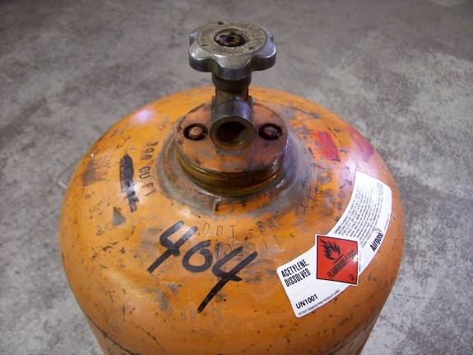

Cylinder Care
•Handle, store, and use cylinders _____________________

•______________ each cylinder to a wall, cart or sturdy table.

•Replace ___________________after each use to protect the valves.

•Use hand pressure to ___________________________
_________________________________

•Never ______________________________________
____________________________________________.

•Store oxygen and acetylene cylinders separately, at least _________from each other.

•Do not store cylinders in areas with _______temperatures as internal pressure could rise to a dangerous level.

•Store full cylinders ____________empty cylinders.

•When in use, ___________________________________
________________________________________________________________________________________________.

•When in use, open the acetylene cylinder ________________________________________________________________________________________________________________________________________________

