AG MECH NAME_______________

FUEL GASES DATE_______________

Oxy-fuel Gases
•Numerous gases are available for use in oxy-fuel operations.

•Oxygen

•Acetylene
•MAPP
•Natural Gas
•Propane

Oxygen
•The presence of oxygen is required to support any burning process.

•It is therefore necessary that oxygen be combined with a “fuel” gas to produce the desired operating flame.

•Oxygen itself is not flammable or harmful.

•However, the presence of pure oxygen will drastically increase the speed and force with which burning takes place.

•Pure oxygen can turn a small spark into a roaring flame.

•Is a colorless, odorless gas contained in the earth’s atmosphere

•When added to a fuel gas such as an acetylene flame, the flame increases in temperature and combustion rate is more rapid.

•Oxygen will not combust or burn in its natural state.

•Oxygen must NEVER be allowed to contact oil, grease or other petroleum-based substances.

•Oil and/or grease in the presence of oxygen becomes HIGHLY EXPLOSIVE.

•Full oxygen cylinders are pressurized from 2000 to 2600 pounds per square inch (PSI)

•Due to high pressure under which oxygen is bottled and stored, cylinders must always be handled with great care.

Acetylene
•A colorless gas, with a strong garlic-like-putrid smell.

•Is the most frequently used fuel gas.

•Is highly combustible when mixed with oxygen

•Produces one of the highest flame temperatures available – 5,600 degrees Fahrenheit.

•Used for welding, cutting, brazing, heating, and hard facing.

•Highly combustible and flammable gas – burns rapidly.

•Acetylene gas is a combination of carbon and hydrogen (C2H2).
•It is produced when calcium carbide is submerged in water.

•The escaping gas from the acetylene generator is then trapped in a gas chamber to be compressed into cylinders or fed into piping systems.

•IMPORTANT- Acetylene is an “unstable gas” when compressed above 15 PSI.

•Therefore cannot be stored in a hollow cylinder under high pressure, for example the way oxygen is stored.

•Acetylene cylinders are filled with a porous material creating in effect a “solid” as opposed to a “hallow” cylinder.

•The porous filling is then saturated with liquid acetone.

•When acetylene is pumped into the cylinder it becomes dissolved in the liquid acetone throughout the porous filling and is held in a stable condition.

•Full acetylene cylinders are pressurized to about 250 PSI.

•Acetylene when combined with oxygen has a flame temperature of (5,589 degrees) or 5,600 degrees in the neutral flame.

•Acetylene makes a good general purpose fuel gas - well suited for numerous applications like heating, welding, cutting, brazing and hardfacing.

MAPP Gas
•MAPP Gas is a new fuel gas in the acetylene family.

•Its components are methylacetylene, propadiene, propylene and other related compounds.

•It can be readily liquefied and shipped in standard L.P.G. containers at 60 PSI.

•Is a good fuel gas for heating and cutting. However, special welding rod must be used to combat the oxidizing characteristics of the flame on the molten metal during the welding process.

•Has a neutral flame temperature of 5,300 Degrees Fahrenheit.

Natural Gas
•Is the most abundant of all the fuel gases.

•City natural gas supplies are generally available at pressures from 5 oz. to 30 PSI.

•Special “injector” type welding and cutting equipment is usually required when using natural gas consumption for a neutral flame.

•Has a neutral flame temperature of approximately 5,025 degrees Fahrenheit.

•It is most commonly used for heating and cutting applications.

Propane Gas
•Propane is an abundant and versatile fuel.

•When compressed, liquefied and confined, it can develop a vapor pressure of 200 PSI.

•Is normally sold in liquid state.

•Propane cylinders range from 20-lb. to 100-lb.

•The neutral flame temperature is approximately 5,200 Degrees Fahrenheit.

•Propane is most commonly used for cutting and heating applications.

Oxygen Cylinders
•Oxygen Cylinders are made from seamless drawn steel and shaped by dies into tanks.

•They provide strong, durable containers with no joints or welded seams

•The thickness of the cylinder wall is at least ¼”

•When fully charged, a standard cylinder holds about 244 cu/ft. of oxygen at a pressure of 2200 psi. at 70 degrees

Acetylene Cylinders
•Low-temperature melting fuse plugs at the top and bottom of the cylinder allow gas to escape if temperatures exceed 212 degrees.

•Escaping gas may cause a fire, but no explosion will occur.

•A typical acetylene cylinder contains about 280 cu./ft. of gas at a pressure of 250 psi.
Fuse Plugs

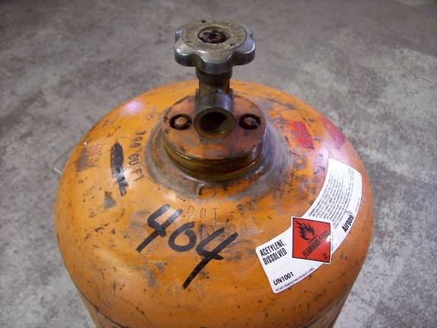

Cylinder Care
•Handle, store, and use cylinders in an upright position.

•Secure (chain) each cylinder to a wall, cart or sturdy table.

•Replace cylinder safety caps after each use to protect the valves.

•Use hand pressure to open oxygen cylinder valves – Never use a wrench!

•Never roll cylinders horizontally or use them as rollers to move a load.

•Store oxygen and acetylene cylinders separately, at least 20 ft. from each other.

•Do not store cylinders in areas with hot temperatures as internal pressure could rise to a dangerous level.

•Store full cylinders away from empty cylinders.

•When in use, fully open the oxygen cylinder valve so oxygen cannot leak around the valve stem.

•When in use, open the acetylene cylinder valve no more than one full turn – so it can be quickly shut off in an emergency.

