AG MECH NAME_______________

RUNNING A BEAD WITH AND DATE_______________
WITHOUT FILLER ROD

The Welding Flame
•A chief advantage of the oxy-acetylene flame is _________
______________________.

•This oxy-acetylene flame can easily __________________ metals.

•The proper mixture of oxygen and acetylene burns at 5,589 degrees Fahrenheit, which makes it ____________ oxy-fuel gas flame.

Types of Flames
•________ types of flames can be produced with the oxy-acetylene torch: _____________, ___________, and _____________.

•The operator must be able to recognize each type of flame by its ___________, ___________, and ___________.

•The operator must also master the adjustment of the _____________________________ on the welding torch to produce the desired flame.

Carburizing Flame
•Flame contains more ____________ than _____________.

•This flame is easy to recognize by the __________, which has a __________ taper with an _____________.

•Inside this outer flame is a ___________, _________ called the ____________ feather.

•Flame has a ____________temperature than the neutral flame.

•Flames are sometimes used for silver brazing, braze welding, and soldering.

Neutral Flame
•The neutral flame is produced by a ______________ of _________and _____________.

•It is approximately 5,589 degrees Fahrenheit and is the ____________________ of the three types of flames.

•As the flame is adjusted from a ____________flame to neutral flame by adding more __________, the___________ acetylene feather ________________.

•At the same time, the brilliant inner cone becomes slightly ____________ and more __________________.

•When a _______________ is directed upon a steel surface, the metal melts _____________.

•The molten metal does not _______and _______ sparks appear.

•The neutral flame ___________the molten steel from _____________, and the weld joint is _______________.

•__________________ welds are produced from this flame.

Oxidizing Flame
•Flame contains more __________ than _____________.

•Is similar to the shape of the _______________, however the _____________ of the oxidizing flame is more _________, ___________, and ______________.

•The flame can also be distinguished from the neutral flame by a loud _________________ caused by the excess rush of oxygen.

•This flame has ______________________ use in welding.

•Its temperature may reach 6,300 degrees Fahrenheit, but the ___________ that form when the excess oxygen combines with the molten metal cause ____________ with the weld.

•Such problems include ____________, ___________, and ___________ around the weld.

Characteristics of the Three Flames
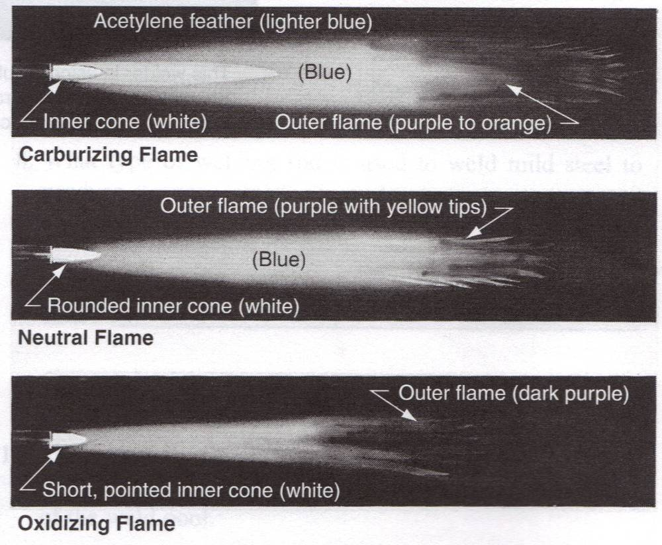

Holding the Torch
•A torch may be held in either ______________ ways, depending on which is the more comfortable for you.

•When welding _____________ metal (under 14 gauge), most operators prefer to grasp the handle of the torch with the hose over the outside of the wrist, in the same manner a ____________ordinarily is held.

•In the other grip, the torch is held like a __________, with the fingers lightly curled underneath.

•In either case the torch should _________________ in the hand to avoid fatigue.

____________ _____________
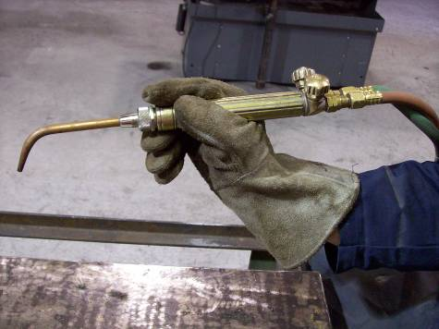
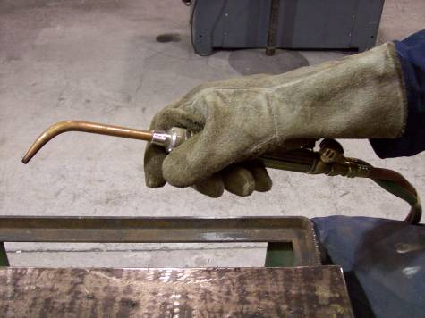

Pushing a Puddle
•Hold the torch so the ___________ points in the direction ________________ and at an angle of about ___________ with the completed part of the weld.

•If you are __________ handed, start the weld at the ______ ___________of the metal and bring the inner cone of the _____________ to within ______ of the surface of the plate.

•The left-handed person reverses this direction.

•Hold the torch _______ until a _______of molten metal forms.

•Then ____________ the puddle across the plate.

•As the puddle travels forward, _________ the torch to form a series of _____________________________________.

•Do not move the torch ________ of the puddle, but ________________forward, giving the heat a chance to ____________________.

•If the flame is moved forward too _________, the heat fails to __________________ and the metal does not _____________________.

•If the torch is ____________________________, the flame will burn a hole through the metal.

Laying a Bead with Filler Rod

•On some types of joints (__________________) it is possible to weld the two pieces of metal without adding metal from a filler rod.

•
The use of a filler rod requires _____________________ _______________.

•One hand must ________________________ to carry a puddle across the plate, while the ____________________ _______________________________________________.

•In most instances the use of a filler rod is advisable because _____________________________________ ______________.

•The strength of a weld depends ____________________ _______________________________________________ _______________________________________________.

Selecting the Filler Rod

•Filler rods come in ______________ ranging from ______ to ____________ in diameter.

•The __________ of rod to use will _________________ upon the ____________________________ being welded.

•The general rule is to use __________________________ ________________________________________________.

•In other words, if a _______ metal is being welded, a _____ diameter rod should be used.

Laying a Bead with Filler Rod Continued
•The __________ is held at an angle of approximately ________________ to the base metal, hold the ________at approximately the same angle as the torch but ________________ from the torch.

•___________ the torch tip over the _______________ and rotate the flame near the metal in a ____________________ motion until the base metal melts into a ________________.

•Once a small pool of the ______________ is established, _______________________________________________.

•ALWAYS _______________________________________ ____________________________.

•The molten puddle will ___________ and ______________, as the rod melts in the pool, advance the torch forward.

•Concentrate the flame on the ____________ and not on __________________.

•Do not ___________________________. If you do this the molten metal will fall through the air to the puddle.

•When this happens it combines with the ________ in the air and part of it burns up, causing _____________________.

Common Difficulties
•The beginner often experiences difficulty in holding the welding rod _____________ which can cause the rod to ______________________________.

•Instead of ___________________________________ where the heat is sufficient to melt it readily, a beginner generally _________________________________ where the temperature is __________. The heat at the edge is not enough to melt the rod and the rod ___________________ base metal.

•If the rod sticks to the base metal, ____________________.

•Simply place the flame _____________ the tip of the rod and the rod ____________________________.

Laying a Bead with Filler Rod Continued
•The __________________ motion should be advanced approximately _______________ until the end of the joint is reached.

•Since the angle of the tip flame is preheating the metals ahead of the weld, ______________________________.

•Slightly raise the welding tip and increase the addition of ____________ to insure a _____________________.

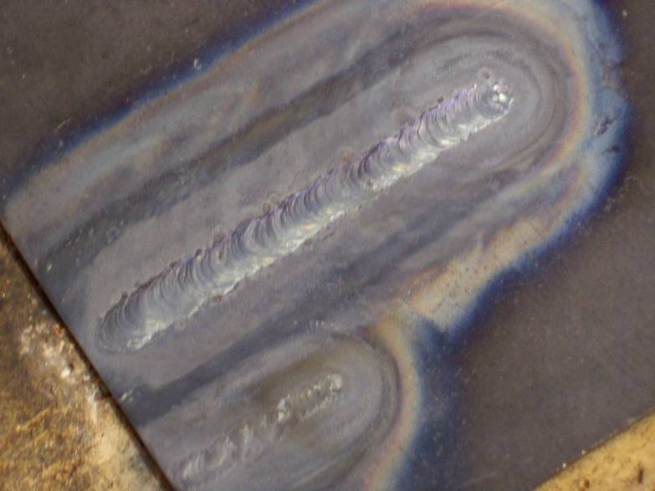
Bead Filler Rod

Bead Filler Rod

