AG MECH OXY-FUEL NAME_______________

EQUIPMENT SAFETY DATE_______________

Identification

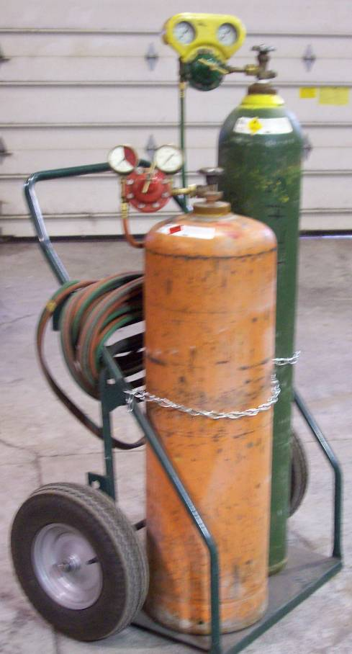

Securing the Cylinder
•________________________ cylinders to a cylinder cart, wall or stable work bench.

•Always keep cylinders secured properly in a ____________________ position.

•Do not drop, strike, or apply heat to ________________ of the cylinder or valve.

Cylinder Protective Cap
•________________ keep the protective safety caps in place whenever cylinders are moved or are in storage ______________________.

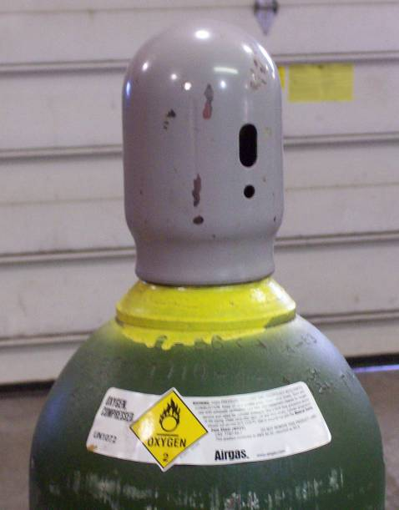
•The cylinder cap has _____ holes on its sides:

Larger Oval Shaped Hole _______________________________ _______________________________ ____________________________.

Smaller Circular Hole _______________________________ _______________________________ _______________________________ ________________________.

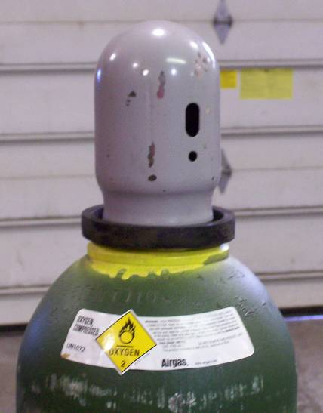
Empty Cylinders
•Mark empty cylinders “EMPTY” or ____________________ ________________________________________.

•Always ____________cylinder valves completely on empty cylinders.

Cracking the Cylinder Valve
•DO NOT ___________________________________. Stand behind the cylinder valve while cracking and be aware of others in the shop, aiming in a safe direction.

•Momentarily open and close the cylinder valve “_____________” - this will blow out any dust, dirt, or debris within the cylinder valve and prevent it from entering the regulator and seats.

•____________________________ If the valve is opened too much the cylinder could tip over from the pressure.

•If Acetylene cylinders spray a mist when cracked, let sit for ________________ allowing acetone to settle.

Inspecting the Cylinder Valve and Regulator
•Make sure the _____________________________ on the cylinder valve are not damaged.

•A damaged screw thread ___________________________________________
____________________________________________________________.

•Carefully inspect the cylinder valves and regulator threads for traces of grease and oil. *________________________________________________________.

Attaching the Regulator
•Connect the ___________ regulator to the ________________cylinder and the _______________ regulator to the ___________________ cylinder.

•_____________________________________________________________.

•Oxygen cylinder valves have _______________ fittings and the oxygen regulator have _________________ fittings.

•_____________________________________________________________.

•Acetylene cylinder valves have ____________ fittings and the Acetylene regulator have ________________ fittings.

•Tighten regulators with a close-fitted wrench (open-end wrench). ___________ ________________________________________________________________.

•Do not over tighten regulators to cylinders. Fittings are made of ___________ a soft metal and ________________________ will likely occur.

•Make sure the regulator has the correct pressure rating for the cylinder being used.

Turning on the Cylinder Valve
•Never __________________________________________________________. Always stand to the side of the cylinder leaving the cylinder between you and the regulator.

•Be certain that the tension on the regulator adjusting screw is released. ____________________________________________ until tension is removed.

•Standing to the side of the cylinder, ___________ open the oxygen cylinder valve until the maximum pressure registers on the high pressure gauge. Then open the oxygen cylinder valve __________________ to seal the valve packing.

•In the same manner, _______________ the acetylene cylinder valve. But only open the Acetylene valve ____________. Allowing the operator to quickly turn off the fuel in case of _____________________.

Adjusting the Oxygen Regulator
Never Exceed ______________ on the working Gauge.

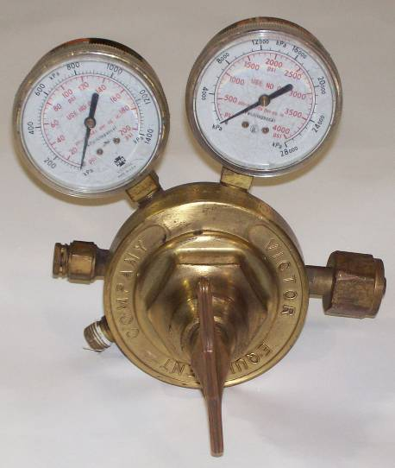

_________________________________________.

Adjusting the Acetylene Regulator
Never Exceed ___________ on the Working Gauge

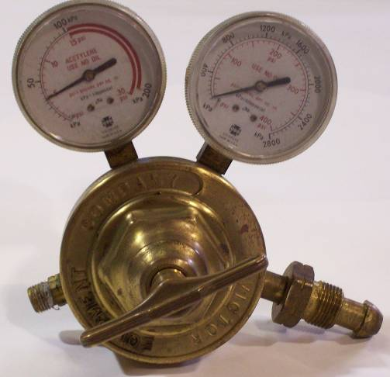
________________________________

__________________________________

___________________________________

____________________________________

Oxy-Fuel Hoses
•______________Hoses- Are ______________in color, have right-handed threads with no markings on the connecting nuts.

•_____________ Hoses- Are ____________ in color, have left handed threads, with notched markings on the connecting nuts.

•New hoses should have the preservative talcum powder blown out before the welding or cutting torch is used.

•Hoses are flame retardant, but should still be kept away __________________ _______________________________________________________________.

Check Valves
•Are installed to ___________________________________ that would result in a combustible mixture in the welding hose, check valves are mounted to the welding torch handle and at the regulator outlet connection.

•Check valves are necessary safety devices attached between ______________ __________________________________________________.

Torch Handle
•The torch handle is probably the most __________ used item in a welding shop.

•______________________________________ are all connected to the torch handle.

•_____________________________________________________________ ______________________________________________________________.

•________________connection is usually marked “OXY”

•_______________ connection is usually marked “FUEL”

Torch Handle Identification
__________________
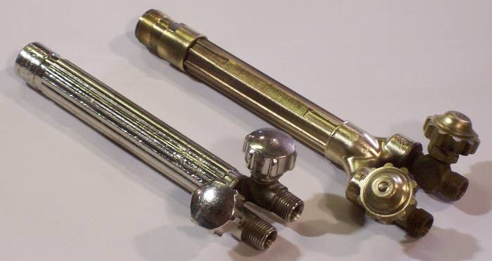
____________________
_______________

________________________

_________________________

Welding Nozzle
•Inspect the _________________________________________ for damage, oil or grease.

•Connect the welding nozzle to the ____________________. Tighten the coupling nut _____________ only. ______________________ may damage o-rings and create a faulty seal allowing leaks.

•Note- There must always be ________ o-rings on the cone end of the nozzle. The absence or damage of either of these o-rings allows __________________ of oxygen and acetylene.

Heating Nozzle
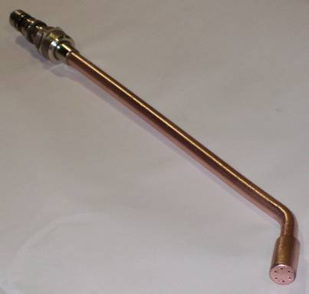

Cutting Head Attachment

_____________ _______________ _______________

VICTOR
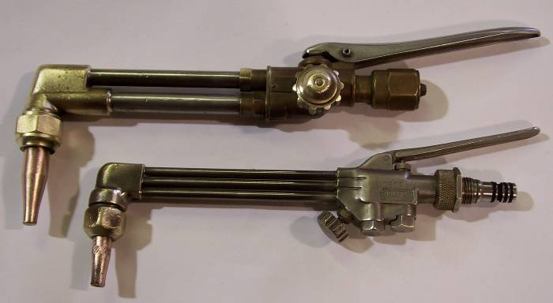

__________________ __________________

SMITH

________________ ____________________________
_______________
__________________
______________

Cutting Tip

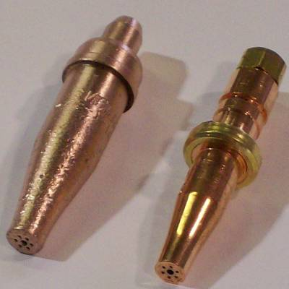
____________________
The mixture of Oxygen and Acetylene Gases (6 surrounding holes)

_____________________________
Pure Oxygen (center hole)

Oxygen Regulator
Oxygen Regulator Cylinder Pressure Gauge
Located _____________________________________________________

Oxygen Regulator Working Gauge
Located _____________________________________________________
*NEVER __________________

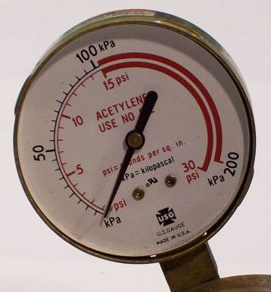
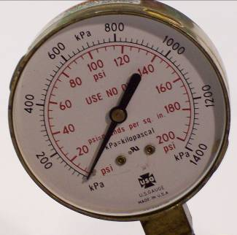

Acetylene Regulator
Acetylene Regulator Cylinder Pressure Gauge
Located on the _______________________________

Acetylene Regulator Working Gauge
Located on the ________________________________
*NEVER ______________

Protective Wear





