AG MECH OXY-FUEL NAME_______________

LIGHTING THE AND DATE_______________
SHUTTING OFF THE TORCH

Lighting the Torch
Torch _____________are located on the___________.

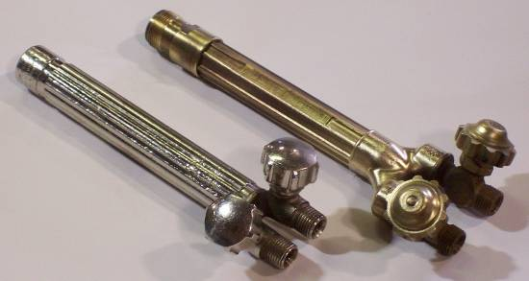

_____________________ are located on the top of each cylinder.

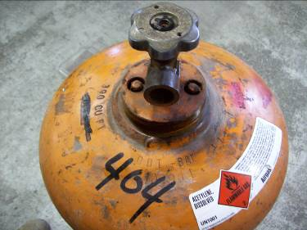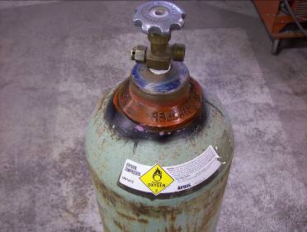

•Regulator ______________are located on the front of each regulator.
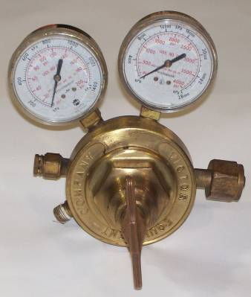
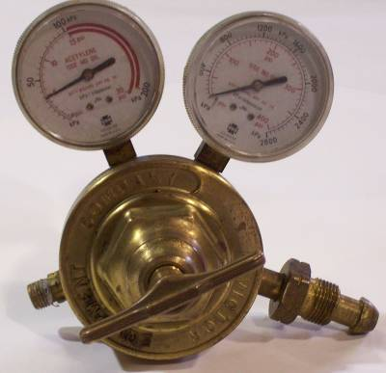

•Knowing the names and locations of these valves and adjusting mechanisms is _______________________________________________________________.

Lighting the Torch
Step 1
•Check that the _________and _________torch valves are closed by turning them in a ________________direction.

Step 2
•Check that the oxygen and acetylene regulator adjusting screws are turned counterclockwise and _____________.

•Do not turn the adjustment screws ________, or they will come off.

Step 3
•Warning do not stand ________________________ when opening the cylinder valve. The high pressure gas could burst the regulator and cause injury.

•__________ open the acetylene cylinder valve, no more than ___________, so you can quickly shut off the gas in an emergency.

Step 4
•__________open the oxygen cylinder valve ____________, ___________________so oxygen cannot leak around the valve stem.

Step 5
•Set the correct ________________ on the acetylene regulator gauge.

•Do this by ________________________________ ________________________________________ is reached.

•Close the _______________________________.

Step 6
•Repeat Step 5 to set the oxygen working pressure.

Step 7
•
Open the acetylene torch valve ______________ turn.

Step 8
•Using a __________________________, light the acetylene gas.

•Always use a ________________________. Never use _____________________. Your hand could be severely injured when the gas fumes are ignited.

•Adjust the flame until it burns ___________ approximately _______ from the torch tip. Then adjust the flame so no ______________ is released.

Step 9
•Slowly open the ___________________ valve.

•Adjust the oxygen until a __________ cone appears at the torch tip.

•This is a ____________________.

•Minor adjustments in the _____________ and ________________________ may be necessary to obtain a neutral flame.

Shutting Off the Torch
•Whenever the welding torch is not in your hand, it should be _______________________.

•If you are leaving the ______________ or are finished for _____________, completely ____________ the equipment by following these steps:

Step 1
•Close the ________________ on the ____________ to _______________the flame.

•Then, close the _________________ so gas is not being released from the torch tip.

Step 2
Close both the acetylene and oxygen _________________.

Step 3
Open both _____________ on the torch body to release any gas still in the lines (_____________________).

Step 4
•___________ the acetylene and oxygen ______________ until you see that the high and low pressure gauges on both regulators read __________________.

Step 5
•Turn the ____________________ on both regulators _____________________ until they turn freely with no tension.

Step 6
•Once the gauges read __________, the _______________ are loose, and the ____________________, roll up the hoses, and put the torch away.

