Birdhouse
Name: _________________
Date: _________________

Description:
Students will build a traditional cedar birdhouse using a layout, wood, hammer, glue, and wood dowel. Agriculture mechanic shop tools such as a miter saw, table saw, drill press, measuring tape, and combination square will be used by students to construct pieces of the birdhouse.

Materials:
1”x6” x 5”x0” Long Cedar Fence Board
4d (1-1/2”) Galvanized box nails
Waterproof Wood Glue
4”-3/8” Diameter Wood Dowel
Sandpaper (120 grit)

Tools:
Table Saw
Power Miter Saw
Claw Hammer
Pencil
Drill Press
Measuring Tape
Combination Square
3/8” Diameter Drill Bit
1 ½” Diameter Drill Bit (Forstner or spade)

Procedure:
- Measure two side panels (5 ½” by 6”) as shown in the plan. Cut out the side panels using a miter saw.
- Measure the front panel (5 ½” by 8 3/4”) and mark cuttings. Cut front wall panel (5 ½” by 8 3/4”) with miter saw. Then measure up 6” and mark. Use a combination square to accurately draw out the 45-degree angle at the top of the panel. Cut the 45-degree angles using the miter saw.
- Measure the center of the holes on front panel with combination square. Large hole is 4 1/2” up and 2 ¾” over. Small dowel hole is 2” up and 2 ¾” over. Then cut out the holes using the correct size bit and the drill press. The large hole needs a 1-1/2” diameter bit and the small hole needs a 3/8” diameter bit for the front panel.
- Measure and cut (1) back wall panel by using the front panel as a template for back panel, to ensure both panels are identical. Do NOT drill holes into the back panel.
- Assemble (2) sides, front, and back panels as shown in figure 4 on worksheet. Glue and nail (3 nails per joint) each joint. We used galvanized nails to prevent them from rusting in the future.
- Measure and cut (1) bottom panel by placing assembled walls on top of oversized, future bottom panel, board as show in in the diagram. Mark (2) edges to be cut from inside of birdhouse as shown in figure 5 on worksheet. (Approximately 4 3/8” by 5 1/2”). Install bottom panel inside assembled walls with glue and nails.
- Measure and cut (1) right roof panel and (1) left roof panel on the miter saw. One panel with be 5 ½” by 9”, while the other will need to be ripped to be 4 3/8” by 9”. Use the table saw to rip the roof panel.
- Install roof panels on house walls. Glue and nail (2 nails per end and 3 nails along ridge) roof panels.
- Cut a 4” long piece of 3/8” diameter wood dowel using the miter saw. Glue and insert dowel into 3/8” diameter hole previously cut out into front panel of birdhouse.

Cutting List:
Quantity | Size | Material | Description
2 | 5 ½” x 8 ¾” | Cedar Fence Board | End
2 | 5 ½” x 6” | Cedar Fence Board | Wall
1 | 4 3/8”x 5 ½” | Cedar Fence Board | Bottom
1 | 4 ½” x 9 | Cedar Fence Board | Roof
1 | 5 ½” x 9” | Cedar Fence Board | Roof
1 | 4” | 3/8” Wood Dowel | Perch

Notes:__________________________________________________________________________________________________________________________________________________________________________________________ ________________________________________________________________________________________________________________________________________________________________________________________________________________________________________________________________________________________________________________________________________________________________________________________________________________________________________________________________________________________________________________________________________________________________________________________________________________________________________________________________________________________________________________________________________________________________________________________________________

Photo/Drawing:
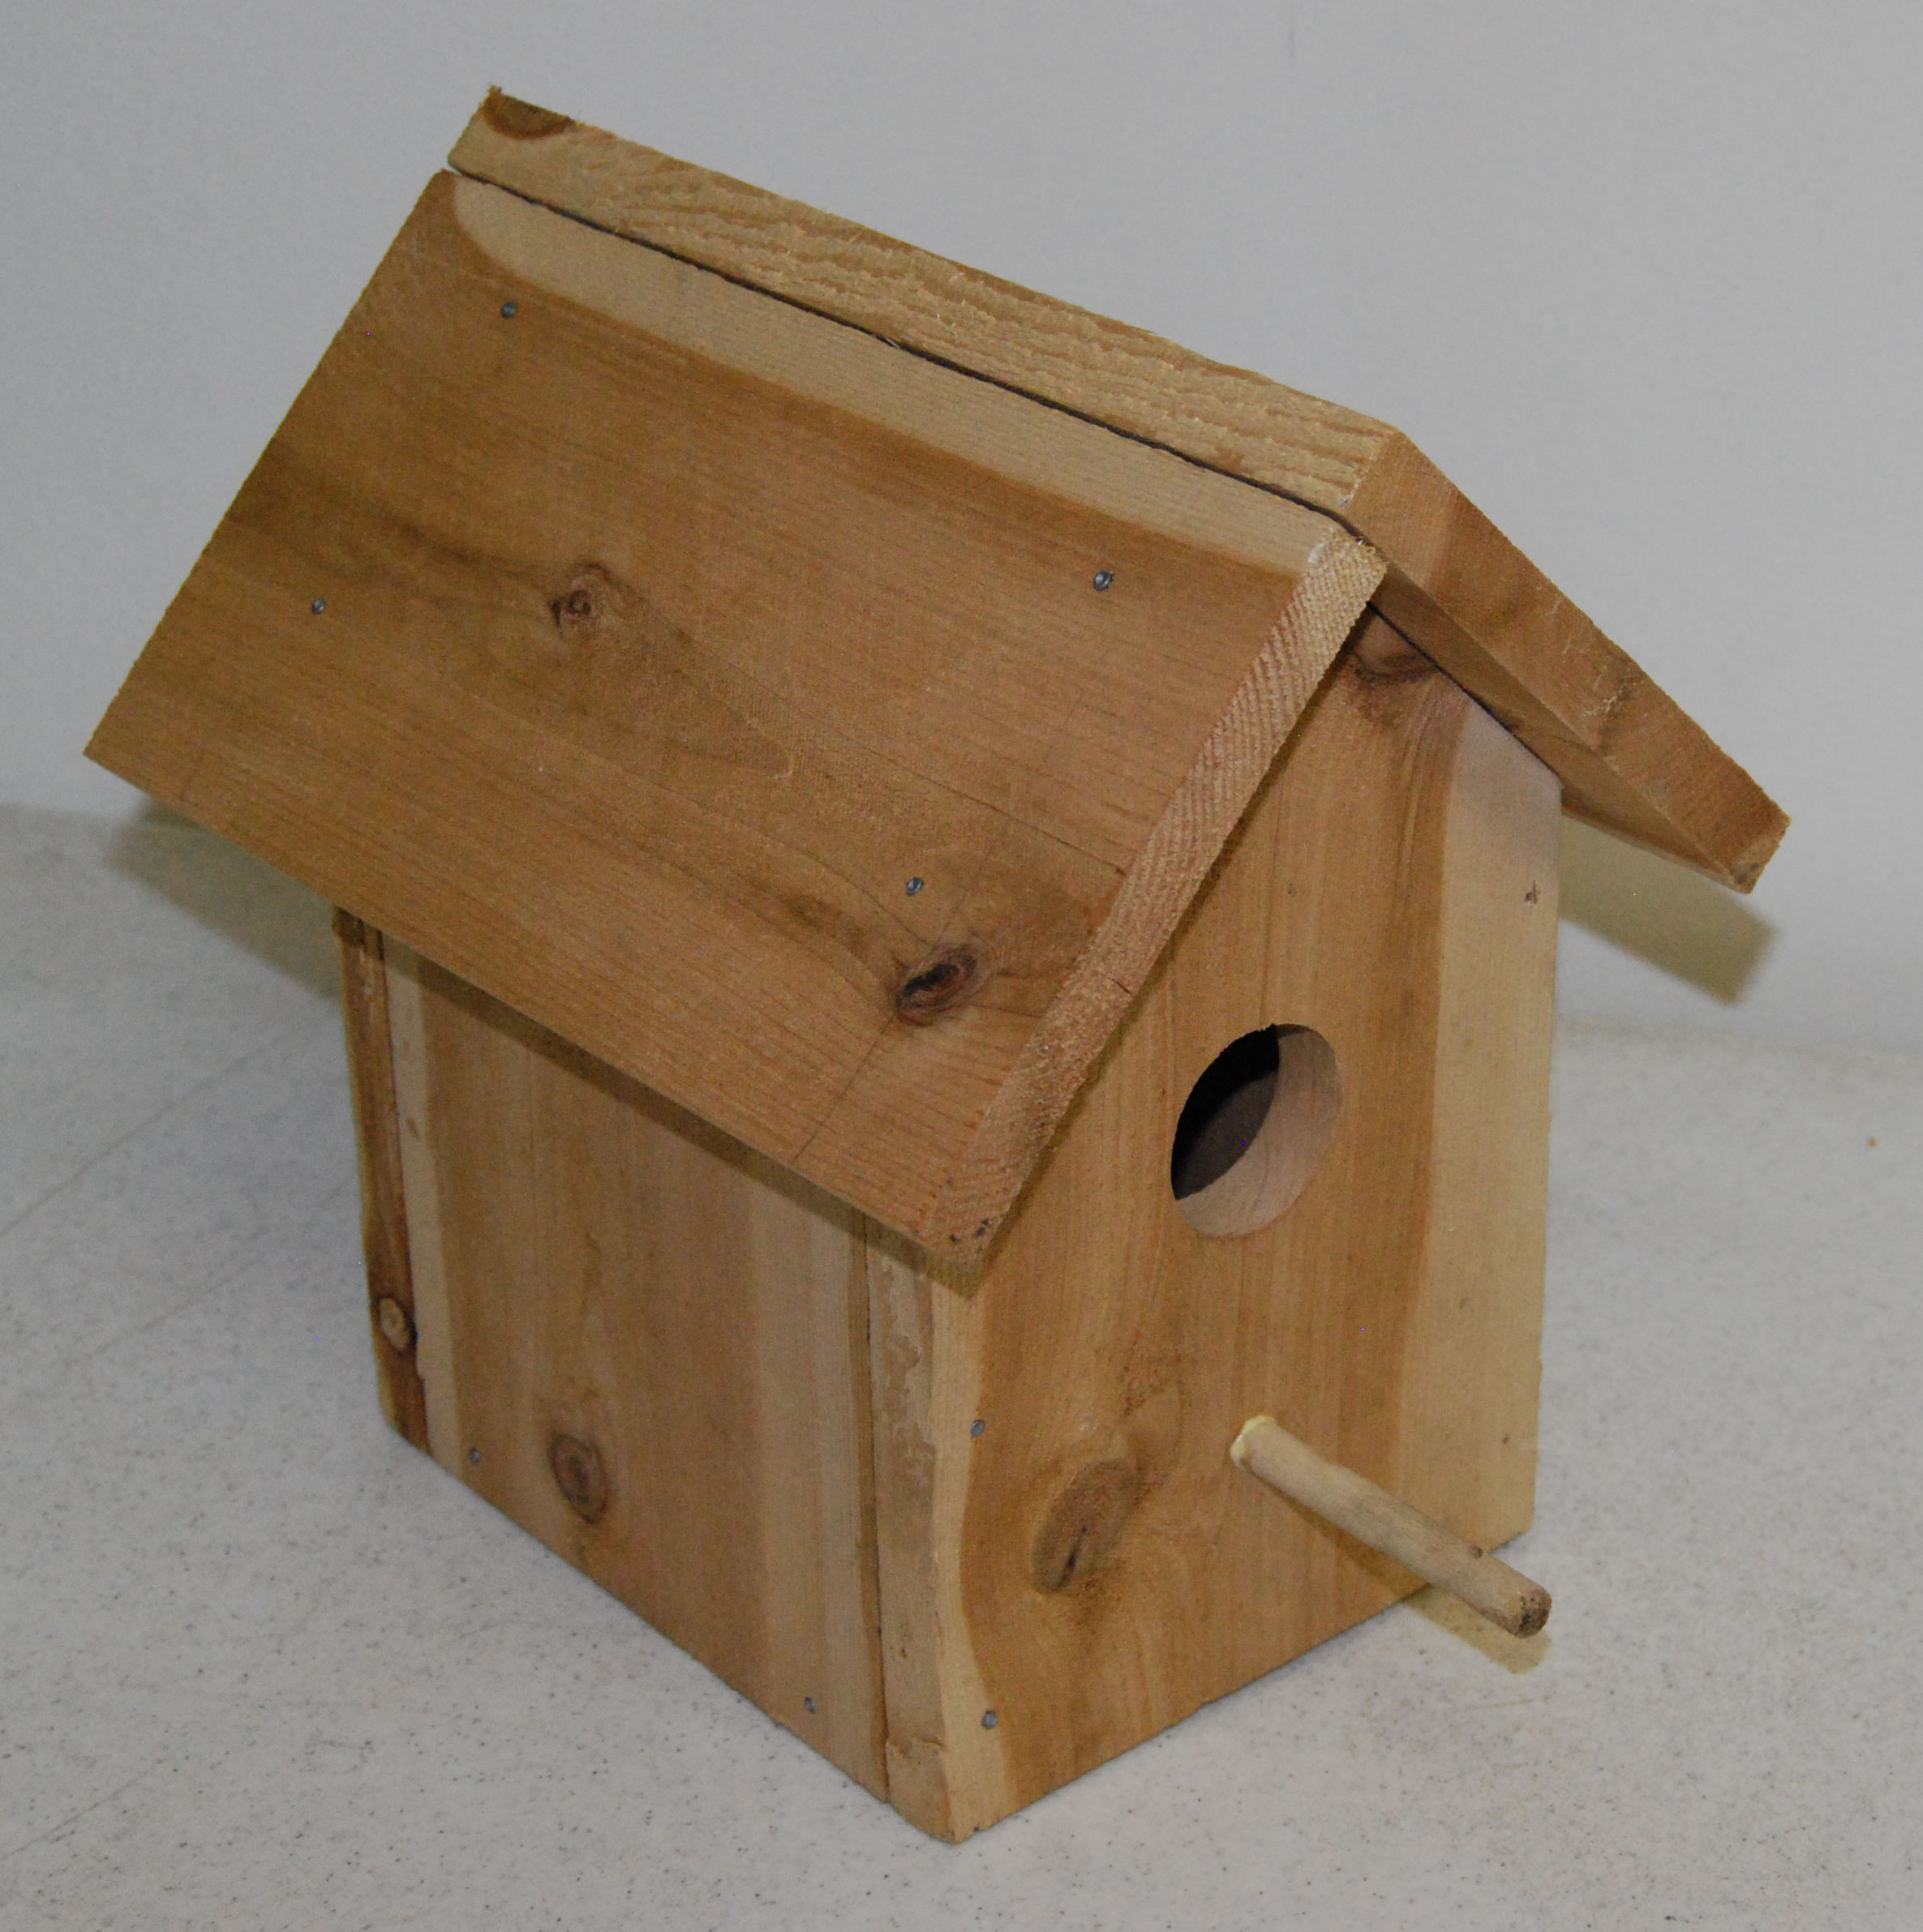
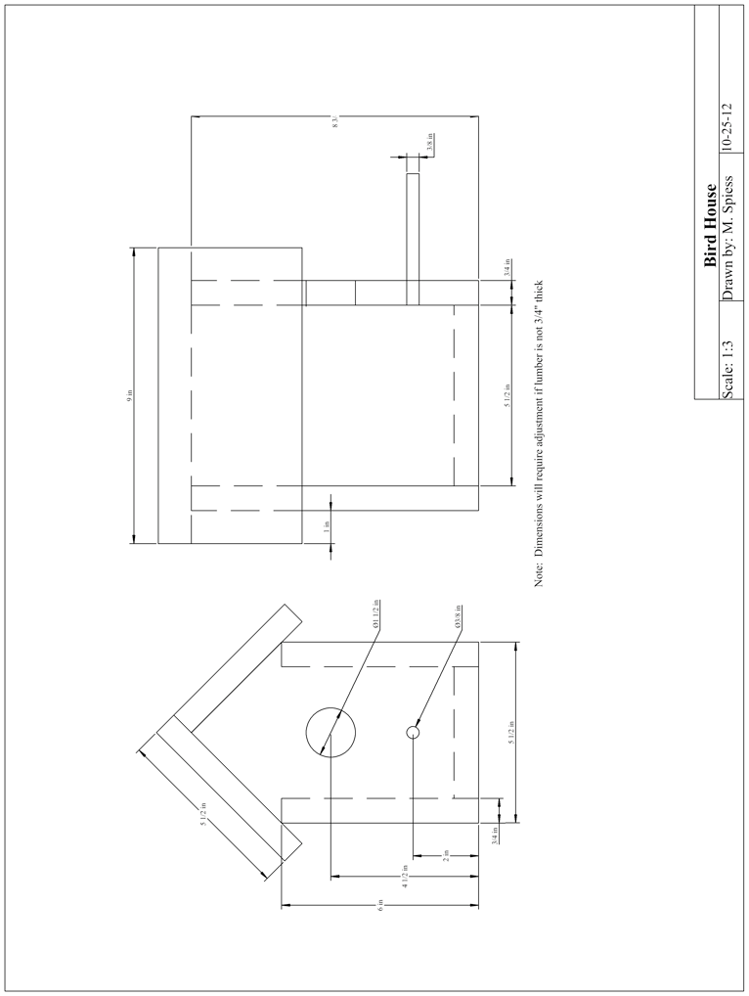

Birdhouse Worksheet
Name:_____________
Date:_____________

- What shop machine will you use to cut the top of the birdhouse at 45 degrees?

- What shop tool will you use to find the center of your circles?

- What diameter size drill bit will you use for the
4 ½ in high hole? ________________
2 in high hole? __________________
- What two finishing tools are we using to secure our birdhouse together?

- Why do we use “galvanized” nails?

- List two safety considerations (hazards) in building this project.

Grading Rubric:
CRITERIA | POSSIBLE | SCORE
Project layout (accurate measurements) | 5
Project cutout (accuracy and quality cuts) | 5
Holes drilled (size and location) | 5
Project finish (corners square, minimal scratches) | 5
Project completed on time and score sheet turned in | 5
Overall appearance of the project (workmanship) | 5
 | 30

Birdhouse Teachers Notes:

Agricultural Standards Met:
B1.0 Students understand personal and group safety:
B1.1 Practice the rules for personal and group safety while working in an agricultural mechanics environment.
B1.2 Know the relationship between accepted shop management procedures and a safe working environment.
B2.0 Students understand principles of basic woodworking:
B2.4 Complete a woodworking project, including interpreting a plan, developing a bill of materials and cutting list, selecting materials, shaping, joining, and finishing.

Objectives:
By properly completing this project, students will be able to:
- Student will be able to read and implement project layout directions.
- Student will be able to efficiently use wood cutting machine to make accurate wood cuts.
- Student will be able to efficiently use drill machine to make accurate hole size.
- Student will be able to implement placement and sanding for workmanship.

Alternative Tools/Methods/Materials:
-A handsaw may be used instead of a table saw- this will impact the construction of the birdhouse as well as the time that it will take students to cut their wood.
-If you use a hand saw, or your miter saw does not have the ability to cut angles, a carpenters square will then be needed to measure out the 45 degree angle on front and back panel.

Safety Review:
- Table saw
- Drill press
- Power miter saw
- All shop rules such as wearing shop glasses, appropriate clothing, and hair back.

Project Time:
Demonstration: | 20 min.
Build: | 1.5 hours
Demonstration Notes
- It is easy to draw the shapes of the front panel, side panel, and bottom panel on the whiteboard. Then write the measurements that need to be made on each drawing on the board, so that the students see it visually and will have the white board to reference while constructing the project.
- The front panel is the best piece to demo for the class, as it is the most difficult and will be the most work with saws and measuring for the students.
- Show the class how easy the combination square is to use for straight measurements and angles measurements.
- The worksheet is recommended so that students can write down measurements and tips during the lecture, so they have it for a reference while constructing the project.
- The bottom will usually have to be custom fitted as lumber will vary in thickness. Be cautious cutting small pieces on the miter saw.
- You may wish to rip several boards for the narrow roof section ahead so students will not have to use a table saw. Also ripping a longer board is safer.
- All pieces are to be cut from 1” x 6” (3/4” thick by 5 ½” wide) cedar fence board. Therefore, all dimensions shown 5 ½” will not require cutting.

Bill of Materials:
Project from: www.craftybirds.com Plan by: Sarah Beth Angle

