Fence Wire Bender
Name:___________________
Date:___________________

Description:
Small tool used to bend wire around another piece of wire for a fence. Processes used to build a wire bender are drilling, cutting and bending. Practices hot and cold metal skills.

Materials:
1/8” x 1” x 5” HR Steel Strip

Tools:
Hydraulic shear
Combination Square
Center punch
Scribe
Drill press and ¼” drill bit
Cutting Oil

Welding torch
Ball peen hammer
Pliers
File
Hacksaw

Procedure:
- Cut out 1/8” x 1” x 5” piece of steel using a hydraulic shear or hacksaw.
- File edges to smooth.
- Layout where the 3 holes are going to be using a combination square and scribe for accuracy.
- Use a center punch to mark the centers.
- Using the drill press, drill 3 holes.
- Scribe the cut lines.
- Put the piece of steel into a vise with the side with the 2 holes up.
- Using a hack saw, cut straight down from the top to the inside edge of the hole made by the drill press
- Use a file to file the edges.
- Position in the vise so the cut side is up. Position a scrap piece of metal even with the bend. This will be used as a spacer to properly bend the cut end.
- Use the welding torch to heat just the area to be bent.
- Using a ball peen hammer bend by pounding over the scrap.
- Put the hot piece in a bucket of cold water to cool the steel down. Use a mill file to remove any sharp edges.

Notes:
______________________________________________________________________________________________________________________________________________________________________________________________________________________________________________________________________________________________________________________________________________________________________________________________________________________________________________________________________________________________________________________________

Photo/Drawing:

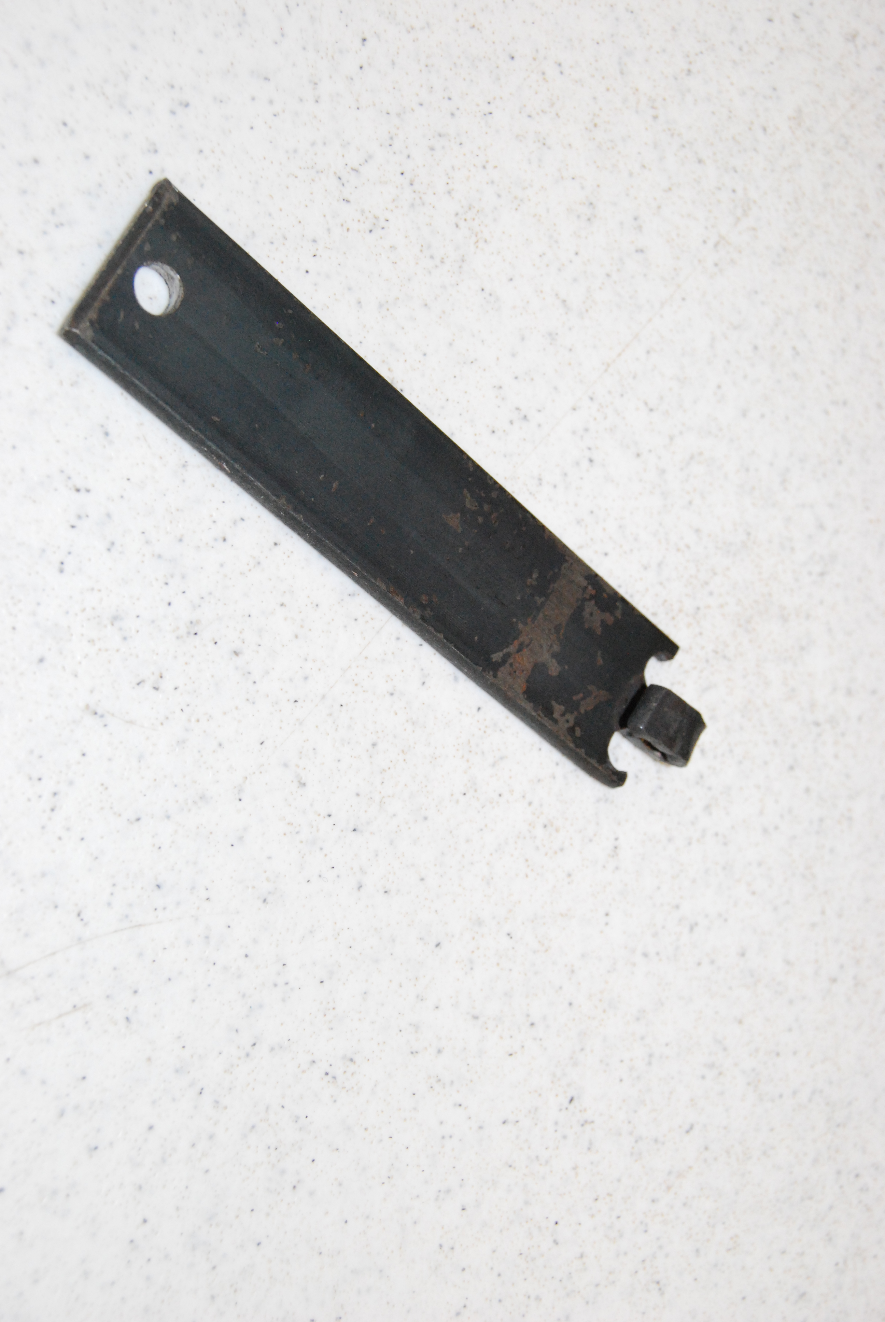

Metal bender Worksheet
Name: ________________________
Date: ________________________

Answer the following questions about building a wire bender

- What is the length in inches of the wire bender including the part that will be bent?

- What is the drill bit size for each of the holes? How many holes will you make?

- When lighting a welding torch, does the oxygen or acetylene get turned on first?

- When hot metal bending, what will you put the steel piece in to hold it?

- What should you be wearing at all times?

Grading Rubric:
CRITERIA | POSSIBLE | SCORE
Length | 5
Hole Locations | 5
Bent hook must be filed down smoothly | 5
Hook cut straight | 5
The hook length and bend | 5
Workmanship | 5
Total | 30

Teacher’s Notes:

Agricultural Standards Met:
6.0 Health and Safety. Students understand health and safety policies, procedures, regulations, and practices, including the use of equipment and handling of hazardous materials:
6.1 Know policies, procedures, and regulations regarding health and safety in the workplace, including employers’ and employees’ responsibilities.
6.2 Understand critical elements of health and safety practices related to storing, cleaning, and maintaining tools, equipment, and supplies.
6.4 Maintain safe and healthful working conditions.
6.5 Use tools and machines safely and appropriately.
6.6 Know how to both prevent and respond to accidents in the agricultural industry.
B1.0 Students understand personal and group safety:
B1.1 Practice the rules for personal and group safety while working in an agricultural mechanics environment.
B1.2 Know the relationship between accepted shop management procedures and a safe working environment.
B5.0 Students understand agricultural cold metal processes:
B5.3 Know layout skills.
B5.4 Know basic cold metal processes (e.g., shearing, cutting, drilling, threading, bending.).
B7.0 Students understand oxy-fuel cutting and welding:
B7.2 Know how to properly set up, adjust, shut down, and maintain an oxy-fuel system.

Objectives:
By properly completing this project, students will be able to:
- Read a plan
- Cut metal with a shear and hacksaw
- Layout on metal
- Properly measure
- Use a drill press
- Make a hot bend

Alternative Tools/Methods/Materials:
- Hand Drill.
- Metal could be bent cold in a vise. Clamp with a scrap and hammer over the scrap.

Safety Review:
- Safety glasses
- Hydraulic Shear (if used)
- Drill press
- Hack saw
- Welding torch

Project Time:
Demonstration: | 15-20 minutes
Build: | 3 hours

Demonstration Notes
- Have the wire bender pre-made and demonstrate how it bends fence wire. See: http://www.kencove.com/fence/flashpopup.php?video=TWTL
- When drilling the holes, take your time to ensure accuracy of the holes.
- Before using the hack saw to saw down the middle, take a file and etch in a little groove on exactly where you would like to cut so the hack saw doesn’t slip when you’re making the first cut.
- When bending the steel after heating it up, you will need to bend it as soon as you heat it or it will become cold and unbendable.

Bill of Materials:
Project adapted from: C. Weston (1966) Plan by: Holly Cordero

