Knife Rack
Name: _________________
Date: _________________

Description:
This project is a hanging, wooden knife rack that is capable of holding 6 knives. This knife rack is 10 inches tall, 8 inches wide, and 3 1/2 inches deep. The pieces of the rack are fastened using 1inch #6 wood screws. Skills used in this project include: Plan reading and layout, material selection, use of cutting tools/power tools, wood project assembly, workmanship and finishing skills.

Materials:
1" x 10" #3 Pine
4'x8'x1/4" sheet of birch plywood
#6 x 1" Flat head woodscrews
Wood glue
120 grit sandpaper

Tools:
Miter Saw
Table Saw
Drill Press
Countersink bit
Power Drill
Palm Sander
Combination Square
Steel Tape
Pencil

Procedure:
- Select Suitable Material.
  - Avoid knots, scars, dents
  - Look for similar grain patters/color
- Mark and cut all pieces.
  - Only lengths are necessary to measure when all the widths are equal.
  - Be mindful of direction of grain.
- Make cuts for knife blades on table saw.
  - Make sure blade is set at 90 degrees.
  - Rotate piece after 3 slots are cut to keep your fingers a safe distance from the blade.
- Locate and drill holes for woodscrews.
  - Make sure to countersink for screw head.
- Locate and drill hole for hanging.
  - Make sure to countersink for screw head.
- Assemble.
  - Be mindful of direction of grain.
  - Use wood glue sparingly and quickly wipe off excess with a damp rag
- Make sure screw heads are deep enough to avoid contact with sander.
- Sand all pieces.
- Varnish or paint.

Cutting List:
Quantity | Size | Material
1  2  1 | 1" x3"x8"  1"x3"x7-1/4"  10"x8" | #3 Pine  #3 Pine  Plywood
1 | 8"x8" | Plywood

Notes:
_________________________________________________________________________________________________________________________________________________________________________________________________________________________________________________________________________________________________________________________________________________________________________________________________________________________________________

Photo/Drawing:
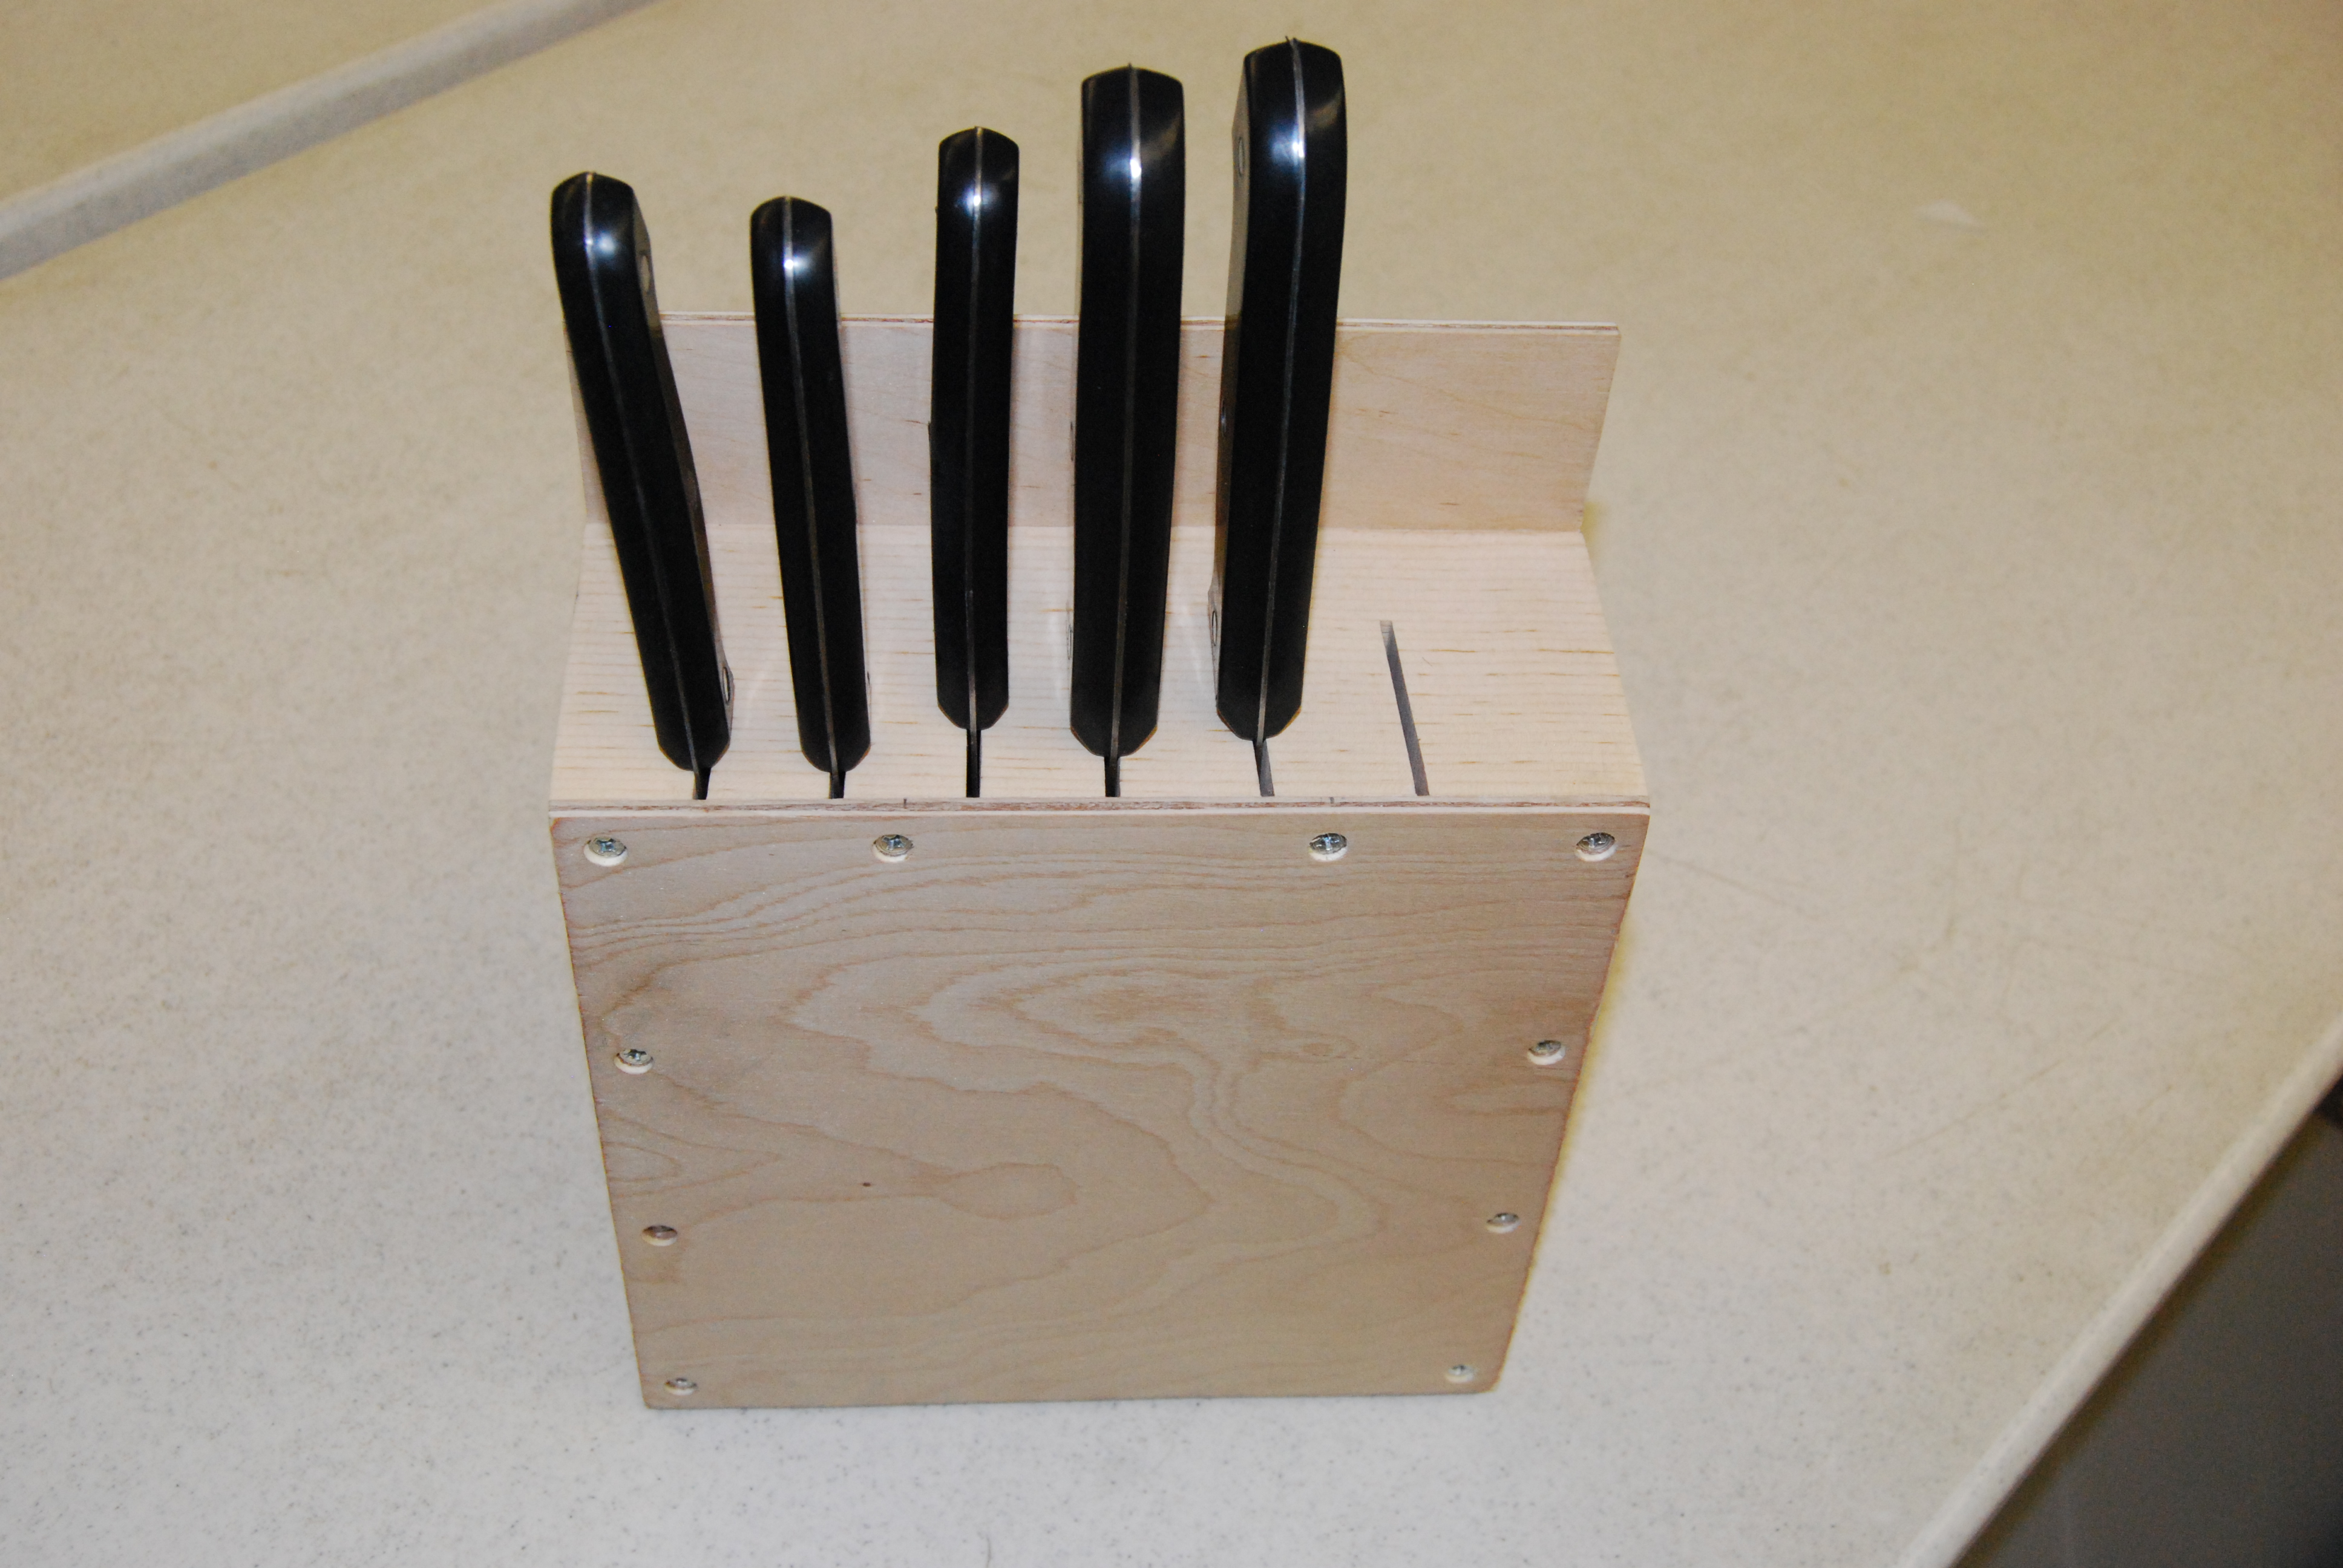
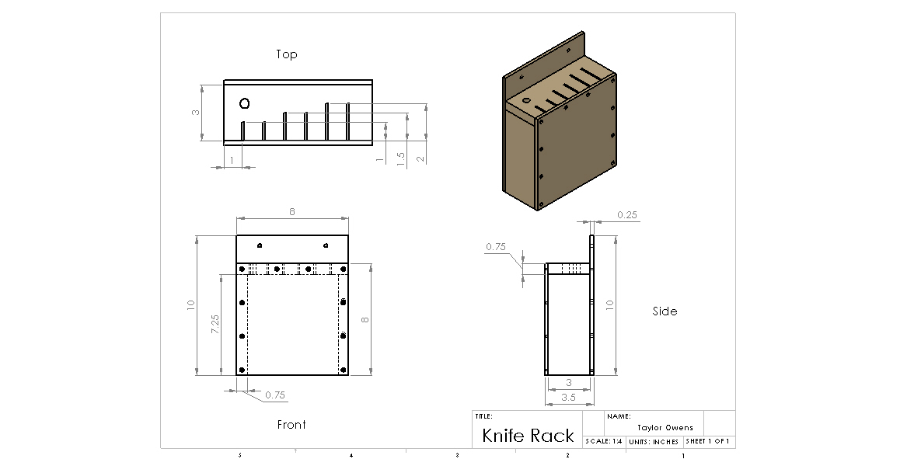

Knife Rack Worksheet
Name: ________________________
Date: ________________________

- What machine is used to make cuts for knife blades?

- What type of wood is used?

- How long of screws are used?

- True or False: Holes must be countersunk for screw heads.

- True or False: All pieces should be fully assembled before sanding.

Grading Rubric:
CRITERIA | POSSIBLE | SCORE
Dimensions are correct | 5
Holes are in correct location | 5
All screw heads are countersunk properly | 5
Project finished | 5
Workmanship | 5
Total | 25

Knife Rack Teachers Notes:

Agricultural Standards Met:
1.1 Mathematics Specific applications of Algebra I standards (grades eight through twelve):
(10.0) Students add, subtract, multiply, and divide monomials and polynomials.
Students solve multistep problems, including word problems, by using these techniques.
(12.0) Students simplify fractions with polynomials in the numerator and denominator by factoring both and reducing them to the lowest terms.
(13.0) Students add, subtract, multiply, and divide rational expressions and functions.
Students solve both computationally and conceptually challenging problems by using these techniques.
(8.0) Students know, derive, and solve problems involving the perimeter, circumference, area, volume, lateral area, and surface area of common geometric figures.
(10.0) Students compute areas of polygons, including rectangles, scalene triangles, equilateral triangles, rhombi, parallelograms, and trapezoids.
(11.0) Students determine how changes in dimensions affect the perimeter, area, and volume of common geometric figures and solids
6.0 Health and Safety. Students understand health and safety policies, procedures, regulations, and practices, including the use of equipment and handling of hazardous materials:
6.1 Know policies, procedures, and regulations regarding health and safety in the workplace, including employers’ and employees’ responsibilities.
6.2 Understand critical elements of health and safety practices related to storing, cleaning, and maintaining tools, equipment, and supplies.
6.4 Maintain safe and healthful working conditions.
6.5 Use tools and machines safely and appropriately.
6.6 Know how to both prevent and respond to accidents in the agricultural industry.
B1.0 Students understand personal and group safety:
B1.1 Practice the rules for personal and group safety while working in an agricultural mechanics environment.
B1.2 Know the relationship between accepted shop management procedures and a safe working environment.
B2.0 Students understand the principles of basic woodworking:
B2.1 Know how to identify common wood products, lumber types, and sizes.
B2.2 Know how to calculate board feet, lumber volume, and square feet.
B2.3 Know how to identify, select, and implement basic fastening systems.
B2.4 Complete a woodworking project, including interpreting a plan, developing a bill of materials and cutting list, selecting materials, shaping, joining, and finishing.

Objectives:
By properly completing this project, students will be able to:
- Read a plan to and layout dimensions.
- Safely and accurately use cutting tools
- Safely and accurately use drill press
- Correctly assemble a wood project
- Demonstrate workmanship and finishing skills

Alternative Tools/Methods/Materials:
- Project can be glued and clamped assembling without screws.
- Project can be assembled without screws using 3d finish nails or brads.
- Instead of rounding the top corners, there is an option of either leaving them straight or cutting them at 45 degree angles.
- Front and back can be made the same height and rack set on counter. (A bottom piece of solid wood can be added.)
- Any other type of wood can be used. Example: a hard wood such as poplar or birch.
- Size can be altered to customize for different knife sets.

Safety Review:
- Table Saw
- Miter Saw
- Drill Press
- Power Tools (Electric drill, Sander)
- Clothing (Safety glasses, loose clothing, long hair)

Project Time:
Demonstration: | 35 minutes
Build: | 3 hours

Demonstration Notes
- If possible, arrange shop and position yourself to be able to observe table saw and miter saw easily.
- Since sanding takes place after the knife rack is fully assembled, it is important to make sure the screw heads are fully countersunk to avoid contact with the sander.
- Add bonus features the students have an option of adding in the event they finish ahead of schedule. (ex. Adding a hole for sharpening rod, rounded edges, wood burning design, etc.)
- Be careful not to over sand the wood. This could result in non-uniform edges, dips, a wobbly base, or grooves.

Bill of Materials:
Plan by: Taylor Owens

