Sheet Metal Nail Box
Name: ___________________
Date: ___________________

Description:
This project is a small box used for holding nails and small parts. The processes of bending, cutting and cold metal processes are practiced.

Materials:
Construction paper
Tape
26 gage sheet metal
1/8” x 1/4” pop rivet

Tools:
Combination Square
Scribe
Box Brake
Foot sheer
Tin snips
Portable drill and 1/8” bit
Spot-welder
Pop-rivet gun

Procedure:
- Create a pattern out of paper
  - Use this paper pattern to figure out which folds and cuts need to be done first.
  - Fold and create a paper version on the box
- Cut a square piece of sheet metal for the box 16” x 14”
- Cut a square piece of sheet metal for the lid 6 ½” x 6”
- Layout your plan on the metal using a scribe and combination square.
- Cut your layout out using the snips
- Bend using the break.
- Spot-weld the tabs on the box.
- Fit the top carefully. Drill 6 holes in the top tabs and install the pop-rivets .

Cutting List:
1 | 16” x 14” | 26 gage sheet metal
1 | 6 ½” x 6” | 26 gage sheet metal

Notes:
______________________________________________________________________________________________________________________________________________________________________________________________________________________________________________________________________________________________________________________________________________________________________________________________________________________________________________________________________________________________________________________________

Photo/Drawing:

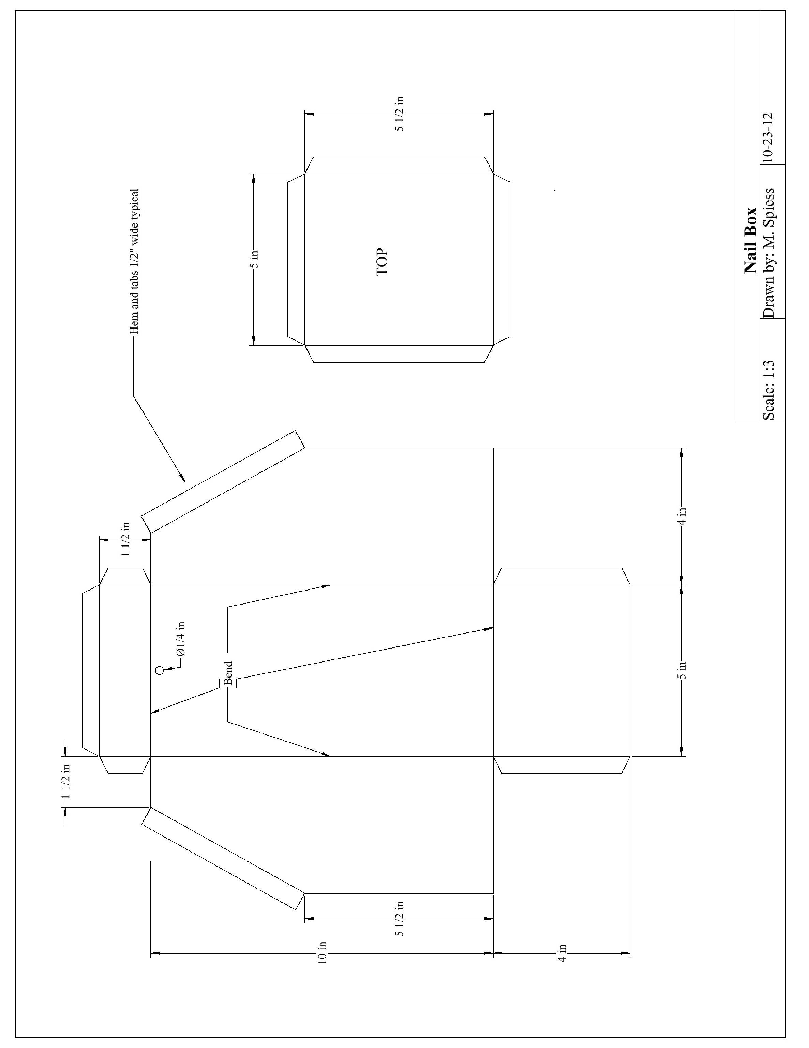

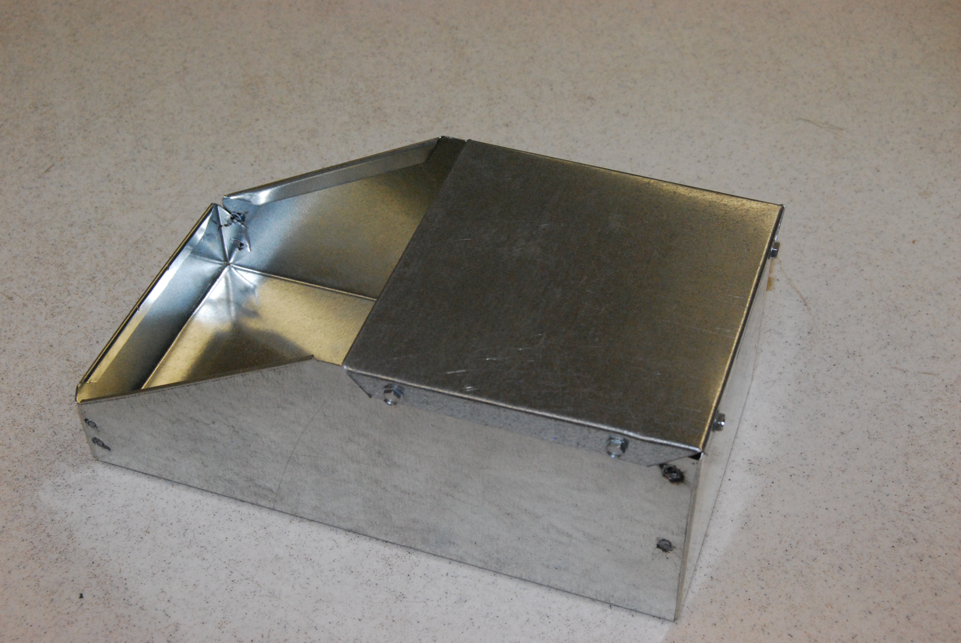

Sheet Metal Box Worksheet
Name: ________________________
Date: ________________________
Name these tools:

- ___________________________ 2, ___________________________________
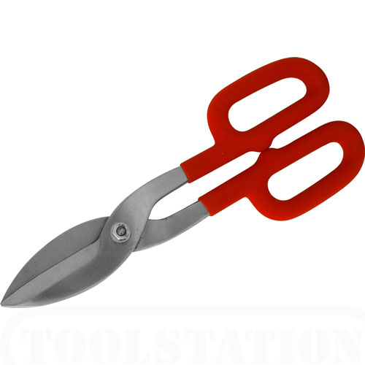
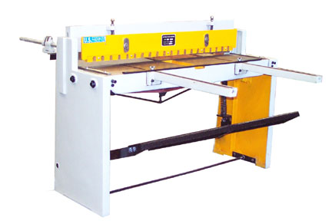

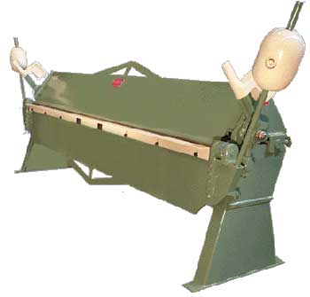
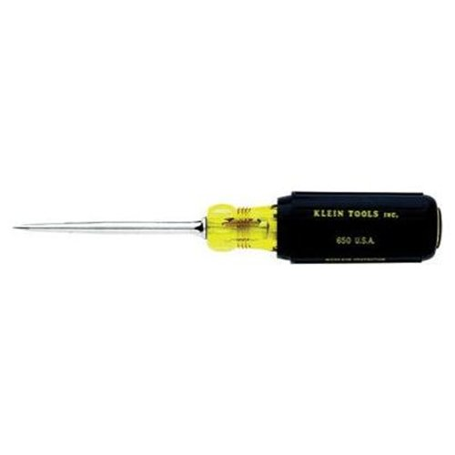
3. ____________________________ 4. ___________________________________

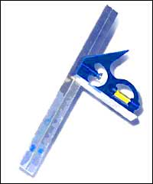
5. ____________________________

6. Why do you not use a sharpie when making a layout?
__________________________________________________________________________________________________________________________________________________________________________
7. Draw the fallowing lines
5 ½ inches

1 ½ inches

Grading Rubric:

CRITERIA | POSSIBLE | SCORE
Measurements | 5
Straightness of bends | 5
Spot weld quality | 5
Cut quality | 5
Workmanship | 5
Total | 25

Sheet Metal Box Teachers Notes:

Agricultural Standards Met:
6.0 Health and Safety. Students understand health and safety policies, procedures, regulations, and practices, including the use of equipment and handling of hazardous materials:
6.1 Know policies, procedures, and regulations regarding health and safety in the workplace, including employers’ and employees’ responsibilities.
6.2 Understand critical elements of health and safety practices related to storing, cleaning, and maintaining tools, equipment, and supplies.
6.4 Maintain safe and healthful working conditions.
6.5 Use tools and machines safely and appropriately.
6.6 Know how to both prevent and respond to accidents in the agricultural industry.
B1.0 Students understand personal and group safety:
B1.1 Practice the rules for personal and group safety while working in an agricultural mechanics environment.
B1.2 Know the relationship between accepted shop management procedures and a safe working environment.

B5.0 Students understand agricultural cold metal processes:
B5.1 Know how to identify common metals, sizes, and shapes.
B5.2 Know basic tool-fitting skills.
B5.3 Know layout skills.
B5.4 Know basic cold metal processes (e.g., shearing, cutting, drilling, threading, bending.).
B5.5 Complete a cold metal project, including interpreting a plan, developing a bill of materials, selecting materials, shaping, fastening, and finishing.

Objectives:
By properly completing this project, students will be able to:
- Cut sheet metal
- Bend sheet metal
- Use a pop rivet gun
- Use a hand drill
- Read a plan
- Use a layout
- Make a template
- Use a spot welder

Alternative Tools/Methods/Materials:
- Pop rivets for all fasteners (replace a spot welder)
- Self tapping sheet metal screws (see photo) can replace some of all pop-rivets.
- Snips (replace the sheer)
- A cornice brake can be used for some of the bends.

Safety Review:
- Watch fingers the edges of sheet metal are sharp
- Spot welder, Do not touch the spot welds they may be hot
- Shear
- Brake
- Portable Drill

Project Time:
Demonstration: | 30 minutes
Build: | 4 hours

Demonstration Notes
- Make sure you let your students know what order to make the folds in. This us why you practice using paper.
- Sharp sheer and snips work best.
- Teach your students to use a combination square well before doing this project
- Have them use a scribe because it is more precise than if they used a sharpie.

Bill of Materials: (complete this spreadsheet)
Plan by: Morgan Corley

Sample Grading Rubric
 | Excellent  5 Points | Great  4 Points | Good  3 Points | Okay  2-1 Point | Bad  O Points
Workmanship | Well presented, no sharp edges, no writing on it, clean | Has one issue (1 sharp edge, 1 place with writing, little dirty) | Has 2 issues | Has 3 issues | Has 4 or more issues
Measurements | Length, width, height, and depth are all corrected | Less then an 1/8 of an inch off on 1 or 2 measurement | More then an 1/8 of an inch off on more than 2 or ¼ of an inch off on 1 or 2 measurements | More then an 1/4 of an inch off on more than 2 | More than 1 measurement is more than ¼ inch off
Strait bends | Bottom and back are total square | Off by 1/16 | Off by 1/8 | Off by ¼ | Off by more than ¼
Spot weld quality | No burn all the way through and correct placement | One burn all the way through or 1 or 2 misplacements | 1 or 2 burn all the way through or 3 or 4 misplacements | 3 burn all the way through or 5 or 6 misplacements | More than 3 burn through or more than 6 misplacements
Cut quality | Straight cuts with no notching of metal | Straight cuts with 1 notch | Strait cuts with 2 notches | Slightly off cuts with 2 or 3 notches | More than 3 notches or poorly cut metal

