Barrel Smoker Plans

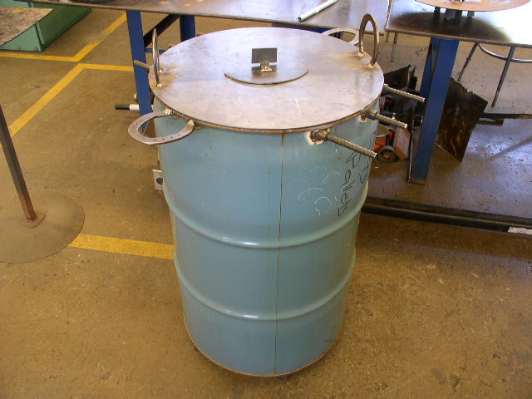
Atwater Ag Shop
Meredith

Materials: (1) 55 gallon barrel, 1.5 x 1.5 x 1/8 angle iron, 4 horseshoes, ½” rebar, ½” black pipe, 10ga sheet metal, 1 x 1 x .120” square tubing¼” round stock, 2 ½ x 1/8 strap, 2’ x 2’ of No. 13 x ½” expanded metal, and 1/8” pop rivets or ¼” nuts & bolts

This set of plans belongs to:______________________________________
(Your Name)

Directions: Follow all steps to complete a successful project. If at any time you do not understand a particular step, consult with the instructor. Pictures are provided to aid in your construction.
Questions or electronic copy: Email smeredith@muhsd.org
- Obtain a food grade 55 gallon barrel; choose a barrel with minimal side damage and in decent fabrication shape.

- Use a disk blade that is less that 22” in diameter. Clean the entire blade from oil or rust.

- Cut (4) 1” pieces of 1.5” x 1.5” x 1/8” or similar angle iron and tack weld to the bottom of the disk blade.

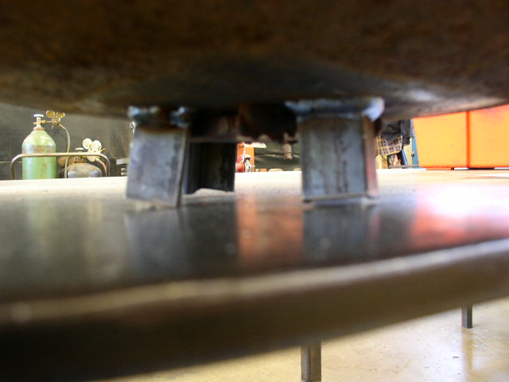

Make sure all pieces are tacked level before welded into place.

- On the top side, weld a 4” piece of 1” x 1” piece of square tubing or similar – make sure the tubing is perpendicular to the center of the blade. After the tubing is welded in place, make a 3” diameter ring from ¼” round stock and weld into the top of the square tubing.
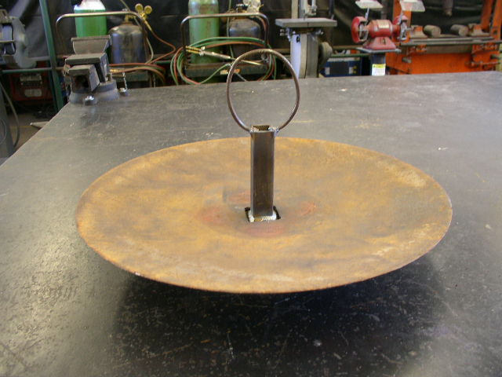

- Cut 3 pieces of ½” rebar 28” long – clean the burrs off the end.

- Find the center of the top lip and cut / drill 7/8” holes. Cut one side first, then measure across the diameter from the inside lip to inside lip. At the longest measurement this is centered. Mark and cut the opposite side also. These holes are to be placed down 4” from the top to allow for an expanded metal grate.

- Place two, 1 ½” long pieces of ½” black pipe in the center holes and run rebar through both pieces. Tack weld once; the pipe to the barrel on each side. Make the pipe almost flush with the inside of the barrel. Run rebar through the pipes and check for level.
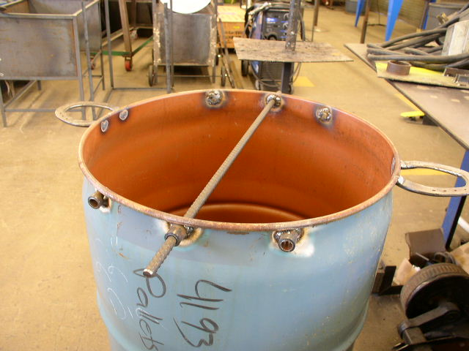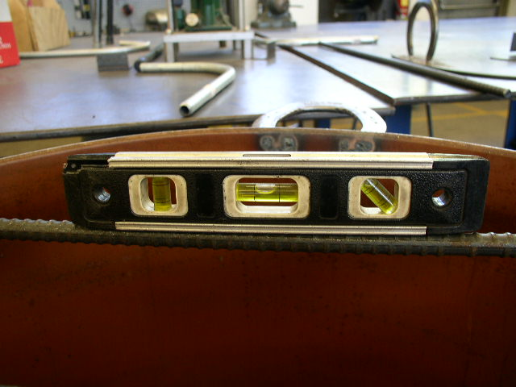

- Once both pieces of pipe are set, tack weld the entire tubing pieces on the inside and outside of the barrel. Keep the rebar in place the entire time and make sure it is always level. Do not burn through the pipe!!!
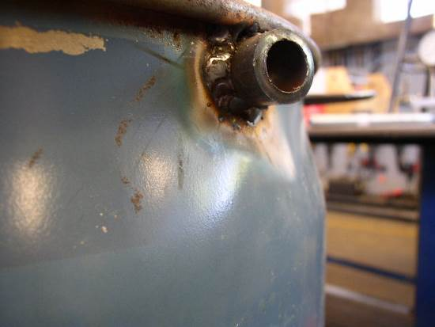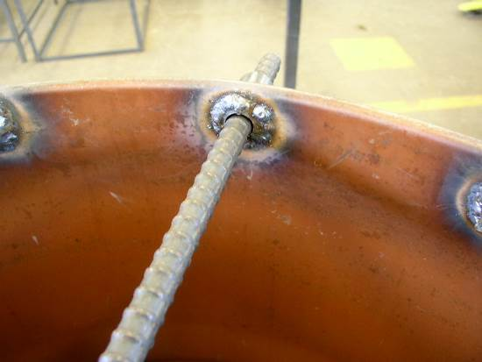

- Repeat 7/8” holes on either side of the center pipe. The holes should be place exactly 5 ½” apart on both sides from the center. Place pipe and tack weld.
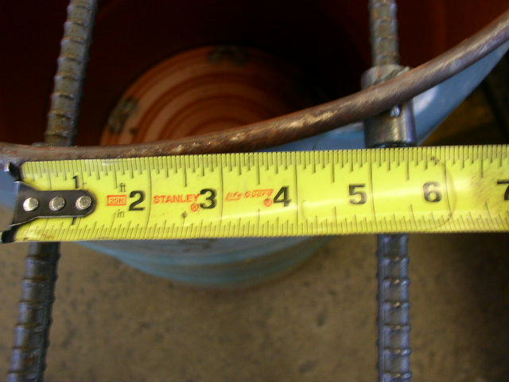
Make sure rebar is in place and level at 5 ½” apart.

- Repeat step nine on both sides. You should now have three pieces of rebar running through the top of your smoker.
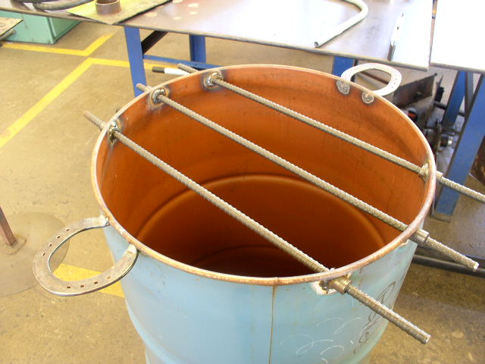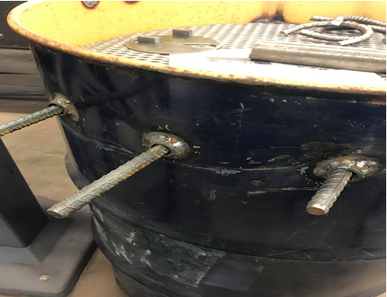
Top Set Non Grill Setting 4” Low Grill Setting

- Place two horseshoes on the outside of the barrel. They should be perpendicular to the rebar and welded under the top lip. Make sure to use your level and spot weld the horseshoes in place. See above. ½” Rebar can be used in place of horseshoe by cutting a 14” piece and bending it with a 2” radius on the diacro bender. Cut off the excess tabs for a flush fit. See below.
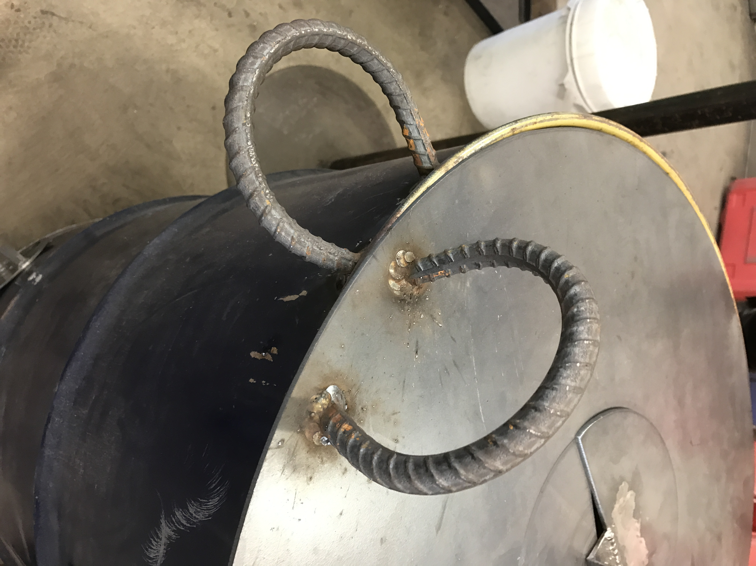

- Cut a 23 or 24” diameter circle out of 10ga sheet metal depending on opening of barrel. This can be done by center punching the center of a lay out circle and using a circle guide to make a perfect circle or by cutting it out on the CNC plasma machine. 22” circle for the exp metal grill.

- Drill a 9/64” hole in the center of the circle. (center punch and drill)

- Cut out an 8” diameter ½ circle from a separate 10ga sheet metal. This cut out is on the same file as the smoker lid in the CNC program.

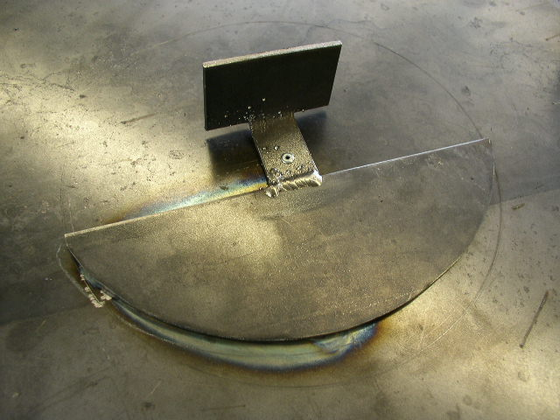

- Make a handle for the top airway be cutting 2 ½” x 1/8” thick strap 3 ½” long. Notch out 1” and leave a 1 ½” lip in the center. The lip should be 1 ½” wide by 1 ½” long.

- Bend the lip to a 90 degree angle and weld the 1” wide lip to the center of the 8” ½ circle. See below.
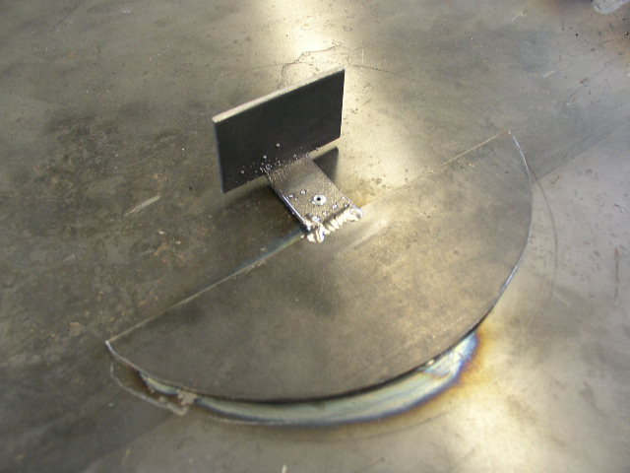

- Drill an 9/64” hole in the middle of the 1” notch. Using a pop rivet, rivet the notch to the center of the cover using a long 1/8” rivet.

- Cut out a quarter circle by tracing a 3 ½” by 2 ½” line and connecting a quarter oval. After traced, see if the rotating air cover will completely cover your quarter circle. If it does not, make your quarter circle smaller until you cannot see your lines. Then cut the air hole. Picture on next page.
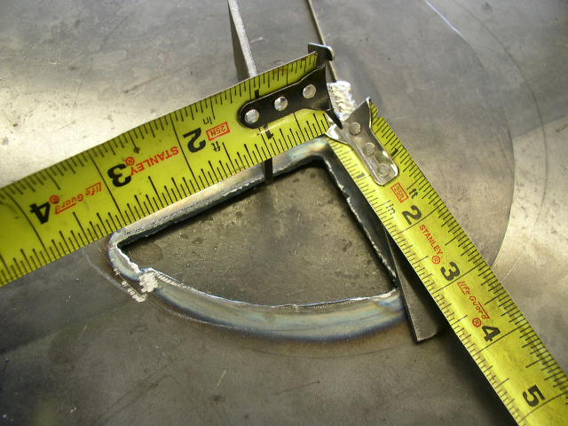
Important: Make sure the air cover will cover the hole completely

- Weld two horseshoes on either side for the cover handles. They should be plumb and 1” in from the edge. ½” Rebar can be used in place of horseshoe by cutting a 14” piece and bending it with a 2” radius on the diacro bender. Cut off the excess tabs for a flush fit.
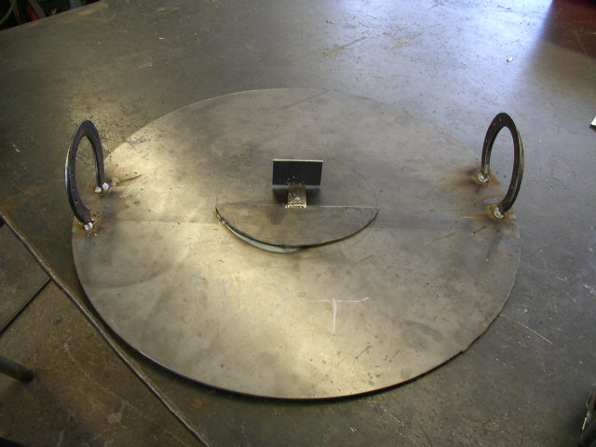

- Cut a 3” x 3” V cut toward the bottom of the barrel. This will allow air flow into the barrel to allow the charcoal to burn. A vent can replace the V. Use the CNC Vent file.
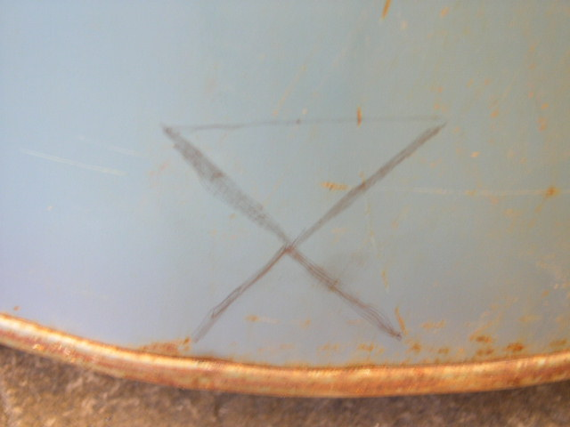
Cut the V out of an upside down triangle!!!
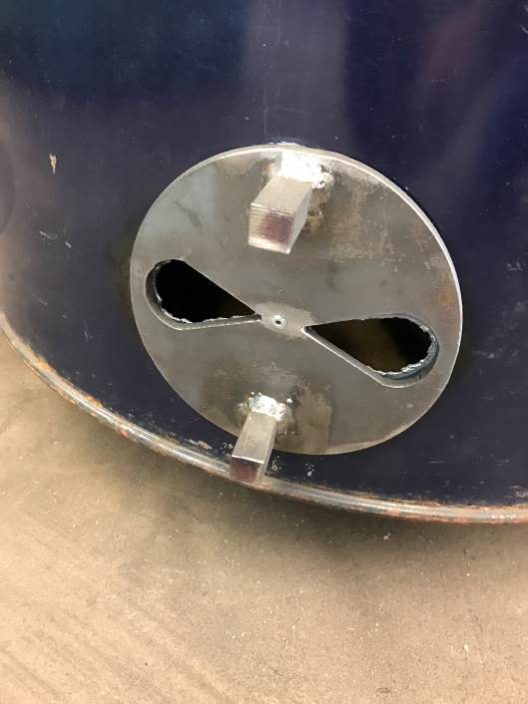
Cut out a vent on the CNC plasma machine, trace the holes, cut holes and drill a 9/64” hole to pop rivet the vent on the barrel.

- OPTIONAL WHEEL ATTACHMENT: Draw an X on the bottom and place 25/64” (3/8”) holes for a 2 ½” x 13/16” swivel caster wheel with a 3/8”-16 ¾” stud. The holes to be drilled are 2 ½” indented from the bottom lip to center. 4 wheels will be needed to keep the barrel from tipping over.

See Pictures on next page for details.
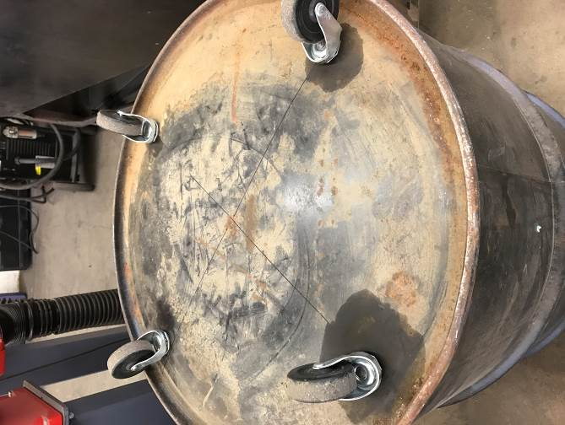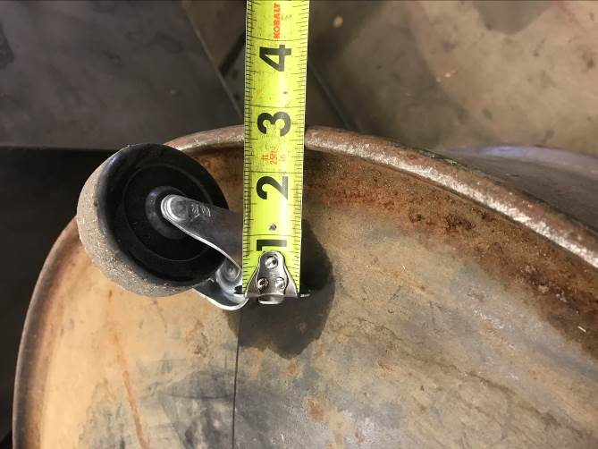

- Using the Smoker Hook Jig, use ¼” round stock to make the meat hooks.
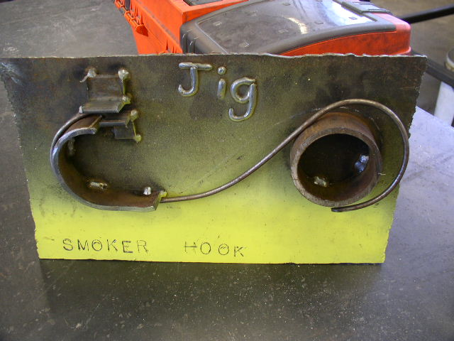

- Start with one end in the angle iron and continue to bend the “S” hook around the Jig in a figure eight motion.
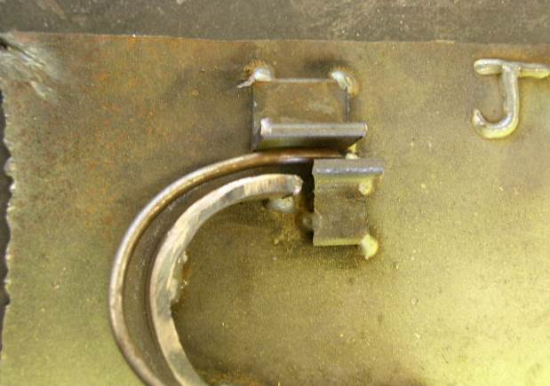
- Cut the “S” hook at desired point using bolt cutter. Grind one end to a sharp point before doing the bend. Repeat step 22 – 24 for additional hooks.

- Cut a 30” piece of ½” rebar. Deburr the ends and bend one end of the rebar into a 180 degree Candy cane hook. Cut another piece of rebar at 10”, deburr the ends. Weld the 10” piece on the straight end “centered” to make a hook that will be able to remove the disk blade assembly with ease.

- Paint the entire exterior of the smoker with high heat paint.
