- Importance of Leveling
  - The determination of elevations is called ________________
  - Measuring relative elevations changes is a comparatively simply process
  - ___________and_____________ control of relative elevations are critical to most construction projects
- The Level
  - A ________________ consist of a high-powered telescope
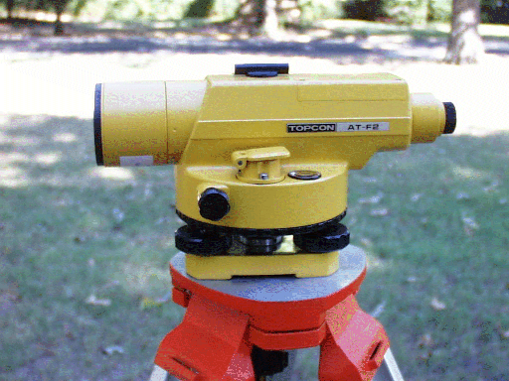
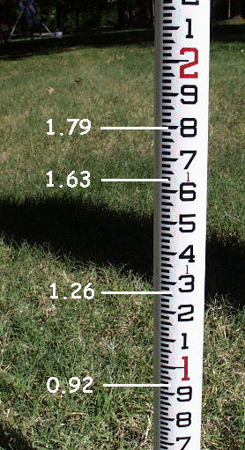
  - The level is attached to a spirit or bubble level that keeps the line of sight of the telescope horizontal
  - Level Instruments

  - Reading the Rod
- Definitions
  - Bench mark (BM) - ______________________
__________________________
  - Backsight (BS) - ________________________________
________________________________
  - Height of instrument (HI) - the elevation of the line of sight of the telescope
  - Foresight (FS) - ______________________________________________
- Computation of Elevations
  - BS + Elevation = HI
  - HI – FS= Elevation
  - Change in elevation- summation of the backsight and the foresight then subtract
  - The initial ________________ is taken to a point of known elevation
  - The backsight reading is added to the elevation of the known point to compute the ________________
  - The level may be moved to a temporary point called a ________________
  - The elevation of a point is the height of the instrument (HI) minus the foresight (FS)

- Common Mistakes
  - Misreading the rod - reading 3.54 instead of 3.45
  - Moving the turning point - use a well–defined TP
  - Field note mistakes - ________________________________
  - Mistakes with extended rod - make sure the leveling rod is fully extended
  - ________________
  - Settling of leveling rod
  - Leveling rod not fully extended or incorrect length
  - Level instrument not level
  - ________________
  - Environment - wind and heat

